Annual session 2009
26 May to 5 June 2009, New York
Item 10 of the provisional agenda

Internal audit and oversight

Report on internal audit and investigations

Summary
The present report provides information on the activities of the Office of Audit and Investigations for the year ended 31 December 2008. In line with Executive Board decision 2008/13, the report also contains (a) a list of the key findings; (b) an overview of the audit ratings; (c) a table showing unresolved audit recommendations by year and category; (d) explanation of findings that have remained unresolved for 18 months or more; (e) the outcome of investigations on the misconduct of staff members; (f) an update on the progress made regarding audits rated ‘unsatisfactory’; (g) the outcome of risk-based audit planning; and (h) the status of the staffing situation of the Office of Audit and Investigations. As had been requested in decision 2006/13, the management response to this report is presented separately. In accordance with the approved oversight policy (DP/2008/16/Rev.1), the annual report of the Audit Advisory Committee is attached to the present report (see appendix).
Elements of a decision
The Executive Board may wish to: (a) take note of the present report; and (b) express its support for strengthening the internal audit and investigations function of UNDP.

Contents

Chapter Page
Introduction 3
I. Assurance in UNDP 3
II. Risk-based audit planning 6
III. Staffing and budget 7
IV. Significant internal audit results 8
A. Country office audits 8
B. Headquarters audits 12
V. Advisory and management services 13
VI. UNIFEM audits 13
VII. Review of audits of projects executed by non-governmental organizations and/or national governments 14
VIII. Investigations 16
IX. Overall conclusion and outlook 19
Annexes (available on the Executive Board web page)
1. Charter of the Office of Audit and Investigations
2. Recommendations unresolved for 18 months or more

Appendix (available on the Executive Board web page)
Annual report of the Audit Advisory Committee for the calendar year 2008

Introduction

- The Office of Audit and Investigations (OAI) of UNDP submits to the Executive Board its annual report on its internal audit and investigation activities for the year ended 31 December 2008.
- As requested by the Executive Board in its decision 2008/13, the report contains a list of the key findings and audit ratings; a table displaying the unresolved audit recommendations by year and category; and an explanation of findings that have remained unresolved for 18 months or more, together with an analysis of the progress made towards resolution. A presentation of investigations complaints processed in 2008 and a description of significant investigations cases are also included. In addition, the outcome of risk-based audit planning and the status of the staffing situation and resources of OAI are presented in this report. In line with decision 2006/13, the management response to this report is presented separately. In accordance with the approved oversight policy (DP/2008/16/Rev.1), the annual report of the Audit Advisory Committee is attached to the present report (see appendix).

Assurance in UNDP

Mandate of the Office of Audit and Investigations
- The oversight policy of UNDP, which is integrated into the UNDP accountability system (DP/2008/16/Rev.1), was approved by the Executive Board in its decision 2008/37. The policy describes how independent internal and external oversight is organized in UNDP to provide assurance to the Executive Board and the Administrator about systems of internal controls in the organization. The policy outlines the institutional set-up of independent internal oversight and describes the internal audit and investigation responsibilities of OAI.
- To carry out its mandate, OAI exercises operational independence. The Director of OAI is directly accountable to the Administrator and independently submits to the Executive Board an annual report covering a summary of the observations and recommendations of OAI. In 2008, the mandate (purpose, authority and responsibility) of OAI was formally acknowledged through the approval of its charter by the Administrator on 8 February 2008 (see annex 1).
- The external quality assurance review that OAI underwent in 2007 (reported in DP/2008/20) led to the strengthening of the internal audit function of UNDP. Following that review, OAI developed its quality assurance and improvement programme to ensure that its audits would be conducted in accordance with the International Standards for the Professional Practice of Internal Auditing (referred to hereafter as the “Standards”), and that it would continuously enhance the quality of its work so as to add value and improve the operations of UNDP. As of 31 December 2008, OAI had substantially implemented the external quality assurance review recommendations and formulated an action plan to improve its audit strategy, management, scope, resources, focus, professional development and training, as well as outreach and communication. To ensure that OAI staff collectively possesses the level of skills required to perform its functions, a learning policy was established in July 2008 that provides the basis for technical and non-technical learning and training. In September 2008, the new web-based audit management software (Governance Risk Compliance) was procured to replace the previous system, Auto Audit. The new system was activated in early 2009. It is expected to enhance overall audit efficiency by facilitating the documentation of audit fieldwork, the preparation of audit reports and audit management reports, as well as quality assurance reviews.
- The UNDP Audit Advisory Committee, consisting of five independent and external experts, reviewed the strategy, annual work plan, budget and annual report of OAI, and provided advice to promote the effectiveness of the audit and investigations function in UNDP. The external auditor of UNDP, the United Nations Board of Auditors, also reviewed the operations of OAI as part of its biennial audit in 2008, in order to determine the level of confidence that the Board of Auditors can have in the work of OAI.
- During 2008, OAI worked with other internal oversight services in the United Nations system, in particular with the United Nations Office of Internal Oversight Services and the internal oversight services of the United Nations funds and programmes. OAI was an active member of the audit working group of the United Nations Development Group, an interagency working group that meets periodically to discuss audit and oversight matters of relevance to the United Nations organizations. OAI participated in the Meeting of Representatives of Internal Audit Services of the United Nations Organizations and Multilateral Financial Institutions and in the Conference of International Investigators.

Disclosure of internal audit reports
- The UNDP oversight policy (DP/2008/16/Rev.1) and the ensuing decision 2008/37 recognize the confidential nature of internal audit reports and provide a set of minimum conditions that must be satisfied when disclosure of such reports is requested by a Member State.
- In two instances in 2008, OAI received a request from a Member State for disclosure of internal audit reports. In response to these requests, access to eight internal audit reports was granted, on OAI premises in New York, under conditions of confidentiality. The Executive Board was informed accordingly.

Basis for providing independent assurance
- During 2008, OAI issued 57 reports, pertaining to three headquarters audits and 54 country office audits (see figure 1). The 54 country office audits included three follow-up audits, three special audits, and two audits of projects directly executed by country offices (see figure 2). While directly executed projects are generally reviewed during the internal audits of country offices, separate audits are conducted in cases where project expenditure is significant or risk exposure is high. Two of the three special audits reviewed the role of UNDP as a principal recipient of grants from the Global Fund to Fight AIDS, Tuberculosis and Malaria (GFATM).
- Since most of the audit reports issued in 2008 covered operations and activities of the UNDP offices during the year 2007, the audit outcome reflects the status of UNDP operations in 2007. The 54 audits of country offices, including follow-ups, projects directly executed by UNDP, GFATM grants and support to national execution accounted for about $0.95 billion (25 per cent) of the $3.9 billion in expenditures that UNDP incurred at the country-office level in 2007. The country office audits and headquarters audits thus represented a solid supplement to the other oversight mechanisms from which the Administrator and the Executive Board derive assurance of the efficient use of resources in UNDP and the effectiveness and adequacy of internal controls.

Figure 1. OAI reports issued in 2008
Headquarters | Atlas risk and controls; information technology governance;  UNDP Procurement Function
Africa | Angola; Burundi; Cameroon; Cape Verde joint office; Central African Republic  (GFATM-funded activities); Chad (follow-up); Côte d’Ivoire; Democratic Republic  of the Congo (GFATM-funded activities); Equatorial Guinea; Eritrea; Ethiopia;  Gambia; Ghana; Guinea; Johannesburg Regional Centre; Mozambique (follow-up);  Republic of the Congo; Rwanda; Senegal; United Republic of Tanzania;  Zimbabwe (follow-up)
Asia and the Pacific | Bangkok Regional Centre; Bangladesh; Cambodia (DEX projects); Malaysia;  Pacific Centre; Pakistan; Papua New Guinea; Thailand; Timor-Leste (DEX projects)
Arab States | Bahrain; Jordan; Kuwait; Libyan Arab Jamahiriya; Saudi Arabia; Somalia
Europe and the CIS | Armenia; Azerbaijan; Belarus; Cyprus; Kosovo; Republic of Moldova; Tajikistan;  Ukraine
Latin America  and the Caribbean | Barbados; Bolivia; Bolivarian Republic of Venezuela; Chile; Haiti;  Honduras (special audit); Jamaica; Paraguay; Trinidad and Tobago; Uruguay
UNIFEM | Programme Office in Afghanistan; Subregional office for West Africa;  Subregional office for the Andean region
Note: DEX = directly executed by UNDP; CIS = Commonwealth of Independent States;
UNIFEM = United Nations Development Fund for Women

Figure 2. Number of country office reports issued in 2008, by scope and region
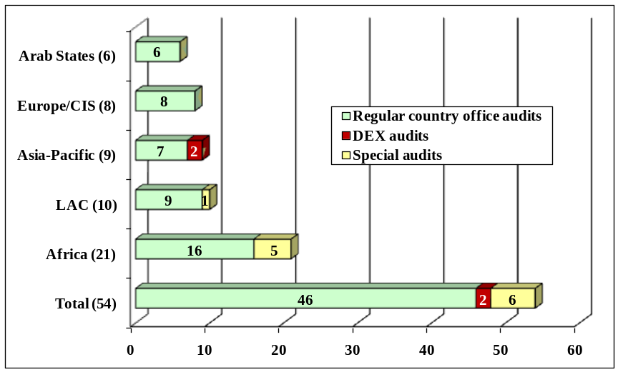
Note: LAC = Latin America and the Caribbean

Risk-based audit planning

- In line with the Standards, which require the planning of audits to be based on a risk-assessment process undertaken at least annually, OAI selected the country offices to be audited in 2008 based on an audit risk assessment conducted in the last quarter of 2007. The audit risk-assessment process was participative, involving the regional bureaux and their country offices. Since its adoption in 2006, the risk assessment model has been refined annually. The most recent risk assessment model, used in 2008 for the 2009 work plan, incorporated indicators reflecting the corruption perceptions index published by Transparency International as well as the results of the annual UNDP global staff survey. In the final selection of offices to be audited, OAI consulted with the United Nations Board of Auditors in order to avoid duplication of audit efforts and to maximize internal and external audit coverage of UNDP operations and activities.
- In line with its present and anticipated capacity, OAI strives to audit offices with ‘high’ audit risk every two years, offices with ‘medium’ audit risk every three to four years, and offices with ‘low’ audit risk every five years. Since the introduction of risk-based audit planning in 2005, OAI has made significant progress towards achieving full audit coverage. Over the five-year period ended 31 December 2008, OAI achieved a 95 per cent coverage against its target (see figure 3). In 2009, OAI expects the coverage to increase to 97 per cent, with only three – all in the ‘low’ audit risk category – of 141 offices remaining unaudited during the last five years.

Figure 3. Audit coverage for the five year period ended 31/12/2008:
Audits completed vs. audits required according to OAI audit cycle
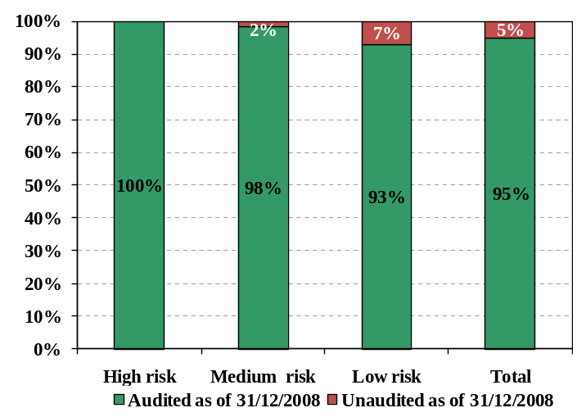
- The most recent country office audit risk assessment conducted in 2008 for the planning of the 2009 audits resulted in four (3 per cent) of the 141 offices assessed being ranked ‘high’ audit risk, 84 (60 per cent) being ranked ‘medium’ audit risk and the remainder being ranked ‘low’ audit risk (see figure 4).
- While OAI has applied a risk-based methodology for country office audits in the past four years, this has not been the case for headquarters units and corporate functions. Compared with country offices that have a more standardized purpose and business model, headquarters units and corporate functions have greater diversity of purpose and highly specific role and functions. Consequently, while a set of standardized quantitative and qualitative factors can be used to assess the audit risk in country offices, a unique set of risk factors is required for headquarters in order to ascertain that the specific nature of each major unit or function is appropriately taken into account.
Figure 4. Distribution of country and regional offices, by risk category
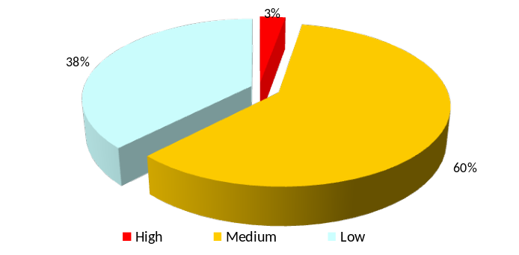

- Given the size and the significance of the corporate functions of the Bureau of Management, OAI conducted a headquarters risk assessment of the Bureau in 2008. The participatory approach included facilitating a workshop attended by heads of units, managers and key staff, who identified the risks and assessed their severity in terms of likelihood of occurrence and of impact if the risk identified were to materialize. The results of the risk-assessment exercise and subsequent consultations with senior management in the Bureau were translated into a tentative three-year audit work plan for the years 2009-2011.

Staffing and budget

- As of 31 December 2008, OAI had 65 posts, 15 of which were vacant. An appointment offer was made in January 2009 to fill one of the vacant posts. Seven of the remaining vacancies were new posts established in 2008, while seven existing posts had become vacant in 2008 as a result of staff movements (such as reassignments between duty stations or offices, secondment on peacekeeping mission service and resignations). On average, the 15 posts vacant as of 31 December 2008 had been vacant for a period of seven months. During 2008, OAI filled 13 positions, using a rigorous selection process that included a written test as well as technical and competency-based interviews. The average duration of the recruitment process was seven months. One of the main obstacles to achieving a faster recruitment process were the language requirements in certain duty stations (Cairo, Egypt; Dakar, Senegal; and Panama City, Panama), which reduced the pool of suitable candidates. Several positions therefore had to be readvertised.
- Among the positions created in 2008 were two posts dedicated to the audit of GFATM grants managed by UNDP, which are aimed at ensuring better audit coverage of the role of UNDP as a principal recipient of GFATM funds, in particular in high-risk programmes. Additional posts at some of the regional audit centres of OAI were created to carry out reviews of audit reports pertaining to projects executed by non-governmental organizations and/or national governments. Inter alia, these positions will enable the OAI auditors to be closer to the country offices in the region and hence provide better guidance and assistance in order to ensure that the audits of such projects are done in an efficient and effective manner.
- In 2008, OAI had an approved overall budget of $12.9 million, representing an increase of approximately 5 per cent over 2007. That followed a budget increase of approximately 50 per cent from 2006 to 2007 that was temporarily funded from other (‘non-core’) resources. In the 2008-2009 biennium, the funding of most of the 2007 budget increase was secured from regular resources, leading to a better alignment between the source of funding and the nature of internal audit and investigations, which is a core function in the organization.

Significant internal audit results

A. Country office audits
- The internal audit of a country office generally covers activities in the following areas: programme management, strategic management, partnerships and resource mobilization, support to United Nations coordination, development services (project management), human resources, procurement and assets management, financial resources, general administration, and information and communications technology.
Audit ratings
21. Six audit reports had no overall rating, since they were either special reviews or follow-up audits, which do not lead to an opinion concerning the overall operations of a country office. Based on the results of the remaining 48 audits, with 40 having either ‘satisfactory’ or ‘partially satisfactory’ ratings (see figure 5), OAI found that the internal controls and risk-management practices were generally established and functioning, but needed improvement in some areas.
22. In 2008, eight audits resulted in an ‘unsatisfactory’ rating, meaning that internal controls and risk management practices were either not established or not functioning well. The majority of the issues identified in these audits were rated ‘high-risk’. They originated mostly in the areas of strategic management and procurement, thus jeopardizing the achievement of the country office objectives.

Figure 5. Number of country-office reports issued in 2007 and 2008, by audit rating
2007 – 42 reports  (excluding 11 reports with no rating) | 2008 – 48 reports  (excluding six reports with no rating)
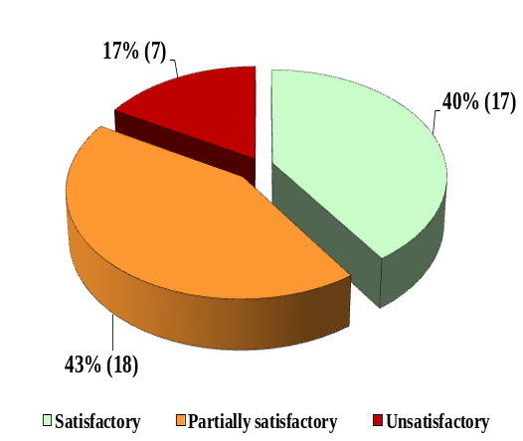 | 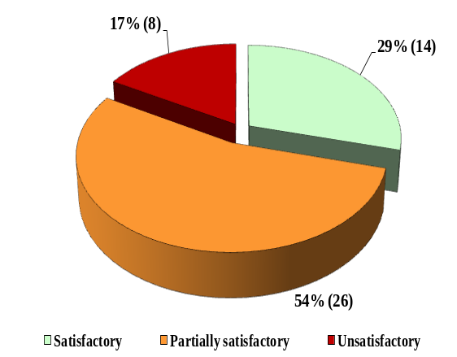

- To closely monitor country offices rated ‘unsatisfactory’, OAI conducts on-site follow-up audits in addition to its periodic desk reviews of the implementation status of audit recommendations. For seven of the eight country offices rated ‘unsatisfactory’ in 2008, OAI will conduct follow-up audits in 2009. The remaining office has been included in the Board of Auditors’ work plan for 2009. Periodic desk reviews showed that two of the eight country offices rated ‘unsatisfactory’ have already made substantial progress in the implementation of recommendations as of 31 December 2008.
- Compared to last year (see figure 5), the share of audits with a ‘satisfactory’ rating declined while the percentage of ‘partially satisfactory’ assessments increased. The percentage of ‘unsatisfactory’ ratings remained stable, at 17 per cent. While this relatively high share of ‘unsatisfactory’ ratings can be attributed primarily to the enhanced audit risk assessment model and the increased focus on country offices with a high audit risk, where UNDP often operates in a weak institutional environment, OAI will rigorously monitor the implementation of the recommendations made and re-assess the situation through follow-up audits and periodic desk reviews. Among the UNDP regions, Latin America and the Caribbean and Africa had the biggest share of audits with ‘unsatisfactory’ ratings (see figure 6).
- With respect to the seven offices rated ‘unsatisfactory’ in 2007, either a follow-up audit or another full-scope audit was conducted in 2008, or a full-scope audit was scheduled for 2009. The results of the desk reviews done by OAI subsequent to these 2007 audits showed a substantial improvement in addressing the issues raised in the reports, with implementation rates for audit recommendations ranging from 44 per cent to 100 per cent as of 31 December 2008.

Figure 6. Audit ratings by region
(excluding six reports with no rating)
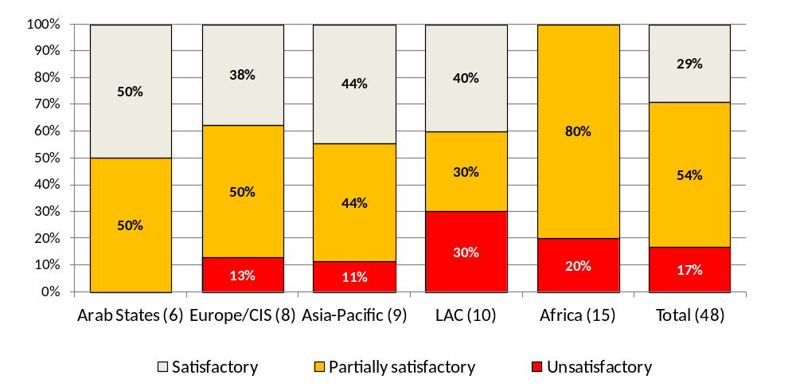

Audit recommendations
- The 54 reports issued in 2008 contained 701 recommendations. Compared to 2007, the average number of audit recommendations per report decreased from 20 to 13. This was due to OAI efforts to make the audit reports more focused and draw the attention of management to matters considered most significant for the country office and/or UNDP in general. As a result, low-priority recommendations are no longer included in audit reports to senior management, but are communicated to the office management while the audit team is still in the field.
- Similar to prior years, the areas with the highest number of recommendations were:
(a) development services (project management); (b) procurement; (c) programme management; and (d) financial resources, which altogether represented 64 per cent of all audit recommendations issued in 2008 (see figure 7).

Figure 7. Distribution and prioritization of country office audit recommendations in 2008 reports
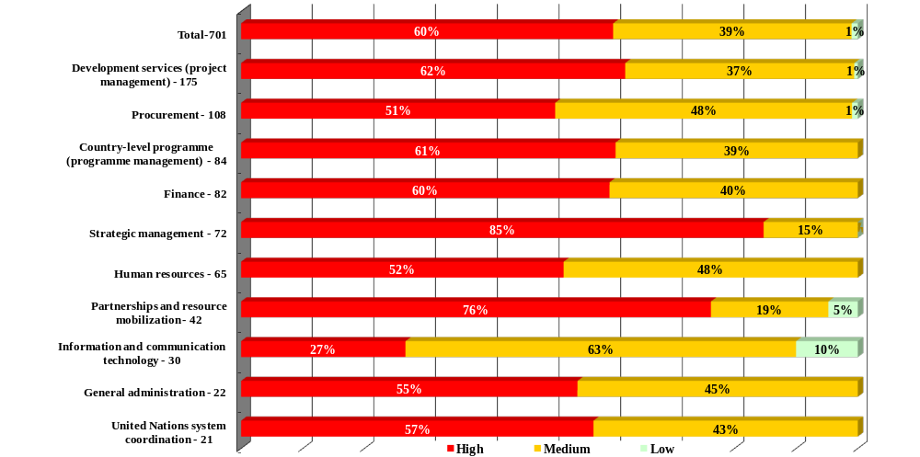

- While the distribution of recommendations into ‘high’ and ‘medium’ priority categories has roughly followed a 60 per cent ‘high’ and 40 per cent ‘medium’ pattern since 2005, there have been substantial changes in the areas with the highest numbers of recommendations. Most notable is the increased share of recommendations made in the areas of development services and the country-level programme. An analogous but less noticeable trend can be observed in recommendations related to partnerships and resource mobilization. At the same time, the share of recommendations given in the areas of human resources and, less obviously, finance, has been decreasing. The share of recommendations in procurement and most other areas has remained more or less stable in recent years.

Key findings and most recurrent audit issues
29. An analysis of the four audit areas with the highest number of recommendations (see figure 7) disclosed similar audit issues, described below. OAI has addressed those issues through audit recommendations agreed with the country office management.
(a) Development services (project management). Sixteen audit reports noted overall weaknesses in project management, meaning that multiple areas of the project management process required improvement. Specific shortcomings in project monitoring were cited in 25 reports and covered a range of issues. For example, insufficient frequency of, and/or reporting on, field visits; absence or incomplete implementation of annual monitoring plans; Atlas not being used effectively as a monitoring tool; and quarterly progress and annual project reports not being prepared, certified and/or submitted. Ineffective project design, appraisal and/or approval mechanisms were recorded in 17 reports. Examples included local project appraisal committees not being duly constituted or, when existent, requiring improvement in their efficiency; their minutes not being properly documented or signed; and project objectives and outcomes requiring a clearer and more measurable definition.
(b) Procurement and asset management. In thirteen audit reports weak procurement management was noted. The findings in this area included cases where procurement transactions needed closer monitoring; and procurement activities required further centralization, or procurement plans were either absent or inadequate. In 18 reports, shortfalls regarding the Contracts, Assets and Procurement Committee or the Advisory Committee on Procurement were noted. For example, procurement transactions exceeded established stipulated thresholds were not submitted for review; members of the Contracts, Assets and Procurement Committee were not appropriately appointed and/or rotated; and effective follow-up on the recommendations of the Advisory Committee on Procurement was required. Sixteen audit reports mentioned weaknesses in asset management and/or physical count of inventory, including cases where physical stock counts were not conducted; asset identification systems needed improvement; and differences in the inventory data between Atlas and actual physical records needed to be reconciled. The management of vendor accounts was raised as an issue in 14 reports and included instances of duplicate vendor listings in country offices and weaknesses, such as incompleteness or inaccuracies in vendor profiles.
(c) Programme management. Twelve reports stated that the direct execution modality was used inappropriately or without the required approval from headquarters. Furthermore, seven audit reports noted that stronger alignment of development with Executive Board decisions was required, and/or development funds were used inappropriately to fund office-related activities. Seventeen audit reports noted shortcomings in the multi-year funding framework exercise. Among those were the need for greater clarity and better measurability of annual targets; stronger coherence of progress reports and annual targets; improved adherence to the guidelines and closer supervision of the process. The absence of well-established project outcome evaluations was raised in 16 audit reports. For example, annual outcome evaluation plans were absent or not updated appropriately, planned evaluations were not carried out, or focal points for evaluation were not duly designated.
(d) Financial resources. Bank reconciliation issues were raised in 16 audit reports. These included instances where bank reconciliations needed to be performed in a more timely manner; the frequency of the reconciliation process required improvement; long-outstanding unreconciled items needed follow-up; and the independent review of bank reconciliations statements required systematic review by country office management. While the area of bank reconciliation processes required further strengthening, OAI noted a marked improvement compared to previous years. Shortcomings regarding payments and payment documentation were noted in 14 audit reports. In some instances, complete supporting documentation for payments was not available, or payments were made without authorized purchase orders.
30. A review of the other audit areas disclosed common issues in at least 25 per cent of the audit reports issued in 2008, as follows:
(a) Strategic management. Issues concerning the organizational structure, the staffing and the governance of the country office were noted in 22 audit reports. Some of the findings in this area included cases where actual and proposed office structures raised questions about financial sustainability or alignment with operational needs; reporting lines and accountability needed clarification, and governance arrangements required improvement.
(b) Human resources. Fifteen audit reports described weaknesses in the recruitment of personnel, such as recruitment processes requiring stronger transparency or competitiveness; the process of screening applications needing improvement; and the existence of inappropriate recruitment practices.
(c) Partnerships and resource mobilization. Shortcomings concerning resources and resource mobilization were noted in 16 audit reports, such as resource mobilization strategies being absent, weak, or not documented.
Audit of directly executed projects
31. During the year, two audits of five projects directly executed by UNDP were completed in the Asia and the Pacific Region. Both audits resulted in ‘satisfactory’ ratings. The qualification of the audit opinion in one instance was due to non-verification of the project inventory and inconsistent accounting for non-expendable equipment.

Follow-up on country office audit recommendations
32. OAI conducts semi-annual desk reviews of the implementation status of audit recommendations, based on updates provided by the country offices and reviewed and validated by OAI regional audit centres. The implementation rate for each country office, as calculated by OAI, is published as one of the indicators of the business process dimension in the UNDP ‘balanced scorecard’.
33. In 2008, OAI introduced a new method for calculating the implementation rate that takes into account the priority assigned to the individual recommendations. This method gives more weight to early implementation of high priority recommendations, thus better reflecting the level of progress made.
34. As of 31 December 2008, the overall implementation rate was 93 per cent, on a rolling basis, which was an improvement from the 90 per cent calculated as of 30 June 2008. Analysis of the implementation rates on a by-report basis showed that a 100 per cent implementation rate was achieved within 18 months, on average, after the audit report had been issued.
35. As of 31 December 2008, 32 recommendations pertaining to 18 country offices had remained unresolved for 18 months or more (see annex 2). This constitutes 0.9 per cent of the 3,407 recommendations from audit reports issued from January 2004 to June 2007. The majority of those recommendations (17 or 53 per cent) were ranked ‘high priority’ at the time of the audit (see annex 2). Analysis showed that the delay in the implementation of most recommendations was attributed to coordination with external parties – the host government, other United Nations organizations and/or implementing partners, or lack of time and financial resources (see annex 2).

B. Headquarters audits
36. During the year, OAI issued three audit reports pertaining to the review of the UNDP procurement function, Atlas risks and controls, and ‘IT-governance’. Two of the audit reports were rated ‘partially satisfactory’ and one did not have an overall rating. The key findings and recommendations were:
(a) Procurement. ‘Partially satisfactory’. The regulatory framework was well defined and established. However, there was a need to increase the effectiveness of the systems, controls and business processes to support its implementation, leading to 28 recommendations, which included changes in the areas of delegation of procurement authority, the Advisory Committee on Procurement, management of vendor accounts, and the use of procurement software tools.
(b) IT-Governance. ‘Partially satisfactory’. Five recommendations highlighted the need to re-establish the Information and Communications Technology Board with appropriate terms of reference, membership and delegated authority, as well as to take into account the life-cycle costs of investments in systems and technology. During the course of the audit, OAI recommended a review of the business case for the replacement of communication equipment.
(c) Atlas risks and controls. No rating. The review covered 18 Atlas modules and included a follow-up on the recommendations of a review conducted in 2005. The key findings included: the need to review and update the internal control framework; the need to address excessive access rights granted to some Atlas users; synchronization of Atlas and Argus user profiles; segregation of duties and process, configuration and reports. Sixty recommendations were made in the following areas: (i) process, configuration and reports; (ii) access; (iii) security; (iv) segregation of duties; and (v) policy and guidelines. The follow-up of the implementation of the 2005 recommendations showed that considerable progress had been made.

Follow-up on headquarters audit recommendations
37. As of 31 December 2008, the implementation rate for all headquarters audit reports issued between 1 October 2006 and 30 September 2008 amounted to 81 per cent, on average, ranging from 42 per cent to 100 per cent on individual audits.
38. For the headquarters audit reports, a total of 10 recommendations, none of which had been assigned a ‘high’ priority, were outstanding for over 18 months as of 31 December 2008 (see annex 2). Of those 10 recommendations, seven pertained to the 2005 Atlas review mentioned above, while the remaining three were related to the Iraq Trust Fund Unit of the United Nations Development Group, in New York.

Advisory and management services

- OAI advised all levels of UNDP management at headquarters, regional centres and country offices. It reviewed and advised management on audit and investigation clauses in agreements – such as multi-donor agreements, cost-sharing agreements, letters of agreement, and letters of understanding – between UNDP and its development partners. OAI provided guidance to country offices on verification missions carried out by representatives of the European Commission in accordance with the Financial and Administrative Framework Agreement.

UNIFEM audits

40. In furtherance of the operational relationship between UNDP and the United Nations Development Fund for Women (UNIFEM), OAI provided internal audit services on a cost-reimbursement basis. During 2008, OAI issued three audit reports, relating to the UNIFEM programme office in Afghanistan and the sub-regional offices for West Africa and for the Andean region. Two of these were given a ‘satisfactory’ rating while one was rated ‘partially satisfactory’.

41. In December 2008, UNDP/OAI and UNIFEM entered into a new agreement to ensure adequate internal audit coverage. OAI established a dedicated auditor position in New York, to be funded by UNIFEM from 2009 onwards.

Review of audits of projects executed by non-governmental organizations and/or national governments

- In 2008, instead of applying the previous fixed threshold limit of $100,000, OAI introduced a risk-assessment methodology in selecting the projects to be audited. This resulted in a sharper focus on higher-risk projects and a reduction of about 200 audit reports compared to last year. A total of 1,765 audit reports from 122 country offices were expected, covering $2.0 billion, 85 per cent of the total expenditure of $2.4 billion related to projects executed by non-governmental organizations or national governments for the fiscal year 2007. For the fiscal year 2008 audit exercise, OAI expects to further reduce the number of audits required while maintaining a high level of audit coverage.
- As of 31 December 2008, OAI had received 1,733 (98 per cent) of the audit reports required encompassing project expenditures totalling $1.96 billion (98 per cent). Considering the 31 May submission deadline, there was a marked improvement in the submission rate this year compared with last year: 87 per cent as of 30 June 2008 versus 78 per cent as of 30 June 2007. This was due to closer monitoring by OAI and enhanced collaboration with regional bureaux and country offices. The few cases of non-submission by offices were referred to senior management.
- All the 1,733 audit reports received were reviewed by OAI, to cover four different elements:
(a) Audit opinion and net financial impact. OAI measures the net financial impact of the qualifications rendered by the auditors as a percentage of the expenditure in the combined delivery reports.
(b) Audit outcome. OAI reviews the audit findings contained in the audit reports, including their risks, severity, and possible impact on the overall management and implementation of projects concerned. The objective is to assess the adequacy of project management.
(c) Audit scope. OAI reviews the adequacy of audit coverage in audit reports of non-governmental organization/nationally executed projects based on the minimum requirements set out in the terms of reference given to the auditors concerned. The objective is to assess the quality of audit work performed.
(d) Audit administration. OAI reviews how the audit was administered by the country office.
- The results of the review were summarized in ‘review letters’ sent to the country offices, highlighting deficiencies and drawing attention to areas requiring immediate action. In that regard, OAI accomplished a significant improvement, with 84 per cent of the review letters issued by 30 September 2008 compared to only 7 per cent at the same time last year. By 31 December 2008, 107 (88 per cent) of the 122 country offices had submitted their action plans on how to address the shortcomings identified.

Audit issues related to projects executed by non-governmental organizations or national governments
- OAI categorizes audit issues concerning non-governmental organization/nationally executed projects into seven areas. Seventy-two per cent of the audit issues pertained to financial management; record-keeping systems and controls; and project progress and rate of delivery (see figure 8). The majority (68 per cent) of the audit issues were ‘medium risk’ (see figure 9).

Figure 8. Distribution of audit issues related to projects executed by non-
governmental organizations or national governments for fiscal year 2007
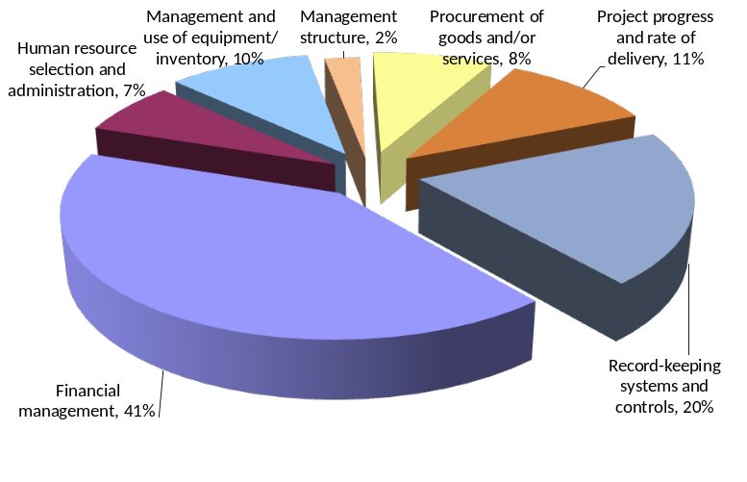
Figure 9. Distribution and prioritization of audit issues related to projects executed by
non-governmental organizations or national governments for fiscal year 2007
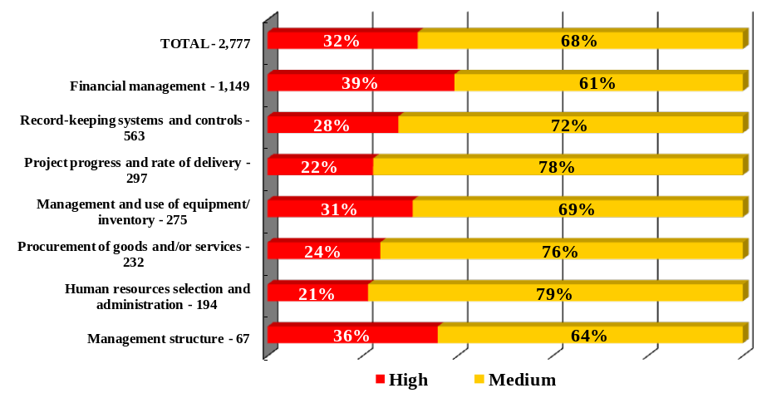
- In 2008, to enhance the tracking of these audit recommendations, OAI launched the first module of a web-based system incorporated in the comprehensive audit report and recommendations database system, known as ‘CARDS’, which is being used to track the recommendations arising from OAI audits.
Audit opinions and net financial impact
- Overall, the auditors of projects executed by non-governmental organizations or national governments found the financial statements to be presented fairly, and thus issued an ‘unqualified’ opinion in respect of 1,292 (75 per cent) of the total 1,733 audit reports. Based on available information, OAI analysed the reports with a ‘qualified’ or adverse opinion and quantified the direct financial impact of audit qualifications to be $14 million, or approximately 0.7 per cent of the total audited expenditures. The financial impact of those audit opinions as a percentage of the total audited expenditure thus remained the same compared to the previous year.
- Two amounts relating to observations in two country offices significantly affected the total financial impact. An amount of approximately $7 million was questioned relative to one award for which the combined delivery report was not made available to the auditors to certify. In another instance, a total amount of approximately $5 million was questioned due to differences in expenditure as recorded in the combined delivery reports and in the project financial records, the existence of ineligible expenditure, and a lack of supporting documentation. OAI noted minimal progress in those two cases.

Harmonized approach to cash transfer
- OAI participated in the Meeting of Representatives of Internal Audit Services of the United Nations Organizations operational sub-group tasked to work on issues relevant to the audit of implementation of the harmonized approach among the participating United Nations organizations. A framework for cooperation was established and circulated for agreement and ratification. The framework sets out the role of internal audit services of the United Nations organizations in the implementation of the harmonized approach at the country level and includes the key elements of cooperation among the participating organizations, including coordination and sharing of information, and the audit approach and general areas to be covered during audits of the harmonized approach at the country level.

Investigations

- With the issuance of the UNDP legal framework for addressing non-compliance with the United Nations standards of conduct in 2007, OAI became the sole entity in UNDP responsible for conducting investigations into allegations of fraud, corruption, abuse of authority, workplace harassment, sexual exploitation, retaliation and other acts of misconduct. This resulted in an increase in caseload and a much higher share of human resources-related complaints, which were previously investigated by the Office of Human Resources (see figure 10).

Figure 10. Number of complaints received, by category, 2008 vs. 2007
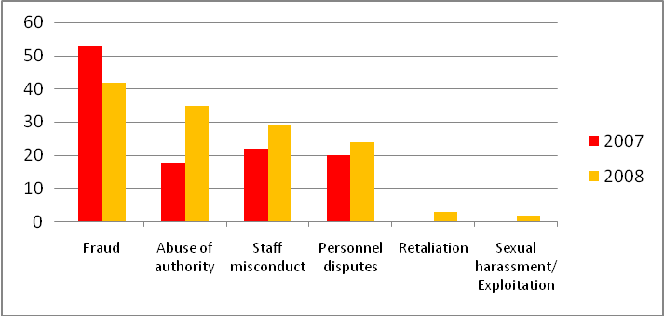
Fraud: Procurement fraud; entitlements fraud; forgery; embezzlement; theft; bribery/corruption or other financial irregularities; Abuse of authority: Abuse of authority; workplace harassment; Staff misconduct: Conflict of interest; violation of local laws; false accusations; assault; breach of confidentiality; abuse of privileges and immunities; insubordination; Retaliation: retaliatory action against a whistleblower or a participant in protected activity (audit or investigation); Sexual harassment/ exploitation: Sexual exploitation; sexual abuse, sexual harassment .

- In 2008, OAI received 135 complaints, which constitutes a further 19 per cent increase in caseload compared to 2007 (113 complaints). In addition, 85 complaints were carried forward from 2007. Almost 85 per cent of the complaints received in 2008 were referred either from management or personnel and 10 per cent through the OAI hotline, while 5 per cent were the result of audit referrals. The majority of the 135 complaints related to fraud or other financial misconduct (31 per cent), abuse of authority or workplace harassment (26 per cent), followed by staff mis-conduct such as insubordination, inappropriate acts, or violation of local laws (21 per cent), and personnel disputes such as those relating to non-extension of contracts or performance evaluation (18 per cent) (see figure 11).
Figure 11. Types of complaints received in 2008
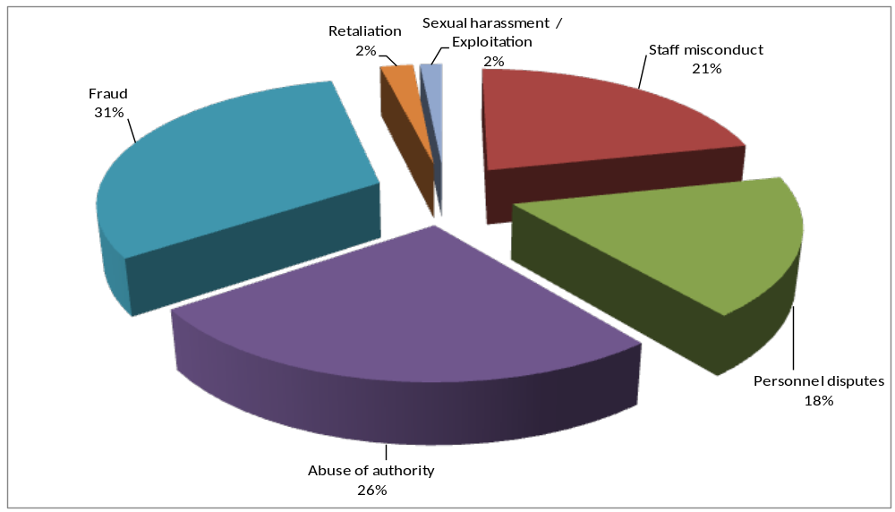
- Despite vacancies in some investigator positions, a total of 142 complaints were closed in 2008 (see figure 12), reducing the open caseload by 9 per cent.
Figure 12. Closing of investigation complaints in 2008
Investigation complaints closed | Number | Percentage
Complaints closed after preliminary assessment
Closed after review | 94 | 66%
Referred to Office of Human Resources | 2 | 1%
Referred to Legal Support Office as contractual complaints | 2 | 1%
Total complaints closed after preliminary assessment | 98 | 69%
Formal investigation by OAI
Cases closed after investigation | 20 | 14%
Investigation report submitted to Legal Support Office | 20 | 14%
Investigation report submitted to Ethics Office | 3 | 2%
Referred to Executive Office | 1 | 1%
Total formal investigations by OAI | 44 | 31%
Total cases closed | 142 | 100%

- OAI receives complaints relating to non-compliance with United Nations standards of conduct. If a preliminary assessment reveals that wrongdoing may have occurred, OAI conducts a formal investigation. If the allegations are substantiated, OAI submits an investigation report to the Legal Support Office for appropriate action.

- In 2008, as a result of the preliminary assessment, 69 per cent of the 142 complaints processed were found to be unsubstantiated and did not require further investigation. Many of them were cases involving performance issues or contractual disputes rather than misconduct issues, or cases where the allegations could not be supported by factual evidence. The rest (31 per cent of the complaints assessed) were formally investigated by OAI. After formal investigation, approximately half of the cases investigated were found to be substantiated, leading to submission of an investigation report to the Legal Support Office (see figure 12). Twenty cases were closed after formal investigation, either because the complaints were found to be unsubstantiated or because the subject of the investigation left the organization during the course of the investigation. In total, 20 investigation reports were submitted to the Legal Support Office recommending disciplinary proceedings against 19 staff members. From February to December 2008, disciplinary proceedings were concluded in 10 cases. Of those, eight resulted in the imposition of disciplinary measures. Due to the seriousness of the misconduct, three of these eight cases led to summary dismissal or separation from service. Furthermore, during the period, additional eight staff members were formally charged with misconduct. Their cases are currently pending before the Disciplinary Committee.
- Significant investigation cases in 2008 referred to the Legal Support Office for appropriate action included the following:
- Allegations of workplace harassment and abuse of authority involving country office senior management (six cases);
- Allegations of fraud and staff misconduct by United Nations Department of Safety and Security personnel under UNDP letters of appointment (four cases);
- Allegations of physical assault (two cases);
- Allegations of sexual harassment (one case);
- Allegations of irregularities in recruitment and staff entitlements involving a high-ranking official (one case); and
- Special forensic analysis of hard-disk drives in connection with allegations of fraud and corruption in a country office (one case).
- In three cases relating to allegations of retaliation, which were investigated at the request of the Ethics Office, the investigation reports were submitted to the Ethics Office. Two of those cases were found to be unsubstantiated and the other was found to be partially substantiated.
- With the objective of enhancing its investigation function, OAI collaborated with various UNDP units, namely the Legal Support Office, the Office of Human Resources, the Ethics Office, and the Office of the Ombudsperson. OAI also worked closely with the United Nations Office of Internal Oversight Services and with the investigation services of the other funds and programmes.
- At the beginning of 2009, OAI subjected itself to an external quality-assurance review of its investigation function. The review will assess the conformity of OAI with generally accepted standards for investigators in international organizations and will identify potential for further improvement.

Overall conclusion and outlook

60. The country-office audit reports issued in 2008 drew attention to areas requiring stronger managerial oversight with respect to development services (project management), procurement, programme management, financial resources, strategic management, human resources, and partnership and resource mobilization, where a number of key issues were found to be prevalent in offices across several regions. The headquarters audits highlighted critical issues and potential for improvement in procurement, Atlas controls and ‘IT-governance’. Although the number and percentage of audits resulting in an ‘unsatisfactory’ rating was relatively high, controls are in place to ensure that weaknesses are addressed in a timely manner, through closer management oversight and through the OAI follow-up process. Towards the end of 2008, OAI launched an improved version of its comprehensive audit report and recommendations database system, known as ‘CARDS’, which (a) allows offices to record in detail the actions taken after the audit, and (b) facilitates the validation of the implementation status by auditors.
61. As far as audit reports related to projects executed by non-governmental organizations or national governments are concerned, the efforts of OAI in reviewing these reports and communicating the related results contributed to a higher level of awareness and reduced risk exposure for UNDP, which ultimately led to an absence of an ‘emphasis of matter’ in the report of the United Nations Board of Auditors on its audit of UNDP financial statements for the 2006-2007 biennium.
62. In December 2008 the Administrator approved the three-year strategy of OAI, 2009-2011, following review and endorsement by the Audit Advisory Committee. The strategy sets out the direction of OAI in providing UNDP with an effective system of independent and objective internal oversight in achieving its developmental goals and objectives, by providing internal audit and related advisory services as well as investigation services.

As stated in the approved Oversight Policy (DP/2008/16/Rev.1), the Annual Report of the Audit Advisory Committee for the Calendar Year 2008 is attached to the OAI Annual Report on Internal Audit and Investigations (see appendix).
In 2008, OAI audit reports totaled 60, including three pertaining to the United Nations Development Fund for Women (UNIFEM). UNIFEM audits are discussed separately in Section VI of this report.
For purposes of this report, the term “country office” encompasses all field-based units, such as regional centres, joint offices, multi-country offices, project offices (in countries with no official representation) and offices in territories that are not Member States of the United Nations.
Per UNDP enterprise resource planning system, Atlas.
As reported in DP/2008/20.
This calculation takes into account all audit reports issued over a rolling two-year period, as well as all audit reports issued more than two years ago which have an implementation rate of less than 100 per cent.
This time frame is based on the OAI audit cycle, whereby country offices are audited at least once in a period ranging from 2 to 5 years. At the end of December 2008, all outstanding recommendation issued after June 2007 were less than 18 months old, while all those issued prior to January 2004 had been superseded by at least one audit exercise.
More than 98 per cent of which relates to nationally executed projects and less than 2 per cent to projects executed by non-governmental organizations.
Revised in May 2008.

