First regular session 2008
21 to 28 January, New York
Item 2 of the provisional agenda

Financial, budgetary and administrative matters

UNDP budget estimates for the biennium 2008-2009
Report of the Administrator

Summary
The present report contains UNDP results-based budget proposals and related estimates for the biennium 2008-2009, forming part of – and underpinning – the strategic plan, as amended and augmented by Executive Board decision 2007/32. It also builds on the recommendations of the December 2004 triennial comprehensive policy review (TCPR) and the role attributed to UNDP therein. Accordingly, these proposals align resources to consolidate and strengthen ongoing reforms for improved organizational performance (including support to operational activities of the United Nations system), especially at the programme country level to achieve international development goals, most notably the Millennium Development Goals (MDGs). In this context, the Administrator proposes the following four areas be strengthened: (a) assurance and oversight; (b) support to operational activities of the United Nations system; (c) strengthened capacity of country offices to deliver development results; and (d) accountability and organizational effectiveness.
For the 2008-2009 biennium, the Administrator proposes a regular resources funded budget in net terms of $778.7 million; in nominal terms, it is $120.8 million greater than the net budget approved by the Executive Board for the biennium 2006-2007 (decision 2005/33). This incorporates total net volume increases of $14.7 million and net cost increases amounting to $109.8 million. The volume increases are net $50.5 million in reductions and shifts to other resources, in line with Executive Board direction, in order to contain costs and increase burden sharing. The estimates also incorporate an increase of $3.7 million to projected income that offsets the gross support budget, amounting to $74.9 million in 2008-2009, from $71.2 million in 2006-2007.
The Administrator also proposes that $31.2 million for United Nations mandated security costs continue to be treated as a distinct requirement from regular resources, and at the same nominal level approved by the Executive Board for the 2006-2007 biennium. In addition, the Administrator proposes that $9.0 million for International Public Sector Accounting Standards (IPSAS) be treated as a distinct requirement from regular resources, in order to meet United Nations mandated system-wide compliance during the 2008-2009 biennium.
Elements of a decision
Suggested elements for a draft decision are presented on page 47.

Contents
 | Paragraphs | Page
Organizational chart |  | 3
I. Executive summary | 1-4 | 5
II. Strategic and financial context of the 2008-2009 biennial support budget | 5-23 | 5
A. Strategic framework | 5-7 | 5
B. Financial framework | 8-23 | 6
III. Proposals for the 2008-2009 biennial support budget | 24-147 | 10
A. Summary of proposals | 24-58 | 10
B. Other considerations | 59-76 | 21
C. Activities and resources by function – harmonized results-based budget framework | 77-127 | 25
D. Activities and resources by function – UNDP specific | 128-147 | 42
IV. Suggested elements for a draft decision | 148 | 47

Lists

List of tables
Table 1. Resource plan |  | 4
Table 2. Summary of main areas of increase/decrease for regular resources |  | 12
Table 3. Proposed budget estimates by function for regular resources, 2008-2009 |  | 16
Table 4. Regular resources posts by location |  | 19
Table 5. Government contributions to local office costs income by category of countries, 2006 |  | 21
Table 6. Government contributions to local office costs waivers by gross national income level, 2008-2011 |  | 22
Table 7. Cost recovery income estimates |  | 23

List of figures
Figure 1. Contributions by funding category, 1998-1999 to 2008-2009 |  | 7
Figure 2. Estimated use of total resources, 2008-2009 |  | 7
Figure 3. Funding modalities for the support budget |  | 9
Figure 4. Regular support budget post changes |  | 11

List of summary tables
Summary table 1. Regional resource plan |  | 49
Summary table 2. Proposed changes in senior posts |  | 50
Summary table 3. Proposed budget estimates by function for extrabudgetary resources |  | 51
Summary table 4. Posts by location – total resources |  | 52

List of annexes
Annex 1. Actions taken to implement ACABQ recommendations as approved by the Executive Board |  | 58
Annex 2. Terminology |  | 61
Annex 3. Methodology |  | 63
Annex 4. List of acronyms |  | 65

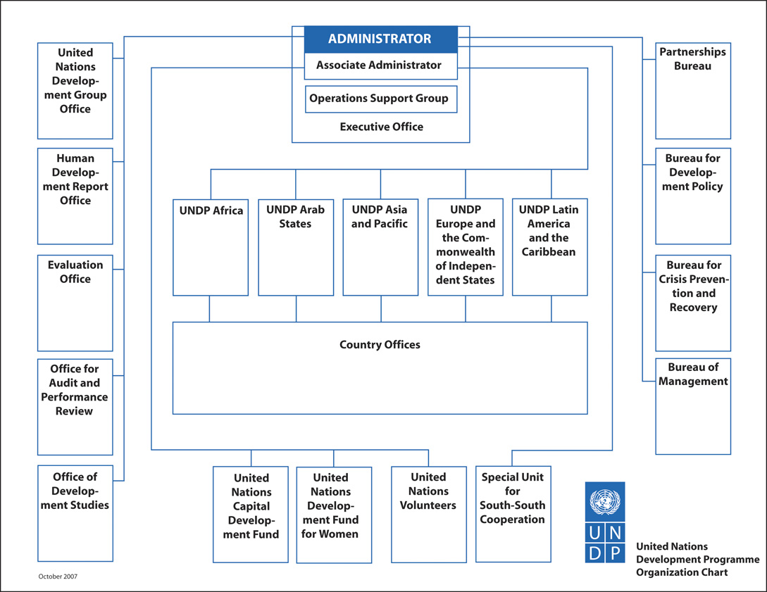
DP/2008/3

3

4

DP/2008/3

Table 1. Resource plan*
(in millions of dollars, nominal)

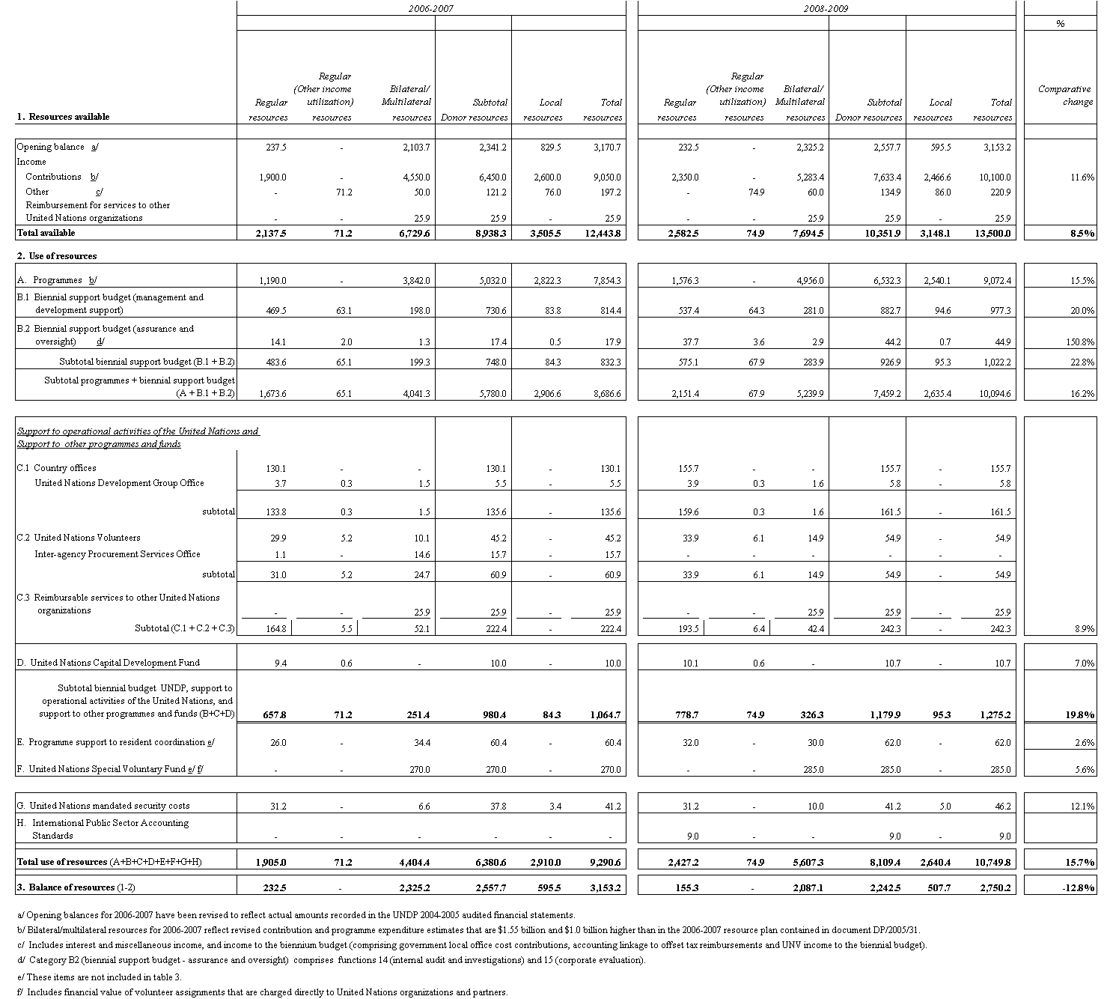
* Note: When amounts between different tables in the present document are cross referenced, there may be differences of +/- 0.1 due to rounding.

I. Executive summary

1. The UNDP 2008-2009 biennial support budget estimates and related proposals of the Administrator reflect the need for consolidating and strengthening ongoing initiatives to support programme countries in their efforts to achieve the MDGs. The proposals also build on General Assembly resolution 59/250 on the TCPR, which reaffirmed that the resident coordinator system (in the context of national ownership) has a key role to play in the effective and efficient functioning of the United Nations system at the country level.
2. A new four-year planning period begins in 2008, reflected in the UNDP strategic plan as amended and augmented by decision 2007/32. The 2008-2009 biennial support budget covers structural requirements of the organization during the first half of this planning period. The estimates and related proposals are presented in a new, results-based format agreed upon by the United Nations Children’s Fund (UNICEF), UNFPA and UNDP, as endorsed by the Executive Board.
3. Following Executive Board decisions 2005/5 and 2005/33, the support budget for the United Nations Capital Development Fund (UNCDF) forms an integral part of the UNDP support budget estimates and related proposals for the biennium 2008-2009. Therefore, it is no longer presented separately.
4. Following consultations with the Executive Board, support budget estimates for the United Nations Development Fund for Women will be presented separately for Board consideration, beginning with the 2008-2009 biennium.

II. Strategic and financial context

A. Strategic framework

5. The 2008-2009 biennial support budget estimates and related proposals are informed by the 2008-2011 strategic plan (amended and augmented by decision 2007/32) and prior Executive Board direction. The growth in regular resources has been apportioned to ensure a maximum possible allocation for development activities, with a minimum allocated to fulfil management functions.
6. Management results prioritized in the 2008-2011 strategic plan focus on institutionalization of a UNDP accountability framework; responsible risk management; strong stewardship over resources; and organizational and functional alignment for improved delivery of development and management results. Prioritized results therein related to support to operational activities of the United Nations system emanate from the December 2004 TCPR; they focus on a strengthened resident coordinator system and enhanced partnerships (particularly between United Nations organizations) to better serve the development needs of programme countries. Notably, the TCPR identified that in countries with large country teams, complex coordination situations or complex emergencies, resident coordinators cannot always meet the demanding tasks inherent in their combined duties of resident coordinator, resident representative, designated official for United Nations security, and in some cases, humanitarian coordinator. In this regard, the appointment of UNDP country directors was endorsed to strengthen UNDP country office capacities to deliver development results.
7. The Executive Board has provided direction on results-based budgeting as well as cost containment and cost recovery, which has helped shape the 2008-2009 biennial support budget proposals. In this regard, results-based budgeting has been introduced; reductions have been proposed; and increased funding of management costs from other resources has improved burden sharing. In this context, UNDP proposes strengthening of:
(a) Internal audit and corporate evaluation functions for more transparent assurance and oversight, and increased effectiveness and accountability for management and development activities;
(b) Support to operational activities of the United Nations system function for a more responsive, enhanced United Nations presence in country offices;
(c) The core mandate and programme management, guidance and oversight functions to improve development results at the programme country level in support of achieving the MDGs and other internationally agreed-upon development goals; and
(d) Several cross-cutting corporate functions, such as human resources and information and communications technology (ICT) management, to improve accountability, transparency and organizational effectiveness.

B. Financial framework

Resource projections
8. Figure 1 provides an overview of actual and estimated contributions by funding category over six bienniums. In nominal terms, regular donor resources continue an upward trend from $1.3 billion in the 2000-2001 biennium, to the targeted level reflected in the strategic plan for the 2008-2009 biennium – about $2.3 billion. This represents nominal growth in regular resources contributions of about $1 billion (83 per cent); in real terms, the growth is $0.4 billion (25 per cent). When comparing the 2008-2009 regular resources contributions target of $2.3 billion with the $1.9 billion estimate for 2006-2007, growth in nominal terms is about $450 million (24 per cent); in real terms, about $260 million (14 per cent).
9. Other donor resources for trust funds and cost sharing are expected to increase nominally by about $0.7 billion (16 per cent) from $4.6 billion in 2006-2007, to $5.3 billion in 2008-2009, after which an overall levelling off is expected. Local resources provided by host governments are expected to decrease by about $0.1 billion (5 per cent) to $2.5 billion. Accordingly, aggregate donor and local contributions for the 2008-2009 biennium are estimated at $10.1 billion.
10. Figure 2 provides an overview of the use of total projected resources for the 2008-2009 biennium – about $10.7 billion – of which about 86.7 per cent will be spent on programme activities, 9.8 per cent on support budget activities and 1.5 per cent on UNDP country office support to operational activities of the United Nations system. In comparison, UNDP country office support to operational activities of the United Nations system, as a function of total United Nations system operational activities, is estimated to remain below 0.5 per cent.
Figure 1. Contributions by funding category, 1998-1999 to 2008-2009
(millions of dollars, nominal)
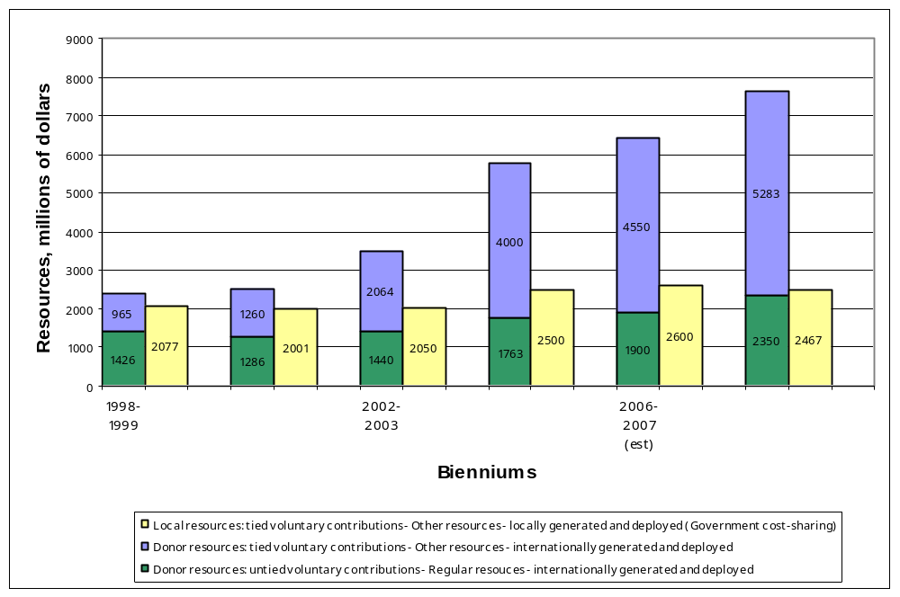

Figure 2. Estimated use of total resources, 2008-2009
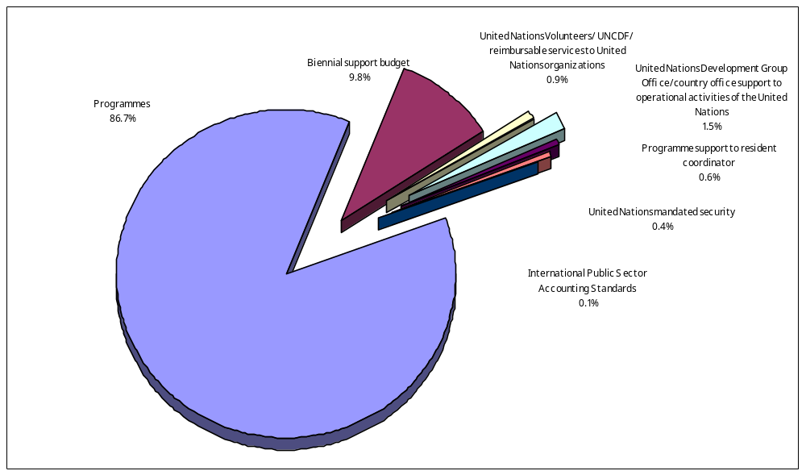

11. The UNDP resource plan for 2008-2009, covering both regular and other resources, is presented in table 1. The resource plan has three sections covering donor and local resources that reflect: (a) $13.5 billion in estimated total resources available, comprising an opening balance of $3.2 billion, contributions of $10.1 billion and other income of $0.2 billion; (b) $10.7 billion in projected use of resources, comprising programmes of $9.1 billion, support budget of $1.3 billion and other of $0.4 billion; and (c) balance of resources of approximately $2.8 billion.
12. The estimated income offsetting the gross biennial support budget is estimated to increase by $3.7 million. It is comprised of three components: government contributions towards local office costs (GLOC), income the United Nations Volunteers (UNV) programme derives from providing volunteers to United Nations organizations, and an accounting linkage to voluntary contributions to offset the cost of reimbursement of staff income taxes on United Nations salaries.
13. Specific proposals and cost implications of the UNDP support budget estimates and related proposals of the Administrator for the 2008-2009 biennium are presented in chapter III.
Results-based budgeting
14. The harmonized results-based budget framework for the 2008-2009 biennial support budget is presented in chapters III, sections C and D, organized by functions representing major groupings of activities funded, for which regular resources are appropriated by the Executive Board. Classified within functions are selected strategic results, presented as justification for the proposed allocation. This is a departure from previous input-based budgeting approaches, where the justification was presented as a listing of organizational units and a staffing table. Key management results are organized under 19 management functions – 16 of which are harmonized with UNICEF and UNFPA, and three of which are specific to UNDP.
Cost recovery
15. Over the past several bienniums, and with guidance from the Executive Board, a policy for the recovery of costs for services provided by UNDP to other resources funded programmes has evolved. It is now practice that regular resources pay for the base structure of UNDP, upon which its universal presence rests and through which UNDP programmes in support of achieving the MDGs are delivered.
16. In the 2004-2005 support budget, UNDP introduced the base structure concept for management activities to be fully funded from regular resources. Complementing the base structure is a gradual approach towards funding management activities above the base structure, through a combination of regular and other resources in the same proportion as the funding composition of the programmes they support. This constitutes the proportionality principle. In this regard, UNDP shifted management requirements above the base structure in the amount of $11.3 million from regular to other resources during the 2006-2007 biennium, and is proposing to shift an additional $37.3 million from regular to other resources during the 2008-2009 biennium.
17. The UNDP cost recovery policy, especially with respect to other resources donor funded programmes that govern general management services and associated recovery rates, has been reviewed and revised on several occasions to support increased proportionality.

18. In the 2002-2003 biennium, the recovery rate for general management services moved from a flat 3 per cent rate to a range of 3 to 5 per cent. That range increased from 5 to 7 per cent in the 2004-2005 biennium. In its decision 2007/18, the Executive Board established a flat general management services cost recovery rate of 7 per cent; over time, management costs above the base structure are expected to be equitably funded from regular and other resources. Figure 3 illustrates the extent to which other resources continue to share total support budget costs – from $121 million (19 per cent) in the 1998-1999 biennium, to $422 million (35 per cent) in the 2008-2009 biennium. Further details are provided in paragraphs 63-67.
19. In table 1, section 2 (use of resources), $422 million of other resources (also shown in figure 3) estimated for the 2008-2009 support budget activities are presented. More specifically, line B1 presents management and development activities funded from bilateral and multi-lateral resources ($281.0 million) and local resources ($94.6 million); line B2 presents assurance and oversight activities funded from bilateral and multilateral activities ($2.9 million) and local resources ($0.7 million); line C1 presents support to the United Nations Development Group Office (UNDGO) funded from bilateral and multilateral resources ($1.6 million); line C2 presents support to UNV funded from bilateral and multilateral resources ($14.9 million); and line C3 presents $25.9 million of fully reimbursable services provided to United Nations organizations related to finance, information and communication technology, human resources, legal and Executive Board secretariat activities carried out on their behalf. In turn, summary table 3 reflects the manner in which $422 million in other resources will be allocated across the 19 functions during the 2008-2009 biennium.
Figure 3. Funding modalities for the support budget
Relative shares of regular resources and other resources
(in millions of dollars, nominal)
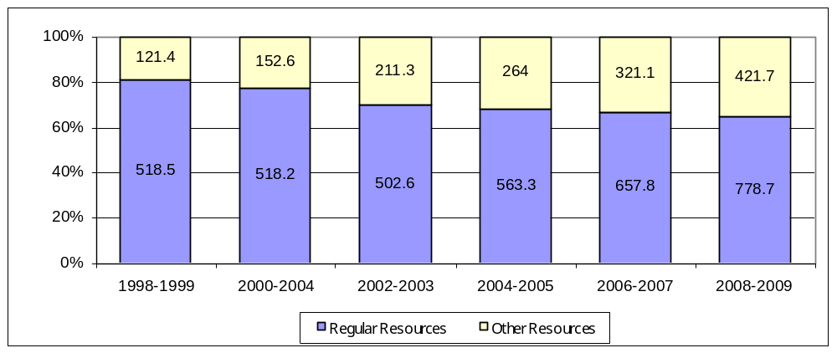

Cost classification
20. At the first regular session 2007, the UNDP strategic plan, programming arrangements and biennial budget (DP/2007/CRP.2) raised questions on cost classification of activities and functions funded from the biennial support budget and programming arrangements. In response, a limited change in classification was approved allowing the transfer of evaluation activities from the programming arrangements to the biennial support budget and gender mainstreaming activities from the biennial support budget to programming arrangements.
21. The Administrator will proactively address cost classification in the 2008-2009 biennium to ensure harmonization with the United Nations system and enhance clarity and accountability around the work of UNDP. In support of this, all activities related to management functions should be fully funded from the biennial support budget and all activities providing support to development effectiveness functions (including those within the biennial support budget, most notably under functions 3 and 4), should be fully funded from the programming arrangements. Recommendations on cost classification will be presented to the Executive Board in 2009 as proposals for consideration of the 2010-2011 biennial support budget as well as proposals emerging from a mid-term review of the 2008-2011 programming arrangements.
United Nations mandated security costs
22. The Administrator proposes that regular resources requirements to meet United Nations mandated security costs – $31.2 million for the 2008-2009 biennium –continue to be treated as a distinctive requirement within regular resources. Further details will be found in paragraphs 68-72.
International Public Sector Accounting Standards
23. The Administrator also proposes that the regular resources requirements to meet IPSAS compliance costs amounting to $9.0 million for the 2008-2009 biennium also be treated as a distinctive requirement within regular resources. Further details are provided in paragraphs 73-76.

III. Proposals

A. Summary of proposals

Background
24. UNDP has experienced rapid growth in total donor contributions over the past two bienniums, which has critical implications on the size and composition of the organizational structure and the funding modalities. This will impact the 2008-2009 biennium with increased demands and scrutiny placed on UNDP to implement timely organizational initiatives to support programme country achievement of the MDGs; and to support operational activities of the United Nations system, including United Nations reform initiatives, in line with TCPR recommendations.
25. Figure 4 reflects an ongoing trend of increasing numbers of professional posts and decreasing numbers of local posts. In this regard, international professional positions during 2008-2009 at the headquarters and country office levels are proposed to increase from 2006-2007 levels by 36 and 60 positions, respectively, in light of the enhanced staff profiles required to discharge more complex and diverse responsibilities in a rapidly changing development and technological environment. In contrast, general service positions at headquarters and country office levels would decrease by nine and 41 positions, respectively. National officer posts would decrease by one. Further details are provided in paragraphs 47-58.

Figure 4. Regular support budget post changes
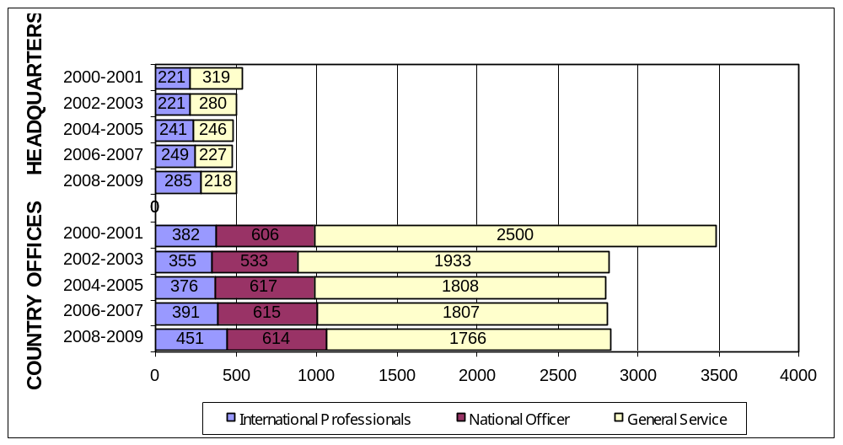

26. In making the following proposals, the Administrator is acutely aware of a number of critical budget-related initiatives requiring in-depth review and analyses during 2008-2009. Particular attention will be focused on:
(a) Structural adjustments needed to ensure country-defined development results are realized, especially in support of programme country efforts to achieve the MDGs;
(b) Enhanced integration of UNDP funding modalities to include equitable burden sharing of management costs between regular and other resources, and clearer cost classifications for management, support to operational activities of the United Nations system, and development effectiveness functions; and
(c) Implementation of new global initiatives pertaining to results-based budgeting and the adoption of IPSAS.
27. The Administrator proposes that these and other emerging priorities be fully addressed in close consultation with the Executive Board during the 2008-2009 biennium, after which they will be fully incorporated into the support budget proposals for the 2010-2011 biennium.
28. After careful review and, to ensure an optimal yet cost effective structure, the Administrator is proposing a regular resources funded budget in net terms of $778.7 million for the 2008-2009 biennium; details are outlined in table 2 and following chapters. This represents a net nominal increase of $120.8 million (16.6 per cent) over the 2006-2007 approved gross appropriation. Major factors impacting the net nominal increase of $120.8 million are reflected in table 2 and discussed in paragraphs 29-37.
Cost increases
29. The net cost increase of $109.8 million in table 2 (15.1 per cent over the 2006-2007 approved gross appropriation) reflects non-discretionary nominal increases required to finance continuing UNDP management structures and activities during 2008-2009. This is a significant increase and underscores the cost increases that began in the 2004-2005 biennium (9.5 per cent) and extended to the 2006-2007 biennium (13.5 per cent).
Table 2. Summary of main areas of increase/decrease for regular resources
(in millions of dollars, nominal)
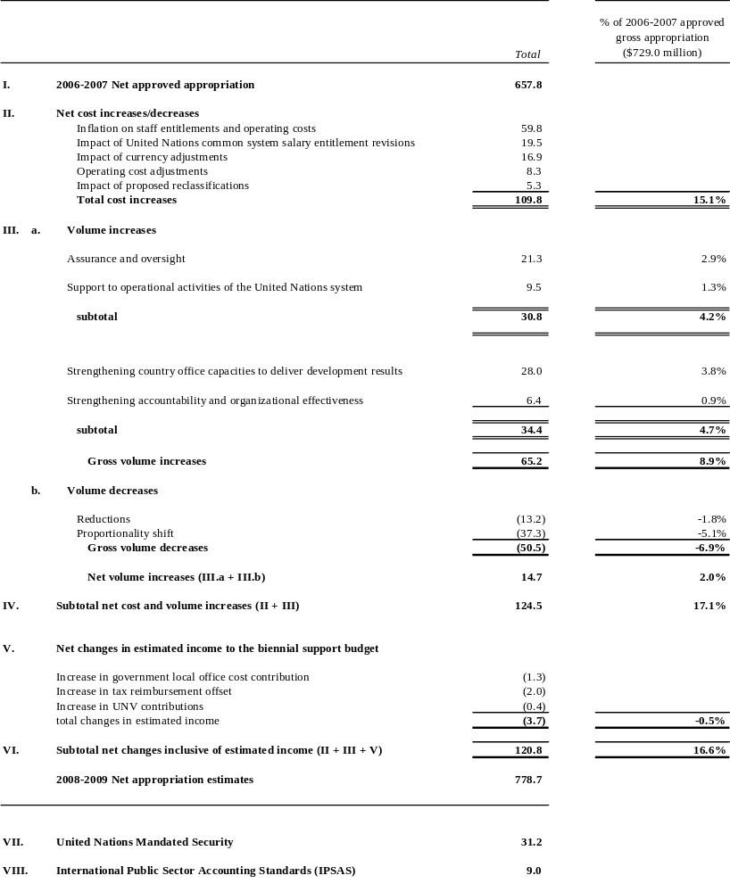
30. Key factors for the relevant cost adjustments are as follows:
(a) Net increase of $59.8 million resulting from the impact of inflation on post adjustment and other entitlements of international and headquarters local staff, entitlements of national officer and country office local staff, and operating costs;
(b) Net increase of $19.5 million resulting from salary entitlements due to with-in grade salary increments of international and headquarters local staff, and United Nations mandated salary revision surveys for national officer, and country office local staff;
(c) Net increase of $16.9 million resulting from currency adjustments due to the continued weakening of the United States dollar;
(d) Net increase of $8.3 million resulting from operating cost adjustments due to reimbursements to the United Nations for services to be rendered, relating to insurance, pension, legal, and other administrative areas, contributions to United Nations system jointly-financed activities, and rent escalation clauses at headquarters locations;
(e) Net increase of $5.3 million resulting from proposed post reclassifications.
31. The full impact of inflation for 2008-2009 is estimated at 4.1 per cent per year, reflecting the combined effect of a 3.2 per cent annual inflation rate at headquarters and a 4.7 per cent annual inflation rate for country offices. This is in comparison an estimated 3.5 per cent per year (2.1 per cent at headquarters and 4.0 per cent for country offices) during the 2006-2007 biennium, and 4.0 per cent (2.4 per cent at headquarters and 4.9 per cent for country offices) during the 2004-2005 biennium.
Net volume increases
32. The Administrator is proposing net real growth for 2008-2009 of $14.7 million (2.0 per cent over the 2006-2007 approved gross appropriation). This reflects a need to strengthen ongoing initiatives and respond to new demands, yet recognizes the need to contain costs and achieve equitable burden sharing of management costs between regular and other resources. In this regard, $65.2 million in new investments are proposed, which are partially offset by $50.5 million in reductions and shifts to other resources.
Volume increases
33. As introduced in paragraph 7, approximately $65.2 million in volume increases (investments) are proposed in four key areas:
(a) Strengthened assurance and oversight support of $21.3 million through increases to the internal audit (function 14) and corporate evaluation (function 15). This includes funding to strengthen capacity and cover increased numbers of national execution (NEX) and direct execution (DEX) audits, and assessments of development results. As a result, funding should be in general alignment with recommendations of the Joint Inspection Unit (JIU) on broad funding levels for oversight functions of United Nations organizations, contained in report JIU/REP/2006/2;
(b) Strengthened support to the operational activities of the United Nations system of $9.5 million (function 17); this includes funding for resident coordinator training courses, One United Nations pilots, and support to regional director teams and non-resident United Nations organizations;
(c) Strengthened country office capacities to deliver development results of $28.0 million through increases to representation and advancement of the core mandate (function 2) and programme guidance, management and oversight (function 4). This includes funding for new country directors, operations managers, deputy regional directors, select country office base structures and to meet Deputy Special Representative of the Secretary-General (DSRSG) funding requirements;
(d) Strengthened accountability and organizational effectiveness of $6.4 million through increases in the areas of executive direction and leadership (function 1), corporate policy and strategy development planning and guidance (function 3), procurement and supply (function 5), crisis prevention, recovery and emergency (function 6), financial management (function 10), information and communications technology (function 11), general administration (function 12), human resources (function 13), and other programmes and funds (function 18). This includes funding for strengthened capacities in each of these functions.
Volume reductions
34. Approximately $50.5 million in real volume decreases are proposed, representing $37.3 million in shifts to extrabudgetary funding and $13.2 million in reductions. This is in response to Executive Board concerns for improved burden sharing of management costs between regular and extrabudgetary resources, and cost containment. Shifts to other resources have been initiated throughout UNDP to include both staff and general operating costs. A portion of reductions are attributed to efficiency gains. The $50.5 million in total volume decreases represents a 6.9 per cent volume decrease over the 2006-2007 approved gross appropriation.
35. Reductions are attributed to the following areas:
(a) Travel costs – resulting from multi-country and multi-purpose missions, teleconferencing and videoconferencing;
(b) Utility costs – resulting from use of voice-over Internet-protocol phone technologies and use of more energy-efficient equipment;
(c) Learning costs – resulting from improved approaches and tools to include use of on-demand training materials, internet-based training and certification programmes, and integration of related training activities into jointly sponsored workshops; and
(d) Consultancy costs – resulting from office realignments and improved utilization of staffing capacities, and automation of prescriptive content.
Estimated income to the budget
36. The total estimated income to the biennial support budget for 2008-2009 is estimated at $74.9 million, representing an increase of $3.7 million in income over the 2006-2007 support budget. This is due to growth in GLOC, tax reimbursements and UNV contributions. This represents a 0.5 per cent increase in income over the 2006-2007 approved gross appropriation.
37. Host government obligations towards GLOC are estimated at $52.6 million – an increase of $1.3 million over the previous biennium. Income relating to UNV is projected to increase by $0.4 million, totalling $5.0 million. The offset amount for tax reimbursements is projected to increase by $2.0 million, bringing the total amount recovered through the accounting linkage to $17.3 million.

Allocation of resources
38. Allocation of resources is at the functional level, in line with planned results and a harmonized approach to results-based budgeting. This differs from the allocation approach of past support budgets, which was at the major appropriation line level based on requested inputs. Proposed estimates by function for regular resources are presented in table 3; estimates for other resources are presented in summary table 3. Cost increases, volume increases and reductions in regular resources are discussed in chapter III, sections C and D.
39. The total gross regular resources proposals for 2008-2009 amount to $853.6 million (table 3). After subtracting the estimated income to the biennial support budget of $74.9 million, the total net regular resources budget is $778.7 million. Total change from the 2006-2007 net regular resources budget is a nominal increase of $120.8 million, comprising net cost increases of $109.8 million and net volume increases of $14.7 million, offset by an income increase of $3.7 million.
40. Under the major appropriation line format of past support budgets, the proposed 2008-2009 gross budget appropriation of $853.6 million would appear as follows:
(a) Programme support to country offices ($375.0 million)
(b) Programme support to headquarters ($85.3 million)
(c) Management and administration ($182.7 million)
(d) Support to operational activities of the United Nations system
(i) Country offices ($155.7 million)
(ii) UNDGO ($4.2 million)
(e) Support to other programmes and funds
(i) UNV ($40.0 million)
(ii) UNCDF ($10.7 million)
41. Total proposed allocations to country offices and headquarters programme bureaux are summarized as follows:
(a) $530.7 million for country offices (including $375.0 million plus $155.7 million as above), funding 421 international professional, and 2 244 local positions (2006-2007 comparison: $464.5 million for country offices, funding 380 international professional, and 2 277 local positions). Refer to summary table 4, former category A1 (programme support country offices). Of this total, $219.8 million is allocated against function 4 and $155.7 million is allocated against function 17 based on the workload study described in paragraphs 44-46. The balance is allocated across the majority of other functions.
(b) $85.3 million for programme bureaux, funding 98 international professional positions, and 65 general service level positions; (2006-2007 comparison: $75.4 million for programme bureaux, funding 95 international professional, and 66 general services level positions). Refer to summary table 4, former category A2 (programme support headquarters). Of this total, $33.0 million is allocated to function 4. The balance is allocated across the majority of other functions.

Table 3. Proposed budget estimates by function
for regular resources, 2008-2009
(in millions of dollars, nominal)
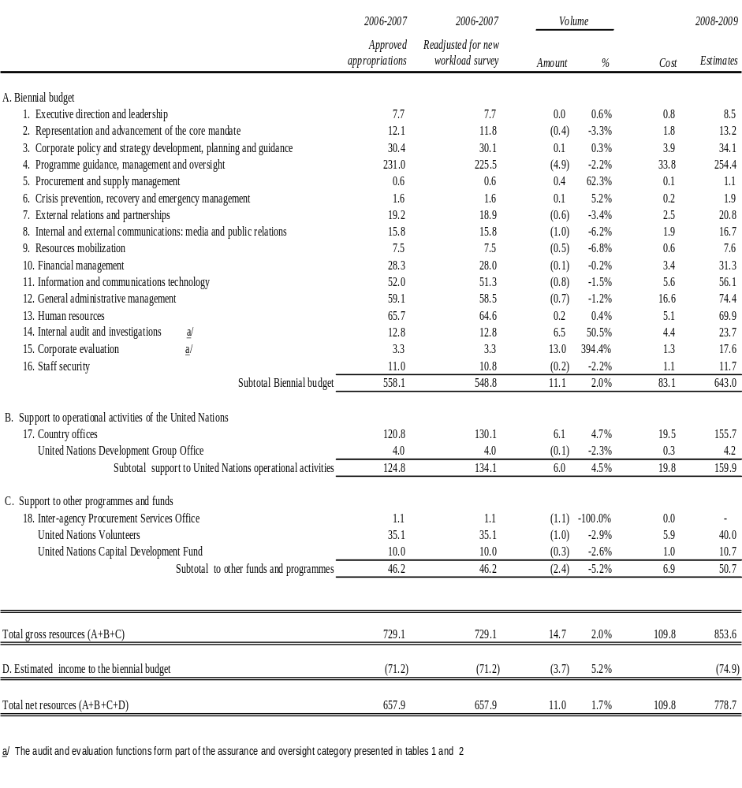

42. Total proposed allocations to headquarters central services bureaux and units is $182.7 million, funding a total of 171 international professional, and 111 local positions (2006-2007 comparison: $139.0 million, funding a total of 118 international professional and 127 local positions). Refer to summary table 4, former category B (management and administration). The total is allocated against the majority of functions.
43. Funding allocated to function 17 ($4.2 million, as above) and function 18 ($40.0 million plus $10.7 million, as above) is as follows:
(a) $4.2 million for five international professional posts, and seven local positions in the UNDGO (2006-2007 comparison: $4.0 million, funding the same number of positions). Refer to summary table 4, former category C;
(b) $40.0 million for UNV, funding 28 international professional, 162 local positions (2006-2007 comparison: $35.1 million, funding the same number of positions). Refer to summary table 4, former category C;
(c) $10.7 million for UNCDF, funding 13 international professional and nine local positions (2006-2007 comparison: $10.0 million, funding the same number of positions). Refer to summary table 4, former category D.
44. In table 3, the column ‘readjusted for new workload study’ captures results from a UNDP workload study undertaken in 2007 to review time and costs associated with supporting operational activities of the United Nations system at the country office level (function 17). Over 3 000 staff in 97 country offices participated, a broad representational sample from which estimates could be drawn.
45. Results from data analysis underscored the inextricable link between the United Nations system and UNDP activities in the UNDP country office structure. For example, material amounts of staff time reported under UNDP unit activities were actually spent providing support to resident coordinator initiatives and operational activities of the United Nations system. Accordingly, costs attributed to the resident coordinator unit in supporting operational activities of the United Nations system should continue to be apportioned entirely across the UNDP country office structure.
46. Twenty-eight per cent of costs at the country office level are attributed to supporting operational activities of the United Nations system during 2008-2009. In this regard, table 3 has been adjusted to reflect $130.1 million for 2006-2007, compared to the $120.8 million originally reflected in DP/2005/31, based on a 26 per cent attribution derived from the previous workload study. Please refer to paragraphs 135-139, under function 17 for further discussion.
Posts changes
47. Table 4 summarizes regular resources posts by location, and summary table 4 contains total resources posts by location. Summary table 2 contains proposed changes in senior posts funded from regular resources.
48. It is proposed that total positions funded from regular resources increase by a net 45 posts (1.4 per cent, from 3 289 during the 2006-2007 biennium to 3 334 during the 2008-2009 biennium). This incorporates a net increase of 60 international professional posts at the country office level and 36 international professional posts at the headquarters level. In contrast, there would be a net decrease of one national officer post and 41 general service level posts at the country office level and nine general service posts at the headquarters level.

49. Total 2008-2009 proposed posts at the country office level are 2 831 (84.9 per cent, inclusive of 120 UNV posts based in country offices). The balance of 503 posts is at the headquarters level and includes 12 posts for UNDGO (0.3 per cent), net 70 posts for UNV (2.1 per cent), 22 posts for UNCDF (0.7 per cent), and 399 posts for all other UNDP units (12.0 per cent).
50. A review of table 4 and summary table 2 reflects proposed net increases at the D2 and D1 levels of 12 and 14 positions, respectively. This is driven by the need to further strengthen senior management capacity in line with higher, broader, and more complex levels of responsibility, especially at the country level. All proposals have been assessed using the International Civil Service Commission (ICSC) post review classification process summarized in paragraph 57. In this regard, the ICSC master standard for job classifications equates director posts with institutional leadership functions, especially resident coordinator posts that lead the United Nations system at the country level by promoting and advancing the agenda of the United Nations within the context of the host government. Similarly, this applies to country director posts, in large and developmentally complex and/or special situations that require enhanced leadership and negotiating skills to represent UNDP. It is within this context, that a number of existing resident coordinator posts and new/existing country director posts are proposed for classification/reclassification at the director level. This should also facilitate and expedite the identification and placement of qualified and competent individuals in these key leadership posts, and strengthen efforts to achieve organizational gender and non-UNDP agency recruitment targets.
51. At the D2 level, proposed changes relate to the establishment of six new positions and six proposed upward reclassifications from the D1 level. Of the six new proposed positions, five are at the country office level as deputy regional bureaux director posts (one per region) to lead UNDP regional centres, enhance country office operational performance, and support United Nations regional coordination teams. A new D2 position at headquarters is also proposed to provide the Bureau of Management (BOM) with a dedicated deputy director to further strengthen accountability and effectiveness of organizational initiatives, especially in the areas of human resources, financial management, information and communications technology, procurement, and general administration. The six posts proposed for reclassification to the D2 level are all in country offices and include the resident coordinator positions in the Republic of Bolivia, the Republic of Guatemala, the Republic of Haiti, the Russian Federation, and the Republic of Rwanda, and the country director position in the Republic of the Sudan. In arriving at these proposals, UNDP has factored in the increased scope, levels of responsibility, and special political, developmental, representational, financial, and operational circumstances within which these six posts function, in line with ICSC post classification standards summarized in paragraph 57.
52. Of the net proposed increase of 14 positions at the D1 level, 13 relate to net new additions adjusted upward by net reclassifications of one post. Eleven new D1 positions are proposed at country level, including 10 country director posts, and one head of office for Southern Sudan, to strengthen leadership and operational capacity on the ground. Four D1 posts are proposed for headquarters and include: a dedicated deputy director in the Office of Audit and Performance Review (OAPR); a director for the newly established Legal Support Office; an ethics advisor to lead the newly established ethics function; and a senior coordinator for policy in the Bureau for Development Policy (BDP) to support the global practice architecture. These additions are offset by two reductions at the headquarters level.

Table 4. Regular resources posts by location
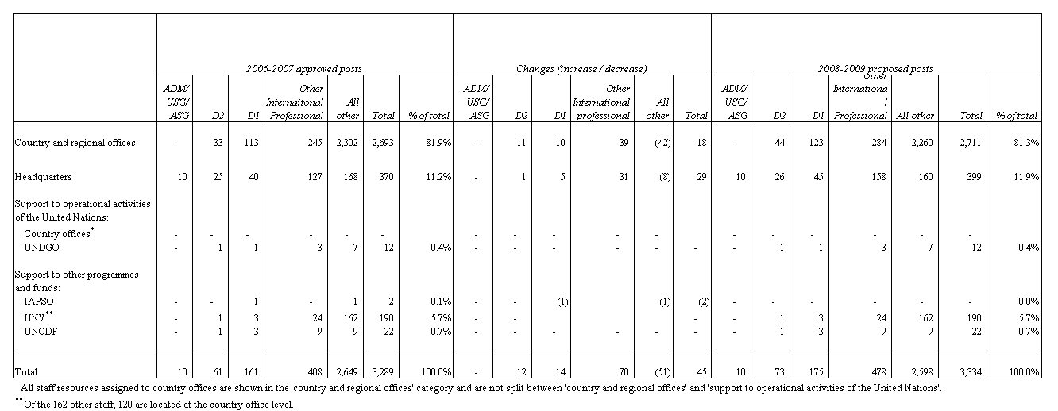

53. The net upward reclassification adjustment of one post at the D1 level is described in paragraphs 54 and 55. In addition to the six resident coordinator posts proposed, an additional six posts – four country director and two headquarters posts – are also proposed. These reclassifications take into account the increased scope and levels of responsibilities attached to these positions, including special political, developmental, representational, financial, and operational circumstances, in line with the ICSC post classification standards, summarized in paragraph 57.
54. The net one upward reclassification is arrived at as follows: 12 upward reclassifications to D1, offset by five proposed downward reclassifications from D1 (five deputy country director positions in Bangladesh, China, Guatemala, India, and Nigeria). A further reduction of six D1 positions results from a like number of proposed reclassifications to the D2 level as outlined in paragraph 51.
55. Of the 12 upward reclassifications to D1, 10 are proposed at the country office level, to include six resident coordinator positions in Djibouti, Gabon, Moldova, Samoa, Sao Tome and Principe, and Swaziland, and four country director positions in Bangladesh, Burkina Faso, Tanzania and Viet Nam. In addition, two upward reclassifications to D1 are proposed at headquarters: the chief of the investigations section of OAPR and the chief of the security team.
56. Of the 478 international professional posts, 96 (20 per cent) are at the P2-P3 entry level. This represents a net increase of 20 posts (26 per cent) over the 76 entry-level professional level posts included in the 2006-2007 budget. That increase includes 17 proposed reclassifications from the national officer (11) and general service (six) levels. The national officer positions proposed for reclassification all reside in regional audit service centres and reflect the international nature and regional scope of audit specialist functions, which include participation in audit teams, training of staff, interaction with senior United Nations country team members, and provision of advisory services on business processes. The six general service level posts proposed for reclassification reside in the Office of Human Resources (OHR) in BOM, and the Partnerships Bureau and are justified as follows:
(a) Human Resources Policy Specialist. To serve as UNDP focal point for United Nations system human resources reforms and as an authoritative source on organizational policy matters.
(b) Human Resources Management Specialist. To provide oversight, quality assurance, and collective accountability support to corporate human resources panels and committees.
(c) Translation Manager. To strengthen management and quality control over a high volume of translation requests, many of which are outsourced.
(d) Internal Communications Officer. To serve as the focal point for all internal communication with headquarters units and country offices.
(e) Writer/Editor. To support the production of high volume, high quality written materials, including press releases and reports, within strict deadlines.
(f) Human Resources Analyst. To respond more substantively to staff requirements, based on an internal management review.
57. The post classification review process for international professional and higher category posts is uniform throughout the United Nations system, based on the application of ICSC standards that entered into effect on 1 January 2004. It consists of two evaluation tools, the new master standard and the grade level descriptors; the former is a factor-based point rating standard for classification based on the nature of work, the enabling environment, partnerships and results. The latter provides a summary of the grade-determining characteristics of work, and job illustrations for all levels. In UNDP, standard setting measures have been introduced through the User guide on job evaluation, an elaboration of a full set of 92 generic job descriptions, and an analysis of senior management structures. UNDP employs all of these tools when reviewing new positions for classification purposes and existing positions proposed for reclassification.
58. A total of 50 country director posts are proposed for funding from the 2008-2009 support budget – 25 are newly proposed (2008-2009) and 25 were established in 2006-2007. With respect to the latter, 12 related to newly approved new positions in the 2006-2007 budget, and 13 related to conversions of existing posts. Of the 13 converted posts, eight are considered temporary conversions of resident coordinator posts, in lieu of newly established DSRSG posts that are cost-shared between UNDP and the United Nations Department of Peacekeeping Operations (DPKO), as established within the United Nations post structure. The temporary conversion of eight existing resident coordinator posts to country director posts is considered a prudent use of available resources. It is also considered a practical interim solution that proactively responds to TCPR recommendations to strengthen UNDP country office capacities in complex emergency situations. Upon cessation of individual DSRSG arrangements in these programme countries, the temporary country director posts should revert to their resident coordinator status and a more permanent solution to establish country director positions should be determined.

B. Other considerations

Government contributions towards local office costs
59. Table 5 shows 2006 GLOC from direct cash payments, accounting linkage with voluntary contributions, and in-kind contributions broken down by the income category of programme countries. Against a total obligation of $48.2 million, total contributions in 2006 amounted to $35.8 million, made up of $25.0 million in direct cash payments and the accounting linkage with voluntary contributions, with the remaining $10.8 million representing in-kind contributions. This is a 74 per cent compliance rate, compared with a 76 per cent rate in 2004.

Table 5. Government contributions to local office costs income by category of countries, 2006
(in millions of dollars, nominal)
Income category | GLOC obligations, including  in-kind contributions | Income received |  |  | Percentage received against obligation
Income category | GLOC obligations, including  in-kind contributions | Cash and accounting linkage | In-kind contributions | Total income received | Percentage received against obligation
Low-income countries | 16.2 | 7.2 | 5.4 | 12.6 | 78%
Middle-income countries | 25.9 | 12.9 | 4.3 | 17.2 | 67%
Net contributor countries | 6.1 | 4.9 | 1.1 | 6.0 | 98%
Total | 48.2 | 25.0 | 10.8 | 35.8 | 74%

60. The Administrator appreciates improvements made by programme countries toward meeting GLOC obligations, and are strongly encouraged to continue meeting them. Middle-income country compliance remains at a less than desirable level. For the 2008-2009 biennium, UNDP will maintain the option to withhold part of support budget resources for countries with significant GLOC deficits, with an emphasis on middle-income countries.
61. An integral part of calculating GLOC obligations of programme countries are waivers, granted based on respective gross national income (GNI) levels. Local costs of a UNDP country office (the basis for the calculation) are reduced by a waiver percentage using the GNI level of the programme country. Waivers are reviewed in line with the decision on a new programming period. As the 2008-2009 support budget coincides with the beginning of the 2008-2011 programming period, table 6 outlines proposed waiver band percentages.
62. It is also proposed to continue the current policy for net contributor countries, whereby the regular support budget pays for the resident coordinator/resident representative based on a country programme, which should at least be at the level of $10 million in the four year programming period. All other costs would continue to be borne through government contributions and cost-recovery income. At the end of the period an assessment would be made as to the nature of UNDP operations in each of the countries for the next programming period.

Table 6. Government contributions to local office costs waivers by
gross national income level, 2008-2011
Base 2005 GNI | Waiver percentage | Category of programme country
5 501 and above | 0 | Net contributor country
1 751 – 5 500 | 25 | Middle-income country
1 051 – 1 750 | 50 | Middle-income country
0 – 1 050 | 75 | Low-income country

Proportional burden sharing of support budget: regular and other resources
63. The level of variable indirect costs associated with the management of the overall volume of other donor resources significantly impacts the size of the biennial support budget. The proportionality principle dictates that each source of funding should bear its fair share of total support costs above a base structure. This avoids subsidization by regular resources of programmes funded through other donor resources.
64. The base structure concept was introduced in the 2004-2005 biennial support budget and is supported by sustainable and predictable funding from regular resources that allows key organizational functions to be discharged, regardless of fluctuations in the volume of programming resources. The Administrator proposes to maintain the base structure for the 2008-2009 biennium at the same level as the previous, subject to minimal adjustments.
65. As highlighted in Report on the assessment of the cost recovery policy (DP/2007/36), an average indirect cost recovery rate of 7 per cent is estimated to generate sufficient extrabudgetary resources to meet the proportionality objective. Executive Board decision 2007/18 established a fixed 7 per cent rate on all new third-party cost sharing and trust fund agreements with respect to recovering indirect costs for general management services. Indirect costs cover project identification, formulation and appraisal; general oversight and monitoring; receipt allocation and reporting of financial resources; determination of execution modality and local capacity; briefing and debriefing of project staff and consultants; and systems, information technology infrastructure, branding, and knowledge sharing.
66. Realization of increased cost recovery income is expected to be gradual due to legacy programmes, for which lower support cost rates were stipulated in line with previous cost recovery policies. It will take several years to apply the 7 per cent recovery rate to the full portfolio of programmes funded through other donor resources. The move towards proportionality will be gradual, in line with the trend to shift increasing amounts from regular resources funded support budget activities to other resources funding. Table 7 summarizes cost recovery income estimates for 2006-2007 and 2008-2009 by major category.

67. In order to maximize available regular resources to fund programmes and further advance proportional burden sharing, the Administrator proposes that $37.3 million be shifted out of the regular resources funded support budget. Accordingly, the regular resources proportionality ratio for resources funded above the base structure would reflect a downward trend from 15.8 per cent in 2006-2007 to around 11 per cent in 2008-2009. During the 2008-2009 biennium, the Administrator proposes a continuation of further rationalizing the funding modalities supporting the operational structure and related activities of UNDP.

Table 7. Cost recovery income estimates

(in millions of dollars, nominal)
 | Other resources income
 | 2006-2007 | 2008-2009
- Income from donor co-financing | $177 | $258
- Income from programme country cost-sharing | $82 | $75
Subtotal income estimate from programme activities | $259 | $333
- Income from services at headquarters | $26 | $26
- Income from services at the country office level | $16 | $18
Subtotal income estimate from United Nations agency services | $42 | $43
Total cost recovery | $301 | $376

United Nations mandated security costs
68. UNDP participates in the approved package of global measures currently under implementation by the United Nations Department of Safety and Security (DSS). These global measures include participation in the United Nations field security coordination programme (approved by General Assembly resolution A/RES/59/276), requiring UNDP to share common United Nations field-based and headquarters-related security costs, including international field security coordination officers (FSCOs), local staff and related operational support. Common United Nations headquarters-based FSCO-related costs associated with professional and general service staff, and related operational costs are also included. The share of total common FSCO-related costs for UNDP during the 2008-2009 biennium is 21 per cent. Following the report of the Secretary-General entitled Inter-organizational security measures: framework for accountability for the United Nations field security management system (A/57/365), minimum operational security standards (MOSS) compliance has been adopted and implemented as a standard United Nations security policy. MOSS compliance at headquarters is also a requirement.
69. During 2006-2007, $41.2 million was earmarked to meet estimated United Nations mandated security costs, of which $31.2 million was appropriated from regular resources and $10 million earmarked from other resources. Approximately $39 million will be spent, including the full $10 million of other resources.
70. Approximately $29 million will be spent by UNDP to cover its share of the field security programme. About $9 million will be spent on country office MOSS compliance assessments, investments, and prioritization of existing and continually emerging MOSS compliance needs. In support of this, $3.7 million has been shifted from the headquarters MOSS compliance category as a consequence of reduced costs. Investments made at the country office level in 2006-2007 have positively impacted the security of more than 5,000 country office staff and over 75 UNDP country offices.
71. It is estimated that $50.2 million (gross) is required during the 2008-2009 biennium to meet United Nations mandated security costs as follows:
(a) Costs associated with the UNDP share of the field security coordination programme ($39.0 million);
(b) Country office MOSS compliance assessments and investments for on site support, premises compliance, office relocations and security equipment ($9.7 million); and
(c) Headquarters MOSS compliance for building locations to include closed caption television, card access readers, package intercept equipment and an alternate off site crisis operations centre ($1.5 million).
72. In line with the gradual proportionality strategy of UNDP, an estimated $15 million of the total $50.2 million in requirements will be covered by other resources funding, and $4 million will be covered by applying an expected credit from DSS in 2008, resulting from 2006-2007 over-billing. UNDP proposes that the remaining amount of $31.2 million, which is at the same nominal regular resources level as 2006-2007, continue to be treated as a separate requirement from regular resources, outside of the 2008-2009 biennial support budget.
International Public Sector Accounting Standards
73. General Assembly resolution A/RES/60/1, requested the United Nations to adopt IPSAS for its financial statements by 2010. IPSAS is considered a best practice by public organizations and its implementation will result in a higher level of transparency, accountability and harmonization, and provide a consistent, comparable and harmonized platform for United Nations system financial reporting and disclosure. It will also:
(a) Support more effective use of UNDP financial and human resources;
(b) Support measures for human resources management and budgetary reform in UNDP;
(c) Enable easier adaptation of the UNDP enterprise risk management system;
(d) Improve the extent to which financial policies, regulations and rules, business practices, and procedures respond to the needs of UNDP; and
(e) Assist in the transition to joint offices.
74. IPSAS is sponsored by BOM and led by the Office of Finance and Administration (OFA), the Office of Information Systems and Technology (OIST), and the BOM Centre for Business Solutions. The adoption of IPSAS will follow a phased approach and disbursements will be made accordingly. During 2008, selected business processes will be piloted to validate the scope of the changes to be implemented. These changes will be prototyped in Atlas, allowing UNDP to experience the changes IPSAS entails. The initial scope will be limited to the recognition of revenue upon signature of contracts, and the recognition of expenditure upon delivery of goods and services. During 2009, the scope will be expanded to include the accrual of employee benefits, tracking and valuation of fixed and intangible assets, and review and capitalization of leases. By 2010, full compliance is expected to include the recording and depreciation of all material assets and the preparation of all financial statements. The following are business processes affected by full implementation of IPSAS:
(a) Revenue will be recognized upon signature of contract with certain pre-defined donors;
(b) Expenditure will be recognized when goods and services are delivered, not when the purchase order is approved;
(c) Employee benefits will be accrued for, such as leave and after service health insurance;
(d) UNDP fixed assets, inventory and intangible assets that are material will be tracked and valued, such as vehicles, pharmaceuticals, and software;
(e) Leases will be evaluated and capitalized as assets when warranted;
(f) Material UNDP assets will be recorded and depreciated; and
(g) Financial statement presentation, consolidation and disclosure changes will be implemented.
75. IPSAS aims to build and maximize the use of internal capacities, both functional and technical, as well as build internal knowledge to ensure the sustainability of implementation while optimizing external costs. However, expert consultants and consultancy firms will be needed in highly technical areas; this constitutes a significant portion of the required financial inputs. Estimates for IPSAS-related costs during 2008-2009 are broken down into three major activities:
(a) Development and application of IPSAS policies ($3.5 million);
(b) Upgrading financial systems and reports ($4.1 million); and
(c) Business process reengineering and change management initiatives ($1.4 million).
76. Based on these estimates, the Administrator proposes an amount of $9.0 million during 2008-2009 to meet United Nations system-wide IPSAS compliance costs. This would be treated as a separate requirement from regular resources, outside of the 2008-2009 biennial support budget.

C. Activities and resources by function – harmonized results-based budget framework

77. This section describes each of the 16 harmonized management functions that constitute the results and activities financed by the biennial support budget; section D contains three functions specific to UNDP. Each function has a narrative definition and description, as well as overall objectives and issues for the 2008-2009 biennium. Linkages with the strategic plan are highlighted, as are regular resources funding levels for the 2006-2007 and 2008-2009 bienniums, including cost increases, volume increases and reductions. The narrative is followed by a matrix highlighting key results to be achieved, indicators used to measure performance and a baseline and target – the baseline represents the biennium starting point, and the target provides the intended goal. Key results do not represent total accomplishments expected for each function; rather they should be considered corporate results that support the management and/or coordination objectives of the strategic plan.
Function 1: Executive direction and leadership
78. Definition and description. The activities that enable senior management to define the executive direction for the organization, based on long-term vision and mandate outlined in the strategic plan. This entails providing effective organizational leadership, driving it towards defined organizational results in an accountable and transparent manner, and enabling managers at all levels to lead their staff towards unit specific results, holding each other accountable for achieving those results within the overall executive direction of UNDP.
79. Issues and narrative. This function directly supports all of the results outlined in the strategic plan in the chapters on: UNDP support to strengthening United Nations system-wide coherence; UNDP operations; and Managing for results: accountability, risks, and resources. During the 2008-2009 biennium, senior management is responsible for defining the direction of UNDP, providing leadership to strengthen organizational results in development and management, and supporting the operational activities of the United Nations system, as outlined in the strategic plan. However, this function could be affected by Executive Board decisions and intergovernmental processes requiring a shift in course and a change in development, coordination or management goals.
80. Accountability and funding levels. Accountability for results in this function rests with the Executive Office. Table 3 reflects funding levels for this function – $7.7 million in 2006-2007 and $8.5 million in 2008-2009 – incorporating zero real increases and $0.8 million in cost increases. There is no net real increase in this function since the upward real increase of $0.4 million for the creation of one international professional position at headquarters is offset by downward shifts and reductions of the same amount. The new position will provide direct support to the Associate Administrator in discharging his responsibilities for the effective and efficient management of UNDP, with particular emphasis on operations.
Expected key results under function 1
Management results |  | Indicators | Baseline | Target
1. | Effective corporate leadership and management | Achievement of strategic plan management priorities, 2008-2009 | New in 2008 | 50%
2. | UNDP leadership contributes to strengthening the management of the resident coordinator system | Stakeholder satisfaction with the leadership of UNDP in strengthening the resident coordinator system | 2007 partners survey | Annual improvement
Function 2: Representation and advancement of the core mandate
81. Definition and description. UNDP country office and headquarters activities related to representing and advancing the core mandate and major programme goals of the organization. Activities in this function are carried out principally in country offices, but may also occur in regional or headquarters units. All units will integrate and apply the strategic plan to daily management, programmatic/policy activities and support to the operational activities of the United Nations system, including the integration of development effectiveness principles into programmes, and the achievement of greater programme concentration in the four focus areas of UNDP.
82. Issues and narrative. This function directly supports results outlined in the strategic plan in the chapters on: UNDP operations and managing for results: accountability, risks, and resources. During the 2008-2009 biennium, the organization will enhance its support to national priorities through effective management of country programmes. Within the core mandate of UNDP, the organization will work towards aligning the global, regional and country programmes and projects with strategic plan priorities. Representing and advancing the organization’s core mandate, along with support to operational activities of the United Nations system (function 17), constitute the greatest portion of the work of the core structure of country offices; headquarters units (programme and regional bureaux), as well as regional centres, play important roles in carrying out this critical function. Aligning UNDP resources with the priorities in the strategic plan is balanced with the need to be responsive and alert to new needs, to react quickly and decisively to emergency situations and crises, and to respond where UNDP is sought by programme countries and partners as a provider of last resort. This will affect the progress of UNDP with respect to alignment.
83. Accountability and funding levels. Accountability for results in this function rests largely with the country offices and the headquarters regional and programme bureaux. Table 3 reflects funding levels for this function – $11.8 million in 2006-2007 and $13.2 million in 2008-2009 – incorporating net real decreases of $0.4 million and cost increases of $1.8 million. The net real decrease of $0.4 million represents the proportionate share of investments in country office capacities to deliver development results, being offset by downward shifts and reductions.
Expected key results under function 2
Management results |  | Indicators | Baseline | Target
1. | All programmes/projects are aligned with the development focus areas reflected in the strategic plan | Programme expenditure ratio within the development focus areas in the strategic plan | 2007 data, mapped against new strategic plan focus areas | TBD
2. | All programmes/projects integrate UNDP cross-cutting issues (capacity development, gender equality and women’s empowerment) | Percentage of new projects/programmes that integrate capacity development | New in 2008 | TBD
2. |  | Percentage of new projects/ programmes integrate gender equality and women’s empowerment | New in 2008 | TBD

Function 3: Corporate policy and strategy development, planning and guidance
84. Definition and description. The planning of goals, business lines and approaches of UNDP. This includes research activities that support strategic planning and guidance to headquarters and country office operations that communicate results of the planning process. Activities in this function will be devoted to assuring policies, strategies, rules and procedures are up-to-date and relevant, reflect overall direction from top management on goals, strategies, business lines and approaches, and are communicated clearly and promptly to organizational units.
85. Issues and narrative. This function supports results outlined in the strategic plan in the chapters on: UNDP operations and Managing for results: accountability, risks, and resources. It is central to supporting the rigorous application of the practice architecture in the development of policy frameworks, products and tools that support global, regional and country offices’ substantive alignment to, quality of, and accountability for strategic plan development results. Integral to success will be incorporating a more systematic approach to risk management into UNDP procedures and policies, the creation of cultural change within the organization, and helping staff members, through leadership, accountability, support and training to adopt risk management as an aspect of good management practice.
86. Accountability and funding levels. Accountability for results in this function rests largely with headquarters units, including the Operations Support Group, BDP, the Bureau for Crisis Prevention and Recovery (BCPR), regional bureaux, and BOM. Table 3 reflects funding levels for this function – $30.1 million in 2006-2007 and $34.1 million in 2008-2009 – containing net real increases of $0.1 million and cost increases of $3.9 million. Real increases of $5.4 million are offset by downward shifts and reductions of $5.3 million resulting in the net real increase of $0.1 million. Real increases relate to: (a) strengthening the global practice architecture to include the establishment at headquarters of one new post at the D1 level, two new international professional posts, and two new general service level posts; (b) strengthening the gender unit to include the establishment at headquarters of one international professional and one general service level post; (c) establishing an ethics function to include the creation at headquarters of one D1 and one general service level posts; (d) strengthening oversight and management support across the organization to include the establishment at headquarters of one D2 level post; (e) establishment of a Legal Support Office to include the creation at headquarters of one D1, four international professional posts; and (f) implementation of the financial disclosure policy.
Expected key results under function 3
Management results |  | Indicators | Baseline | Target
1. | Effective system and culture of accountability embedded in UNDP | Implementation of system of formally documented functions, authority and accountability within UNDP and between UNDP management and the  Executive Board | New in 2008 | In place by 2008
1. |  | Percentage of staff reporting a good understanding of accountability and transparency issues | New in 2008 | TBD
1. |  | Percentage of operating units that have completed their risk log for their unit risk analysis | New in 2008 | 90%
2. | UNDP results-based management tools available and effectively support the implementation of programmes | User satisfaction with enhanced results-based management system | 2006 headquarters products and services survey (HQPSS) 53.5 per cent | 75%
3. | Policy frameworks, products and tools support practice alignment and coherence. | Quality assurance and clearance process established. | New in 2008 | Process agreed / implemented by end of 2008
3. |  | Percentage of country offices satisfied with policy advisory services received. | New in 2008 | Percentage increase TBD
4. | Knowledge management frameworks, products and services support the policy, programming and project cycles | Percentage of country offices reporting that communities of practice and knowledge networks are integral to their daily work | New in 2008 | 50%
4. |  | Percent of country offices reporting satisfaction with the quality and relevance of knowledge products and services provided | New in 2008 | 50%

Function 4: Programme guidance, management and oversight
87. Definition and description. The development, approval and implementation of UNDP programmes at the country, regional and global levels, including guidance to programme formulation and implementation, oversight of programmes (for example, of country programmes from regional offices), and overall programme management of country operations to ensure programmes proceed toward approved results. This function does not cover operational management of the specific programmes themselves – those costs are an integral part of the programmes. The objective of this function during the 2008-2009 biennium is to ensure country programme strategies (and programmes within them) are of high quality and are prepared, approved and implemented in alignment with the goals of the strategic plan and with UNDP prescriptive content.
88. This is the last of the three functions that comprise the development effectiveness continuum – the first two being Representation and advancement of the core mandate (function 2), and Corporate policy and strategy development, planning and guidance (function 3). All three functions support the development and cross-cutting institutional results in the UNDP operations chapter of the strategic plan. These functions all contain programme support activities found within country office structures and headquarters programme bureaux that continue to be funded from the support budget. These and other activities will be carefully reviewed in the context of the proposed cost classification exercise planned for 2008-2009.
89. Issues and narrative. This function directly supports results outlined in the strategic plan in the chapters on: UNDP operations and Managing for results: accountability, risks, and resources. In this regard, the function ensures the overall alignment of UNDP programmes with development priorities and plans of programme countries, while taking into full consideration UNDP comparative advantages in its four key focus areas. In addition, it supports the practice architecture through linking policy and programming support, as well as promoting coherence between programming at various levels. The regional service centres play a critical role in performing this function through close proximity to programme countries. Integral to success is ensuring programmes are guided by programme country plans and priorities. Political limitations, security risks, capacity and resource constraints influence the success of this function.
90. Accountability and funding levels. Accountability for results in this function rests largely with the country offices but is shared by the headquarters regional and programme bureaux. Table 3 reflects funding levels for this function – $225.5 million in 2006-2007 and $254.4 million in 2008-2009 – reflecting net real decreases of $4.9 million and cost increases of $33.8 million. Net real decreases in this function of $4.9 million are the result of real increases amounting to $11.9 million, which are more than fully offset by real decreases due to shifts and reductions of $16.8 million. The real increase of $11.9 million represents a portion of total investments of $28.0 million earmarked for strengthening country office capacities to deliver development results in the following areas: (a) strengthening operations management to provide increased capacity to deliver development results to include the establishment in country offices of 15 new international professional posts, and a net increase of one local post; (b) establishment of base structures for the Montenegro country office and Southern Sudan sub-office to include the establishment of one new D1 level post, one new international professional and nine new local posts; (c) establishment of 25 country director posts to include 10 new D1 and 15 new international professional posts in country offices; (d) establishment of five D2 field-based deputy regional bureaux directors; (e) contributions to the cost of DSRSGs; (f) support to country offices for premises relocations, alterations, and leasehold improvements; and (g) programme bureaux related realignments, resulting in a net increase of one international professional and a decrease of one local post.
Expected key results under function 4
Management results |  | Indicators | Baseline | Target
1. | Programme development support and guidance enhanced | Percentage of country offices satisfied with the quality of programme support services;  number of regional service centre missions undertaken to support country offices in programme development and support | 2007 data  New in 2008 | 75 per cent  TBD
2. | Programme monitoring and oversight enhanced | Percentage of country offices receiving one annual programme management monitoring mission;  percentage of comprehensive reviews of country programmes undertaken before end of programme cycle | 2007 baseline  2006-2007 biennium | TBD  TBD
3. | The quality of programme management is enhanced | Percentage of country programmes rated as being effective in contributing to national development outcomes (based on assessment of development results);  partner satisfaction with contribution of UNDP programmes/projects to  human development | New in 2008  New in 2008  (partners survey) | TBD  TBD
Function 5: Procurement and supply management
91. Definition and description. To provide central guidance and oversight on the procurement of goods and services, and ensure value for money through an organizational knowledge network on supply and procurement issues. The objective is to ensure UNDP has systems and resources in place to support effective administrative and programme procurement by country offices and headquarters units. The function does not include the procurement process; that is included within individual programmes and under General administrative management (function 12).
92. Issues and narrative. This function supports the results outlined in the strategic plan in the chapter on Managing for results: accountability, risks, and resources.
93. Accountability and funding levels. Accountability for results in this function will largely rest on the newly-created central UNDP procurement support office. Table 3 reflects funding levels for this function – $0.6 million in 2006-2007 and $1.1 million in 2008-2009 – reflecting net real increases of $0.4 million and cost increases of $0.1 million. The net real increase of $0.4 million is comprised of a real increase of $0.8 million for the establishment of the procurement support office, to include the establishment at headquarters of two new international professionals and one new local post, offset by a real decrease of $0.4 million in shifts and reductions.
Expected key results under function 5
Management results |  | Indicators | Baseline | Target
1. | Procurement capacity is strengthened | Percentage of procurement practitioners certified | 77.9%  (876 out of 1125 buyers) | 95%
2. | Procurement support and oversight are provided to clients effectively and timely | Percentage of operating units satisfied with timeliness and quality of procurement support | 2007 data  77 per cent (2006 HQPSS) | 80%

Function 6: Crisis prevention, recovery and emergency management
94. Definition and description. The capacity to respond quickly to crisis situations in developing countries. This function establishes and maintains a core capacity for programmatic response to emergency and crisis situations and ensures UNDP headquarters can support disaster preparedness and rapidly respond to country office requirements. Broad corporate policies related to crisis prevention are covered under function 3, corporate policy and strategy development, planning and guidance.
95. Issues and narrative. This function supports the results outlined in the strategic plan in the chapters on: UNDP operations and Managing for results: accountability, risks, and resources. More specifically, this function includes developing, updating and dissemination of policies, strategies and guidelines for emergency response and recovery support, and maintaining the core capacity. This permits UNDP to respond to crisis situations and support recovery efforts. BCPR leads efforts to ensure that the role of UNDP in crisis and post-crisis situations is clearly defined; that UNDP is properly equipped to fulfil its role and that all levels of the organization are prepared to deliver recovery and development support in the aftermath of a natural disaster or conflict.
96. Timeliness is critical to the success of this function. However, the occurrence of numerous simultaneous crisis situations could potentially overwhelm organizational response capacity, thereby compromising timeliness. Political limitations and security risks may also threaten success in deploying UNDP resources. This function supports the strategic plan coordination output relating to implementation of the United Nations International Strategy for Disaster Reduction and also the management outputs on reducing risk management and increasing accountability.
97. Accountability and funding levels. Accountability for results in this function rests with BCPR, as outlined in the matrix. Table 3 contains funding levels for the function – $1.6 million in 2006-2007 and $1.9 million in 2008-2009 – reflecting real increases of $0.1 million and cost increases of $0.2 million. The net real increase of $0.1 million is comprised of a real increase of $0.2 million to strengthen operational support for the effective execution of this function, offset by real decreases of $0.1 million in shifts and reductions.
Expected key results under function 6
Management results |  | Indicators | Baseline | Target
1. | Timely deployment of financial resources and personnel in emergency situations | Average deployment time of emergency financial grant | 72 hours | 48 hours
1. |  | Average deployment time for ‘surge’ advisors | 2007 data | 5 days

Function 7: External relations and partnerships
98. Definition and description. Support for and relations with the Executive Board, other oversight bodies, and governments as well as partnership building with civil society organizations, public and private sector organizations and others (beyond those related to specific UNDP programmes). This function also includes relations with other entities within the United Nations system and with international financial institutions. UNDP activities carried out with other United Nations organizations are covered under Support to operational activities of the United Nations system (function 17). An important objective for 2008-2009 is an increased understanding of, and support for, UNDP by current and new UNDP partners, and a more participatory role in programme and strategy development by partners.
99. Issues and narrative. This function supports the results outlined in the strategic plan in the chapter on UNDP support to strengthening United Nations system-wide coherence. Success in achieving results in this function hinge on the willingness and ability of other organizations to establish platforms for joint action and to build partnerships with UNDP.
100. Accountability and funding levels. Accountability for results in this function rests with the Partnerships Bureau at headquarters. Related activities carried out in country offices are covered under function 2, representation and advancement of the core mandate. Table 3 reflects funding levels for this function – $18.9 million in 2006-2007 and $20.8 million in 2008-2009 – incorporating net real decreases due to shifts and reductions of $0.6 million and cost increases of $2.5 million.
Expected key results under function 7
Management results |  | Indicators | Baseline | Target
1. | UNDP partners have an increased understanding of and support for the organization | Percentage of clients and partners who think partnership with UNDP is valuable | 2007 data | 5% increase over baseline by 2009
2. | Strengthen existing and building new partnership arrangements with United Nations and other  multilateral partners | Number of new memoranda of understanding, action plans/joint initiatives with United Nations partners to assure practical division of labour and create synergies in 2008 and 2009 | New in 2008 | 12 additional by 2009
2. |  | Percentage of United Nations organizations satisfied with UNDP support | 2007 data | 5 % increase over baseline by 2009
3. | Establish platforms for United Nations system-wide support for private sector development, civil society and decentralized cooperation partnerships | Number of private sector, civil society and foundation initiatives launched at country and global level | New in 2008 | 12 platforms by 2009
3. |  | Number of alliances with decentralized cooperation partners forged (ie. regional and local government entities) | New in 2008 | 12 alliances by 2009

Function 8: Internal and external communication: media and public relations
101. Definition and description. An increased understanding by external and internal audiences of the role, activities, and programme and management goals of UNDP through enhanced communication. Activities in this function publicize the mandate and accomplishments of UNDP to the global public and lay the foundation for later programming activities, including advocacy of specific policies and programmes.
102. Issues and narrative. This function supports the results outlined in the strategic plan in the chapters on: UNDP support to strengthening United Nations system-wide coherence; UNDP operations; and Managing for results: accountability, risks, and resources. External factors influencing the success of this function include the climate among populations in donor and programme countries regarding the United Nations, and UNDP in particular. The achievement of results in this function is important to prevent the possibility of an erosion of the status and relevance of UNDP in the global arena. This function supports overall implementation of the strategic plan.
103. Accountability and funding levels. Accountability for results in this function rests with the Communications Office in the Partnerships Bureau at headquarters; related functions carried out in country offices are covered under function 2, representation and advancement of the core mandate. Table 3 reflects funding levels for this function – $15.8 million in 2006-2007 and $16.7 million in 2008-2009 – containing net real decreases due to shifts and reductions of $1.0 million and cost increases of $1.9 million.
Expected key results under function 8
Management results |  | Indicators | Baseline | Target
1. | Reference to UNDP key messages in significant media | Number of times UNDP key messages are covered in major media outlets, the world wide web, or in academic journals. | Second semester 2007 (actual) | 5% by 2009
2. | Response to corporate accountability and risk management goals | Percentage of country office websites compliant with corporate information disclosure and transparency requirements | 2007 data | 80% by 2009
3. | Increased cooperation on communications amongst entities in the United Nations development system (including United Nations Information Centres) | Number of United Nations entities using UNDP-sponsored communications tools. | 2006/7 data | 40% of United Nations entities

Function 9: Resource mobilization
104. Definition and description. To attract and leverage resources from donors and programme governments, non-governmental organizations and through partnerships with other public and private organizations. The activities in this function are intended to assure that United Nations and UNDP contributions are in line with projections made in the strategic plan.
105. Issues and narrative. This function supports the results outlined in the strategic plan in the chapters on the integrated financial resources framework and UNDP support to strengthening United Nations system-wide coherence. It also supports the strategic plan objective of having core contributions rise more rapidly than non-core to rebalance the ratio of core to non-core resources. Resource mobilization entails a number of uncertainties: political (the general climate of support for the United Nations and UNDP); financial (exchange rate fluctuations); economic (the condition of worldwide donor government budgets); and substantive (donors may continue to limit the amount of core funding while contributing more to non-core for a variety of reasons).
106. Accountability and funding levels. Accountability for results in this function rests with the Partnerships Bureau. Related functions carried out in country offices are covered under function 2, representation and advancement of the core mandate. Table 3 reflects funding levels for this function – $7.5 million in 2006-2007 and $7.6 million in 2008-2009 – containing net real decreases due to shifts and reductions of $0.5 million and cost increases of $0.6 million.
Expected key results under function 9
Management results |  | Indicators | Baseline | Target
1. | Regular and other resources contributions are in line with strategic plan | Amount of regular contributions in line with strategic plan projections | 2007 actual | From the strategic plan
1. |  | Amount of donor and multilateral non-core contributions (other resources) in line with strategic plan projections (third party cost sharing and trust funds) | 2007 actual | From the strategic plan
2. | Increased contributions by non-traditional / non-OECD/DAC donors in support of UNDP regular resources | Size of volume increase | 2007 non-OECD/DAC contributions | 10% increase by 2009
3. | Resources effectively administered by UNDP on behalf of the United Nations | Number of new governance / administrative arrangements in place | 2007 data | 4 by 2009
3. |  | Percentage of partners satisfied with UNDP as managing agent of resources on behalf of the United Nations system | New in 2008 | 80%by 2009

Function 10: Financial management
107. Definition and description. To establish and maintain systems of financial management and accountability, manage financial and other assets of UNDP, support the allocation of programme and operating resources to optimize the use of expected/available funds based on planning and budget priorities, and manage and report on financial transactions involving the use of UNDP resources.
108. Issues and narrative. This function supports the results outlined in the strategic plan in the chapter on managing for results: accountability, risks, and resources. Improving financial management and implementing the results-based biennial support budget will require trained financial staff to ensure proper comprehension of new concepts and procedures raised by a results-based approach.
109. Accountability and funding levels. Accountability for results in this function rests with OFA and the Office of Planning and Budgeting (OPB) at headquarters; all units in the organization are accountable for financial management results. Table 3 reflects funding levels for this function – $28.0 million in 2006-2007 and $31.3 million in 2008-2009 – containing net real decreases of $0.1 million and cost increases of $3.4 million. Net real decreases of $0.1 million are comprised of real decreases of $0.9 million due to shifts and reductions, and real increases amounting to $0.8 million attributable to improved oversight tools, support to inter-organization accountability framework initiatives, and strengthening of corporate financial management functions.
Expected key results under function 10
Management results |  | Indicators | Baseline | Target
1. | Audit recommendations  managed systematically | Percentage of reduction in frequency and number of high-risk audit observations, especially in areas of NEX management, compliance with internal controls and bank reconciliation | 30 high risk audit observations | Reduction by 50% in number of high risk audit observations
1. | Audit recommendations  managed systematically | Audit opinion from BOA for 2006-2007 biennium | Unqualified audit opinion from BOA for 2004-2005 biennium with three emphases of matter | Unqualified audit for 2006-2007 biennium with no emphases of matter
1. | Audit recommendations  managed systematically | Rate of audit recommendations to country offices and headquarters units implemented by target completion date | 100% implemented by target date | 100% implemented by target date
2. | Financial management capacity strengthened | Percentage of operating units with green rating in the financial data quality dashboard (FDQD) | 34% of all country offices and headquarters units have green rating | Achievement of an overall green rating in the FDQD for all areas of financial management for all country offices and headquarters units
3. | Biennial support budget resources allocated and managed based on results | Percentage of operating units implementing results-based budgeting | New in 2008 | 90% by 2009
3. |  | Percentage of corporate sponsors of results-based budget functions reporting semi-annually to UNDP management on progress toward management results | New in 2008 | 100% by 2009
4. | Costs for managing non-core resources are fully recovered | Percentage of operating units that meet 7% cost recovery rate targets for new programmes and projects | 2007 data | 75% by 2009
Function 11: Information and communications technology management
110. Definition and description. To develop and manage modern information technology to serve the needs of the organization worldwide and ensure UNDP investments in ICT promote and enhance organizational and development effectiveness.
111. Issues and narrative. This function supports the results outlined in the strategic plan in the chapter on managing for results: accountability, risks, and resources. Risks associated with achieving planned results in the function include the possibility that vendors and/or hosting services might not be able to meet service level standards. Results are produced through the provision of a variety of information technology services including: (a) developing and procuring information systems and equipment that serve the organization’s business needs; (b) ensuring that worldwide communication capability (such as telephone, e-mail and fax) is installed and available to permit effective organizational operation; and (c) providing technical support to UNDP staff in developing and utilizing systems applications to improve business operations, assuring that existing systems and equipment are operating successfully, protecting intellectual property, privacy and other assets of the organization, and managing UNDP knowledge databases.
112. Accountability and funding levels. Accountability for results in this function rests with OIST at headquarters; country offices are also accountable for achieving results. Table 3 reflects funding levels for this function – $51.3 million in 2006-2007 and $56.1 million in 2008-2009 – containing net real decreases of $0.8 million and cost increases of $5.6 million. The net real decreases of $0.8 million are comprised of $2.4 million in shifts and reductions and real increases amounting to $1.6 million attributable to resources required for financing information technology hosting costs, oversight support, document management and data archiving. These inputs are required to ensure UNDP operations take full advantage of new technology, and to accomplish management results outlined in the matrix.
Expected key results under function 11
Management results |  | Indicators | Baseline | Target
1. | The UNDP ICT platform serves programmatic and management needs effectively | Availability and uptime of corporate systems, including Atlas and messaging systems | Atlas  99.5% (estimate)  Messaging system  99% (estimate) | Atlas  99.5%  Messaging system  99.5%
1. |  | Achievement of information management strategy initiatives | New in 2008 | 50%
2. | UNDP operations meet prescribed technology standards | Compliance with UNDP ICT standards | 2nd Quarter 2007 ICT survey (provided by OIST in early 2008) | Each unit at least 90% compliance
2. | UNDP operations meet prescribed technology standards | Internationally recognized certification for ICT support staff | 25% | 70%

Function 12: General administrative management
113. Definition and description. The provision of workplace and support services (travel, assets and general services) that permit UNDP staff at all locations to carry out the mission of the organization. Costs include rents and utilities relating to office facilities at headquarters and country offices, supplies and equipment needed to carry out biennial support budget functions, and the cost of staff that provide administrative services.
114. Issues and narrative. This function supports the results outlined in the strategic plan in the chapter on Managing for results: accountability, risks, and resources. Results are produced through delivery of efficient and cost-effective general administrative and management services. The training of staff responsible for asset management is of paramount importance however, operational needs may take precedence over training in some cases, resulting in fewer staff being trained during the biennium.
115. Accountability and funding levels. Accountability for results in this function rests with OFA; headquarters units and country offices are also accountable for results. Table 3 reflects funding levels for this function – $58.5 million in 2006-2007 and $74.4 million in 2008-2009 – incorporating a net real decrease of $0.7 million due to shifts and reductions, and cost adjustments of $16.6 million, the latter amount incorporating operating cost adjustments of $8.3 million in reimbursements to the United Nations for services to be rendered, jointly-financed United Nations system activities, and rent increases at headquarters locations.
Expected key results under function 12
Management results |  | Indicators | Baseline | Target
1. | Assets are safeguarded | Percentage of operating units that complete semi-annual and year end certification by due date | 2007 (actual) | TBD
2. | Ensure efficient and strategic administrative management | Percentage of staff members who are satisfied with how his/her office space and office equipment are maintained | New in 2008 | TBD
2. | Ensure efficient and strategic administrative management | Operating units’ satisfaction with quality and timeliness of administrative services provided by OFA | 2007 (actual) | TBD

Function 13: Human resources management
116. Definition and description. To ensure that capable staff are in place to achieve organizational goals and key priorities of the strategic plan. Achieving this will require: (a) recruiting qualified staff internally and externally to fill vacant posts; (b) deploying and rotating staff to support achievement of UNDP programmes and objectives; (c) training and educating staff to assure that skills and competencies required for agency functions are available; (d) establishing and managing a system of performance review and evaluation that rewards personal and organizational performance and provides remediation for less than satisfactory performance; and (e) providing adequate counselling for agency staff on issues such as career development and grievances.
117. Issues and narrative. This function supports the results outlined in the strategic plan in the chapter on managing for results: accountability, risks, and resources. It also supports ongoing efforts to achieve gender balance throughout the organization. Factors that could affect the achievement of planned results include a projected high retirement rate in the biennium, which will put pressure on the recruitment system, and the impact of the United Nations inter-agency mobility programme, which could influence intake and outflow of staff.
118. Accountability and funding levels. This function is managed centrally by the OHR; all headquarters and country office units are accountable for results in this area. Table 3 reflects funding levels for this function – $64.6 million in 2006-2007 and $69.9 million in 2008-2009 – incorporating net real increases of $0.2 million and cost increases of $5.1 million. The $0.2 million in net real increases are comprised of real decreases of $2.5 million due to reductions and shifts, and real increases amounting of $2.7 million to improve strategic recruitment and talent management (supported by one new international professional post), local salary surveys, global staff forums, the resident coordinator assessment centre.
Expected key results under function 13
Management results |  | Indicators | Baseline | Target
1. | Ensure UNDP has competent, qualified and motivated staff | Time to fill vacant posts (100, 200 and 300 series) | About 3 months | 3 months
1. | Ensure UNDP has competent, qualified and motivated staff | Percentage of staff satisfied, measured through global staff survey | 2006 - 67.8% | 70%
1. | Ensure UNDP has competent, qualified and motivated staff | Percentage of staff whose Results and Competency Assessments are linked to the office workplan | New in 2008 | 50%
2. | Achieve gender parity | Gender ratio of staff at all levels | 45% male, 55% female | 50% male, 50% female
2. | Achieve gender parity | Gender ratio of staff at senior management level | 66% male, 34% female | 55% male, 45% female
3. | Effective management of talent by ensuring retention and career development | Number of staff members with key corporate certifications | New in 2008 | At least 1 staff member per country office/ unit for each certification line
3. |  | Percentage of learning plans implemented | 2007 - 62% | 80%
3. |  | Leaders pool established with criteria for middle / senior management functions | New in 2008 | Pool established for  50%
3. |  | Retention rates of national officers, leadership development programme (LEAD) and junior professional officer programme (JPO) staff | 75% (LEAD)  15% (JPO) | 75% (LEAD)  50% (JPO)

Function 14: Internal audit and investigation
119. Definition and description. The effective internal audit and investigative oversight of UNDP programmes and operations that ensure the integrity and efficiency of the organization. This function captures the costs of planning and performing internal audits plus investigations by a special unit embedded within OAPR. OAPR provides independent and objective internal audit services designed to add value and improve UNDP operations by bringing a systematic, disciplined approach to assess and improve the effectiveness of risk management, control, and governance processes. Investigation is an independent and objective review, documentation, examination and reporting on allegations of fraud, misconduct or wrongdoing in accordance with regulations.
120. Issues and narrative. This function supports results outlined in the strategic plan in the chapter on managing for results: accountability, risks, and resources. Results are produced through delivery of efficient and cost-effective internal audit services, including: implementation of the OAPR three year audit plan, 2007-2009 and following-up on the implementation of internal audit recommendations. The main issues relating to audit implementation are those of security and political risks, which could prevent OAPR from doing its work in some locations.
121. Accountability and funding levels. OAPR is accountable for this function across the organization. Table 3 reflects funding levels for this function – $12.8 million in 2006-2007 and $23.7 million in 2008-2009 – incorporating net real increases of $6.5 million and cost increases of $4.4 million. Net real increases of $6.5 million are comprised of real decreases of $0.8 million due to shifts and reductions, and real increases of $7.3 million for strengthened internal audit and investigation capacities, increased numbers of DEX and NEX audits, and enhancement of audit tools. These investments bring overall resources linked to oversight functions in line with levels suggested by the JIU report JIU/REP/2006/2. The strengthened capacities include establishment at headquarters and country office locations of one new D1, 13 new international professional posts and six new local posts.
Expected key results under function 14
Management results |  | Indicators | Baseline | Target
1. | Internal audit  Internal audits fully assurance levels established by UNDP management in consultation with the Audit Advisory Committee and contribute to the efficient management of UNDP operations | Frequency of internal audit of each business unit conducted | Once every three to four years | Once every three to four years
2. | Investigation  Effective support to the promotion of ethics and business integrity in UNDP | Time to review and complete registered cases | Average 300 days | Average 180 days
3. | Successful implementation of the three year (2007-2009) audit plan | Average time to issue internal audit report upon completion of audit fieldwork | 7 months | 4 months
3. |  | Percentage of key outputs of the three year plan achieved by end of 2009 | 2007 data (Year 1 of plan) | 100%
4. | Follow-up on the implementation of internal audit recommendations | Frequency of reporting on the implementation of internal audit recommendations | 2 times per year | 2 times per year
Function 15: Corporate evaluation
122. Definition and description. A longstanding and widespread function in UNDP carried out by the operational programmes of the organization (decentralized evaluations), and by the Evaluation Office. This function captures only corporate (central) evaluation, as operational programmes evaluation is integral to the monitoring and evaluation of programmes. The evaluation policy of UNDP (DP/2005/28), as endorsed by the Executive Board (2006/20), guides evaluation activities.
123. Issues and narrative. This function supports the results outlined in the strategic plan in the chapters on: UNDP operations; managing for results: accountability, risks, and resources; and monitoring, evaluation and reporting. Corporate programme and strategic evaluations support accountability, inform decision-making, and contribute to organizational learning through the provision of systematic, independent assessment of results and development effectiveness of UNDP strategies, policies and programmes. It is possible that some planned evaluations may not be carried out because of security and/or political issues in particular regions.
124. Accountability and funding levels. The Evaluation Office is accountable for this function across the organization. Table 3 reflects funding levels for this function – $3.3 million in 2006-2007 and $17.6 million in 2008-2009 – incorporating net real increases of $13.0 million and cost increases of $1.3 million. The net real increases of $13.0 million are comprised of real decreases of $1.0 million due to shifts and reductions, and real increases of $14.0 million. The real increases are comprised of the transfer of the evaluation programme from the programming arrangements to the biennial support budget, strengthened evaluation capacities, and the implementation of a comprehensive evaluation programme on development results prior to approval of new country programme documents. These investments bring overall resources linked to oversight functions in line with levels suggested by the JIU report JIU/REP/2006/2. The strengthened capacities include establishment at headquarters of 11 new international professional posts and four new local posts.
Expected key results under function 15
Management results |  | Indicators | Baseline | Target
1. | Independent evaluations conducted according to the annual evaluation agenda approved by the Executive Board | Percentage of independent evaluations completed according to evaluation plan approved by Executive Board | 80%  12 out of 15 | 90%, proposed in an earlier draft
2. | Management information system to monitor and analyze information on compliance, coverage and management responses of evaluations conducted within UNDP | Annual report on evaluation to Executive Board | 100%  1 annual report | 100%
3. | Quality enhancement of evaluation function through methodological guidance, quality assurance and capacity development support to country offices and programme units | Percentage of norms and standards for conducting evaluation aligned with United Nations Evaluation Group quality standard. | 100% | 100%

Function 16: Staff security
125. Definition and description. To ensure a safe, secure environment for UNDP personnel and facilities so that programmes may be planned and implemented effectively. This also entails building an enabling environment for safe programme delivery, ensuring staff safety and security, and reducing the number of staff who are detained, injured or killed.
126. Issues and narrative. This function supports the results outlined in the strategic plan in the chapter on managing for results: accountability, risks, and resources. Results are produced through delivery of efficient and cost-effective security provision for staff, including establishing and maintaining policies and systems of security management and accountability. Resources will be deployed to assure that highest priority needs are met first and that risks will be mitigated in an acceptable manner in relation to assessed threats. Costs included under this function are those only incurred directly by UNDP. Complementary security support is provided at the country office level through DSS-sponsored FSCO programme as described in paragraphs 68-72. These costs are considered a distinct requirement from regular resources and are funded outside of the biennial support budget. Local conditions in some parts of the world make it difficult to achieve complete security.
127. Accountability and funding levels. The BOM Security Team is accountable for this function. Table 3 reflects funding levels – $10.8 million in 2006-2007 and $11.7 million in 2008-2009 – incorporating net real decreases of $0.2 million and cost increases of $1.1 million. The net real decrease of $0.2 million is comprised of a real increase to ensure adequate backstopping of global staff security measures amounting to $0.2 million (for the establishment at headquarters of one new general service level post), and real decreases of $0.4 million due to shifts and reductions.
Management results |  | Indicators | Baseline | Target
1. | Staff security is ensured | MOSS compliant UNDP offices | 66% (2007 data) | 15% increase
1. | Staff security is ensured | Percentage of country offices with completed or updated threat and risk assessments | N/A | 100%
2. | Enabling environment for safe programme delivery ensured | Percentage of new UNDP programmes and projects at corporate, regional and country levels into which security risk management is mainstreamed | N/A | 100%
2. | Enabling environment for safe programme delivery ensured | Average effective first response time to security emergencies | 5 to 8 days (2007 estimated) | 48 hours by 2008
Expected key results under function 16

D. Activities and resources by functions – UNDP-specific

128. This section covers activities and resources by function that are specific to UNDP.
Function 17: Support to operational activities of the United Nations system
129. Definition and description. The mandated work of UNDP, emerging from General Assembly resolution 59/250 on the TCPR, which firmly underscored UNDP as the manager of the resident coordinator system and reaffirmed that the resident coordinator system, within the framework of national ownership, has a key role to play in the effective and efficient functioning of the United Nations system at the country level.
130. Issues and narrative. This function supports the results outlined in the strategic plan in the chapter on UNDP support to strengthening United Nations system-wide coherence. Expected key results are derived therein and summarized in the management matrix. This function could be affected by intergovernmental processes and Executive Board decisions requiring a shift in course and change in coordination goals.
131. UNDP plays a critical role in leading the United Nations team at the country level towards achieving a cogent and effective development effort. This is accomplished through the management and sponsorship of the resident coordinator function, the global network of 136 UNDP country offices to support coordination development activities for much of the United Nations system, and UNDP participation in important policy making forums, such as the United Nations Development Group (UNDG) and the United Nations system Chief Executives Board for Coordination (CEB). More specifically, a major function of the resident coordinator is to promote international development goals, most notably achievement of the MDGs, by engaging country-level development partners in policy dialogue and by bringing together the operational arms of the United Nations system for a strengthened presence. The resident coordinator also promotes the streamlining and integration of country-level United Nations system operational support functions to generate economies of scale in line with the reforms of the Secretary-General. Finally, this function also supports strategic plan objectives calling for enhanced quality of United Nations Development Assistance Frameworks (UNDAFs).
132. Accountability and funding levels. The function is coordinated at headquarters by the UNDGO, which provides coordination and support to UNDG. Regional bureaux, the Partnerships Bureau, BOM, and BDP all contribute to ensure that substantive, operational and financial dimensions of this function are adequately supported. Ultimately, UNDP country offices are accountable for providing direct support to the operational activities of the United Nations system.
133. Table 3 reflects funding levels for this function – $134.1 million in 2006-2007 and $159.9 million in 2008-2009 – incorporating net real increases of $6.0 million and cost increases of $19.8 million. Net real increases of $6.0 million are comprised of real decreases totalling $3.2 million resulting from shifts and reductions and net real increases amounting to $9.2 million. Real increases include: (a) establishment of six field-based coordination advisor posts to support regional director teams; (b) establishment of 14 field-based national officer posts to support operational activities of non-resident United Nations system organizations; (c) UNDP support to One United Nations pilots; (d) UNDP support to resident coordinator training; and (e) UNDP support to United Nations knowledge management initiatives.
134. Total UNDP resources supporting the operational and programmatic activities of the United Nations system during 2008-2009, inclusive of those described in paragraph 133, are estimated at $223.5 million and can be summarized as follows:
(a) $155.7 million of regular resources apportioned in the support budget to support the management activities of country offices based on an updated workload study described in paragraphs 44-46. See table 1, section C1;
(b) $4.2 million of regular resources apportioned in the support budget to support the management activities of UNDGO. See table 1 section C1;
(c) $1.6 million of other resources (cost recovery) to support the management activities of UNDGO. See table 1, section C1;
(d) $32.0 million of regular resources earmarked in the programming arrangements to provide programme support to the resident coordinator. See table 1, section E;
(e) $30.0 million of other resources from contributions by donors to the Country Coordination Fund, which provides programme support to United Nations country teams. See table 1, section E.
Furthermore and as reflected in paragraph 10, UNDP country office support to operational activities of the United Nations system, as a function of total United Nations system operational activities, is estimated to remain below 0.5 per cent.
135. The workload study described in paragraphs 44-46 represents a simplified activity-based costing methodology initiated in 1992 that is periodically updated to confirm the activities and validate the adequacy of the percentage of total support budget resources country offices expect to use in supporting the operational activities of the United Nations system. The workload study should therefore not be construed as representing a scientific methodology for appropriating or allocating resources. Rather it represents a rational approach for estimating and validating the reasonable distribution of activities and costs between the United Nations system and UNDP related initiatives at the country office level that are funded from the biennial support budget.
136. The current workload study underscores the findings of previous studies with respect to the inextricable link between the United Nations system, as well as UNDP activities in the UNDP country office structure. Accordingly, it provides a snapshot of UNDP staff time equivalents supporting operational activities of the United Nations system, and UNDP activities supporting programme, management, public information and other areas. These time equivalents are derived from specific activities against which staff time is attributed and costed.
137. Activities identified as operational activities of the United Nations system fall under several different groupings, including United Nations system coordination support with respect to: substantive support to thematic areas and UNDAFs; representation on behalf of the United Nations system; representation of non- resident agencies; support to regional director team functions; mobilization of United Nations resources; United Nations system leadership in harmonization and simplification initiatives; partnerships to support the United Nations system; MDG monitoring and reporting; and United Nations country team reporting.
138. Other areas in the workload study falling within the scope of support to operational activities of the United Nations system include: provision of support services for managing common/shared services such as for premises, information technology; communications and dispensaries; United Nations system public information and advocacy initiatives; coordination of emergency, humanitarian and relief activities; common system security-related functions; and activities responding to special requests from the Secretary-General and other senior United Nations officials.
139. In view of the above, 28 per cent of costs at the country office level are attributed to supporting operational activities of the United Nations system during 2008-2009. This is in line with the results of past workload studies attributing 26 per cent to the 2004-2005 and 2006-2007 biennial support budgets; 23 per cent to 2002-2003; and 27 per cent to 2000-2001. The first two workload studies conducted in 1992 and 1997 arrived at 29 per cent and 34 per cent attribution rates, respectively.
Expected key results under function 17
Management results |  | Indicators | Baseline | Target
1. | Effective country office support to operational activities of the United Nations system | Common programming instruments approved (regional director team reports on the quality of UNDAFs and joint programmes) | 2007 data | TBD
2. | Increased trust and confidence in resident coordinator system | Global partners survey reflects increased confidence in resident coordinator system | 2006 data | 5% increase by 2009
2. |  | Clear demarcation of the roles of resident coordinator and country director defined | New in 2008 | By 2009
2. |  | Percentage increase in resources mobilized for United Nations system/joint programmes | 2007 data | TBD
2. |  | Percentage of non-UNDP resident coordinators selected | 2007 data | 40% by 2009
3. | Strengthened regional director teams carry out common resident coordinator / humanitarian coordinator appraisal for each country | Common inter-agency appraisal system for all resident coordinators / humanitarian coordinators in place | New in 2008 | In place by  end 2008
3. |  | Resident coordinator recourse procedure established | New in 2008 | By 1st quarter 2008
4. | Implementation of intergovernmental legislation by UNDP with UNDG | Number of TCPR recommendations implemented | TBD | TBD

Function 18: Support to other programmes and funds (United Nations Volunteers programme and United Nations Capital Development Fund)
140. Definition and description. The UNV programme, UNCDF and the Inter-Agency Procurement Services Office (IAPSO) fall under this function. This function covers the management activities that support UNV and UNCDF results in their areas of development expertise in the four focus areas, and approaches for development effectiveness contained in the strategic plan, as well as within the broader context of the United Nations system. In that regard, UNDP support to IAPSO will cease in the new biennium.
141. General Assembly resolution A/RES/60/134 reaffirmed volunteerism as an important component of poverty reduction strategies and requested the UNV programme to continue its efforts to raise awareness of volunteerism; increase reference and networking resources; provide technical cooperation to developing countries in the field of volunteerism; and enhance cooperation. In resolution 1521, the General Assembly agreed in principle to establish a United Nations capital development fund; resolution 2186 formally established UNCDF to assist developing countries achieve accelerated and self-sustained economic growth. Accordingly, UNCDF was designated as a fund administered by UNDP.
142. Issues and narrative. This function supports results outlined in the strategic plan in the chapters on UNDP operations and managing for results: accountability, risks, and resources, specifically with respect to the unique contributions of the UNV programme and UNCDF. The Executive Board at its 2006 annual session reviewed the latest report of the Administrator on the United Nations Volunteers programme (DP/2006/24). The report highlighted the range and depth of UNV-supported activities that reinforce linkages between volunteerism and development, and the strong performance in the number of volunteers mobilized and deployed by the programme. The Executive Board expressed its appreciation for the activities of UNV and welcomed its business model and results framework that captured areas of distinctive contributions to development effectiveness, and allowed for enhanced analysis and understanding of UNV activities and impact on the achievement of the MDGs. In 2006, more than 7 600 United Nations Volunteers of 163 nationalities carried out more than 7 800 assignments in 144 different countries. The financial equivalent of all activities in the broader United Nations system context surpassed $170 million. The success of the UNV programme in promoting volunteerism for development, including the mobilization of volunteers, is projected to continue during 2008-2009.
143. UNCDF addresses the specific needs of least developed countries (LDCs) through its investments in and technical support for local development and microfinance programmes. Since 2006, the UNCDF administrative budget has been integrated into the UNDP biennial support budget in line with Executive Board decisions, while UNCDF regular resources income has been used to support joint programmes with UNDP and other United Nations agencies in more than 30 LDCs. In its decision 2007/28, the Executive Board noted with appreciation the progress made by UNCDF in implementing its business plan and in integrating its contributions in the areas of local governance and microfinance into the UNDP strategic plan. Beginning in 2008, UNDP and UNCDF will further integrate their strategic planning and results frameworks as part of an overall effort to bring the two organizations more closely together. This closer collaboration is expected to enhance achievement of development outcomes set forth in the strategic plan.
144. Accountability and funding levels. UNV and UNCDF are accountable for providing effective support to programme countries in their areas of development expertise. Table 3 reflects funding levels for UNV and UNCDF of $45.1 million in 2006-2007 and $50.7 million in 2008-2009, incorporating net real decreases of $1.3 million and cost increases of $6.9 million. Net real decreases of $1.3 million are comprised of real decreases totalling $2.0 million resulting from shifts and reductions and net real increases of $0.7 million relating to increased operational support to UNV. Table 3 also reflects funding levels of $1.1 million in 2006-2007 for IAPSO and nil for 2008-2009 as a consequence of cessation of UNDP support to the organization.
Expected key results under function 18
Management results |  | Indicators | Baseline | Target
1. | Quality of UNCDF contributions to development effectiveness in its areas of expertise enhanced | Number of LDCs in which UNCDF contributions are integrated in the United Nations country-level programming framework | 28 LDCs (2006) | TBD
1. |  | Non-core income received by UNCDF for joint programmes in which both UNDP and UNCDF are involved | TBD | TBD
2. | Quality of UNVcontributions to development effectiveness in its areas of expertise enhanced | Level of inclusion of volunteering as a component of national development strategies Common Country Assessment/UNDAF and development partners’ operational programmes | 2007 data | Evidence in 50 programme countries
2. |  | Number of UNVs and other volunteers associated with the UNV programme mobilized for MDG activities and peacebuilding | 2007 data | 8000  on-site  2500  online

Function 19: Provision of services to other United Nations entities on a fully reimbursable basis
145. Definition and description. The provision by country offices and headquarters units of common and shared services, administrative/transactional/ad hoc support services and corporate-level services to United Nations entities, and the full recovery of all associated service costs through specific cost recovery mechanisms.
146. Issues and narrative. This function supports the results outlined in the strategic plan in the chapter on managing for results: accountability, risks, and resources. This function ensures the delivery of quality and timely services to United Nations entities, as well as effective implementation and management of the cost recovery policy and process.
147. Accountability and funding levels. This function is administered by OPB. Accountability rests with the concerned units that provide the services. Funding levels for this function are expected to remain at the same level as in 2006-2007 on a fully reimbursable basis of approximately $25.9 million.
Expected key results under function 19
Management results |  | Indicators | Baseline | Target
1. | Memoranda of understanding and associated agreements covering services are concluded | Percentage of signed memoranda of understanding / service-level agreements per service provider | 2007 data | 100%
2. | Services are billed and payments received in timely manner to assure sustainable provision of services | Payments received as a percentage of bills issued by service provider | 2007 data | 80% (2009)

IV. Suggested elements for a draft decision

148. The Executive Board may wish to:
1. Take note of the functions, management results, indicators and resource requirements in the report on the biennial support budget as contained in document DP/2008/3;
2. Approve gross regular resources in the amount of $853.6 million representing the total biennial support budget 2008-2009 and note that the income estimates of $74.9 million shall be used to offset the gross regular resources appropriation, resulting in estimated ‘net’ regular resources appropriation of $778.7 million;
3. Resolve that the appropriated amount be used to achieve the results as specified in the functions as presented in document DP/2008/3;
4. Approve the amount of $31.2 million from the regular resources for covering the security costs mandated by the United Nations;
5. Approve the amount of $9.0 million from the regular resources for covering IPSAS-related compliance costs.
Summary tables
DP/2008/3

49

Summary table 1. Regional resource plan
(in millions of dollars, nominal)
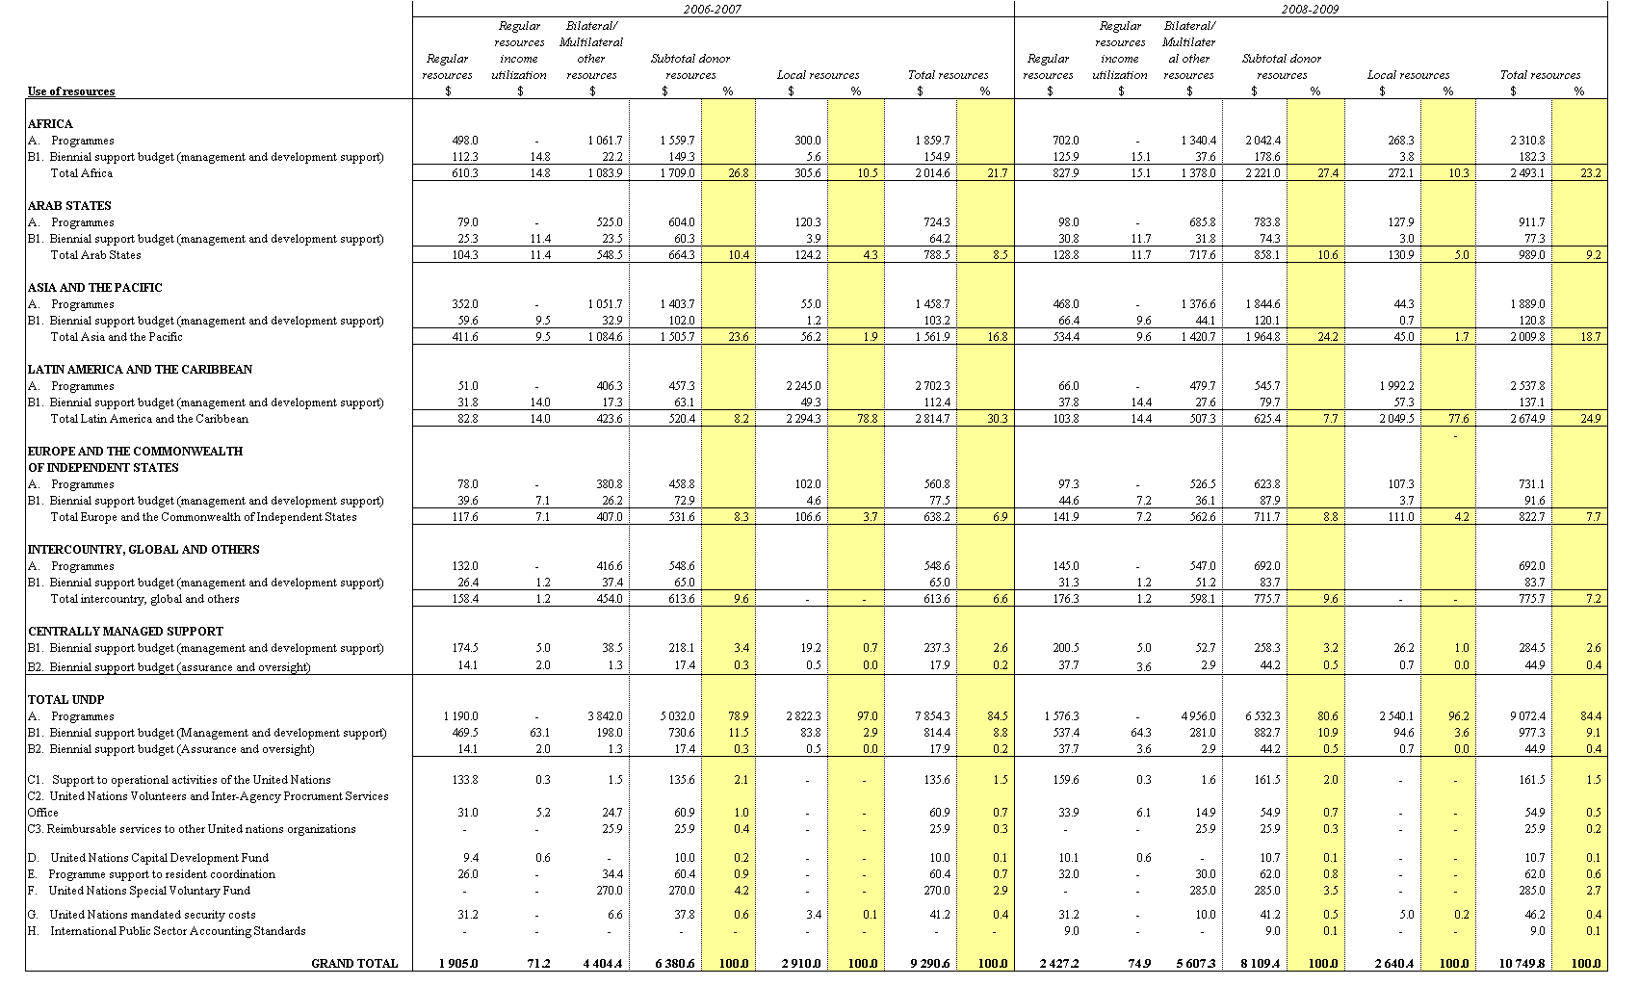
Summary table 2. Proposed changes in senior posts

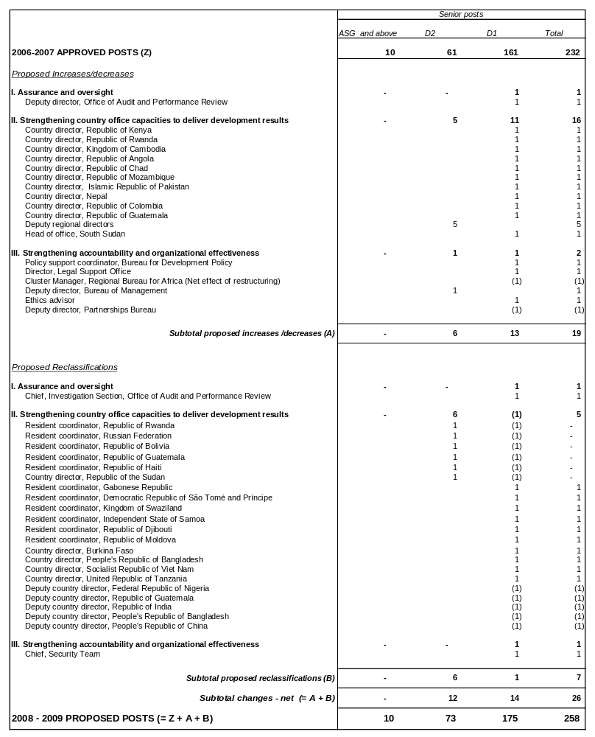

Summary table 3. Proposed budget estimates by function for other resources
(in millions of dollars, nominal)

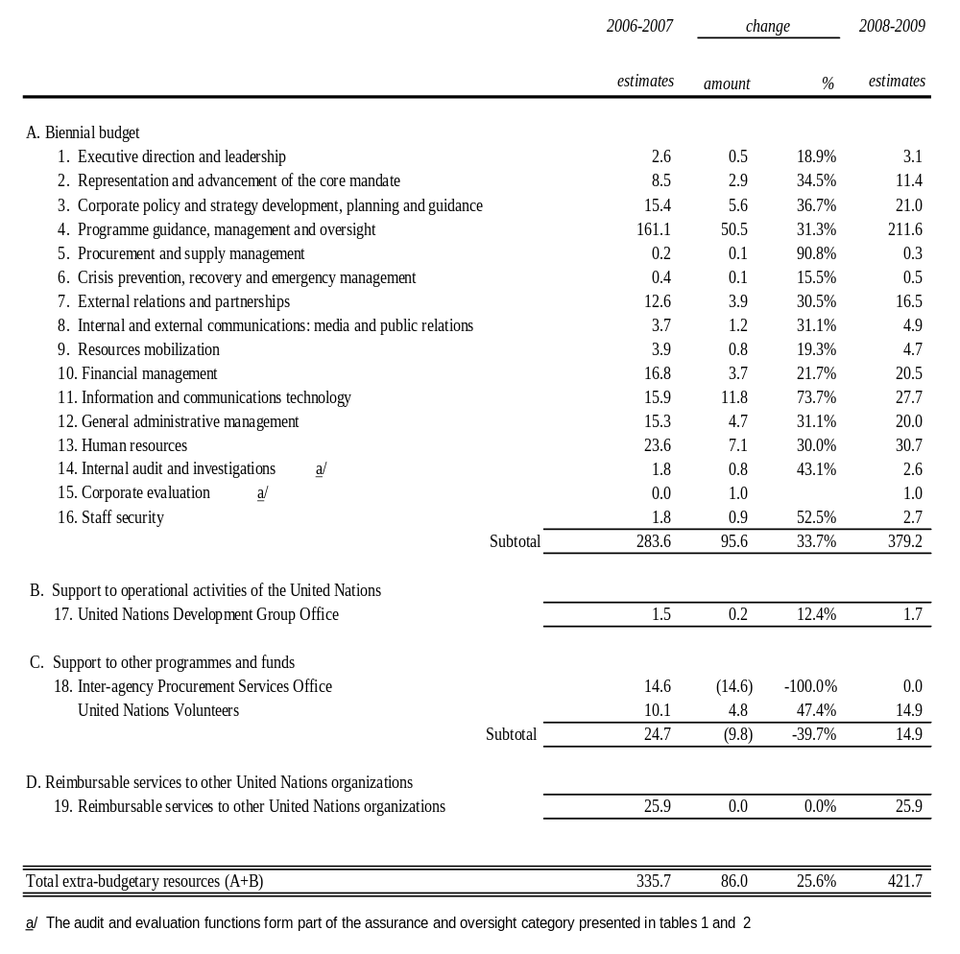

Summary table 4. Posts by location – total resources*
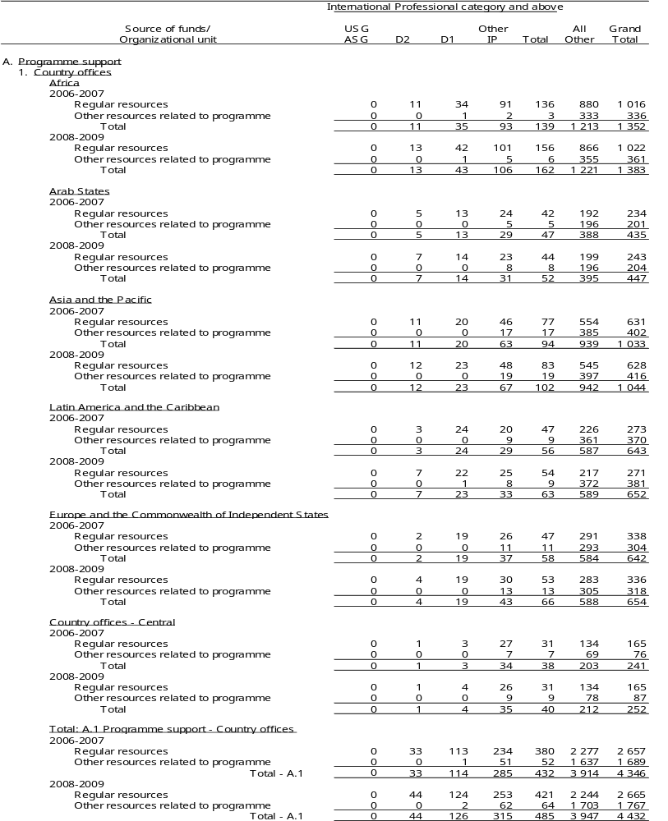
Summary table 4, cont’d

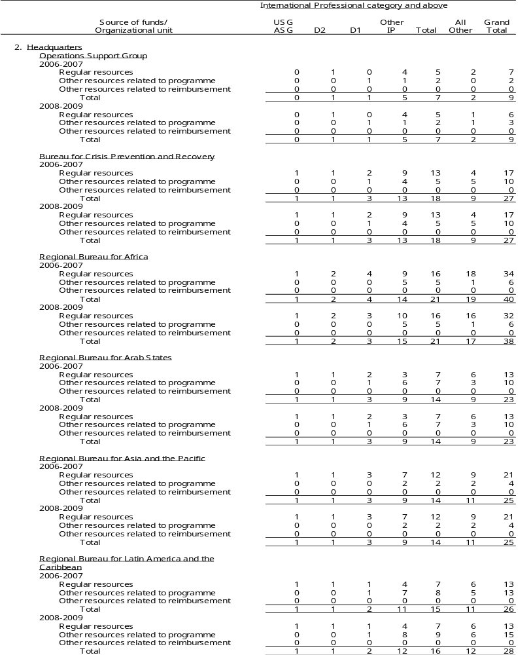

Summary table 4, cont’d
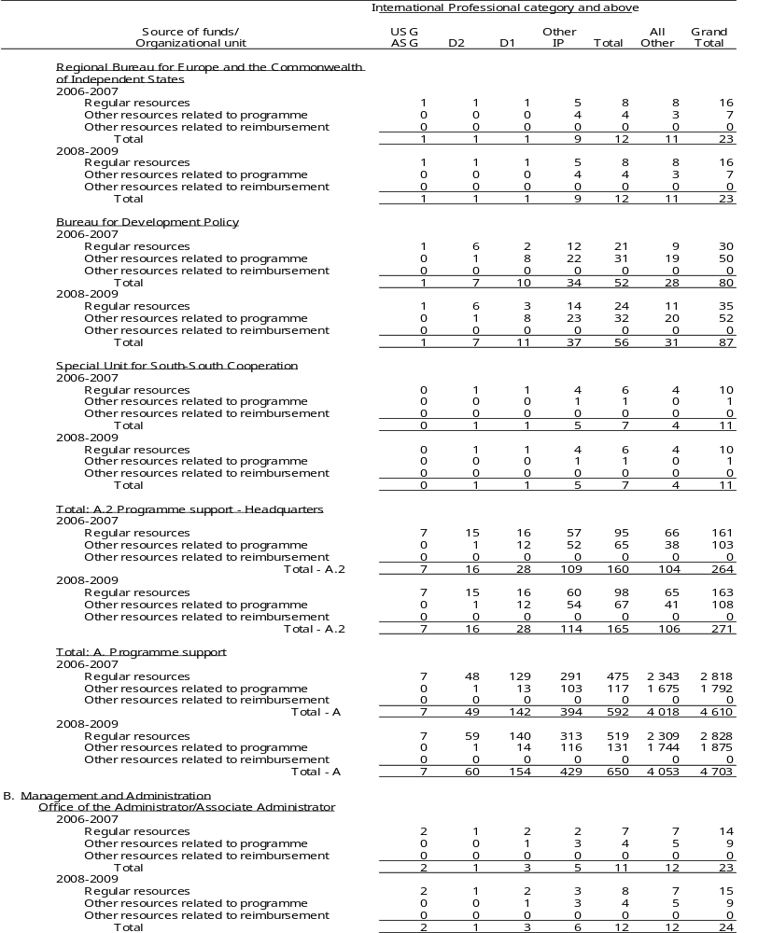

Summary table 4, cont’d

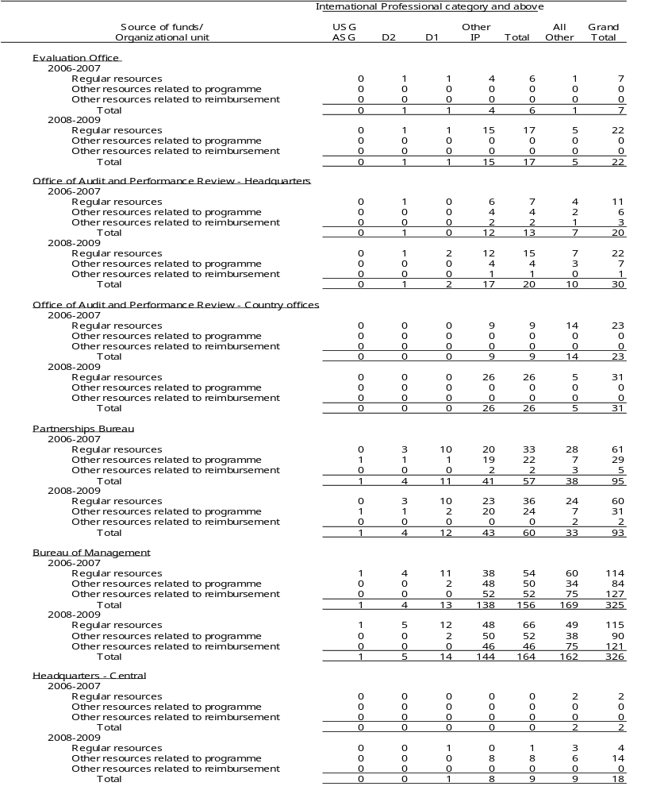

Summary table 4, cont’d
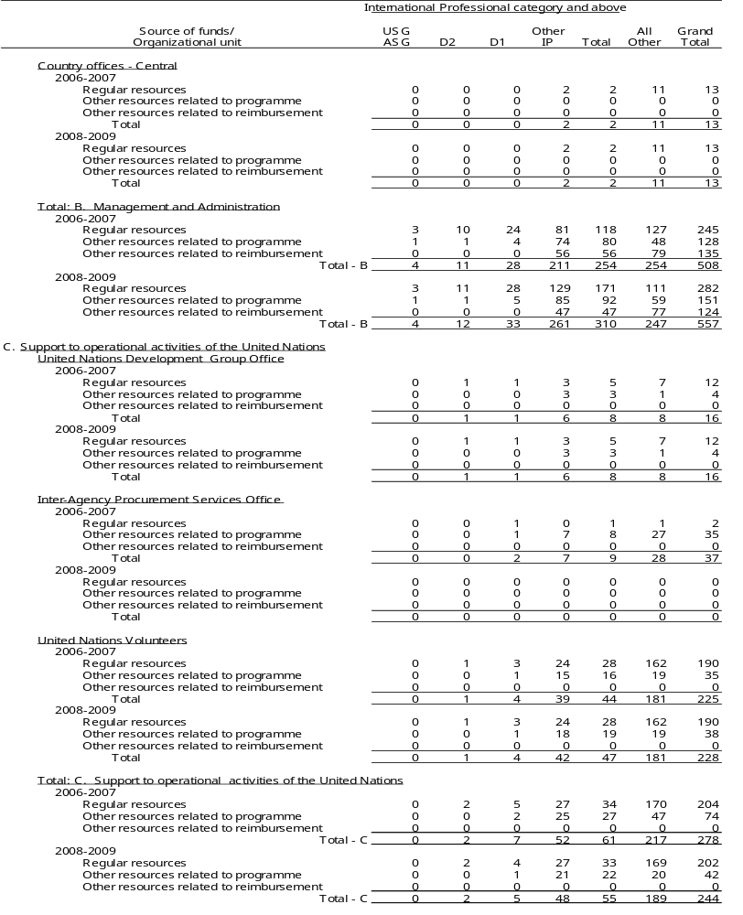

Summary table 4, cont’d

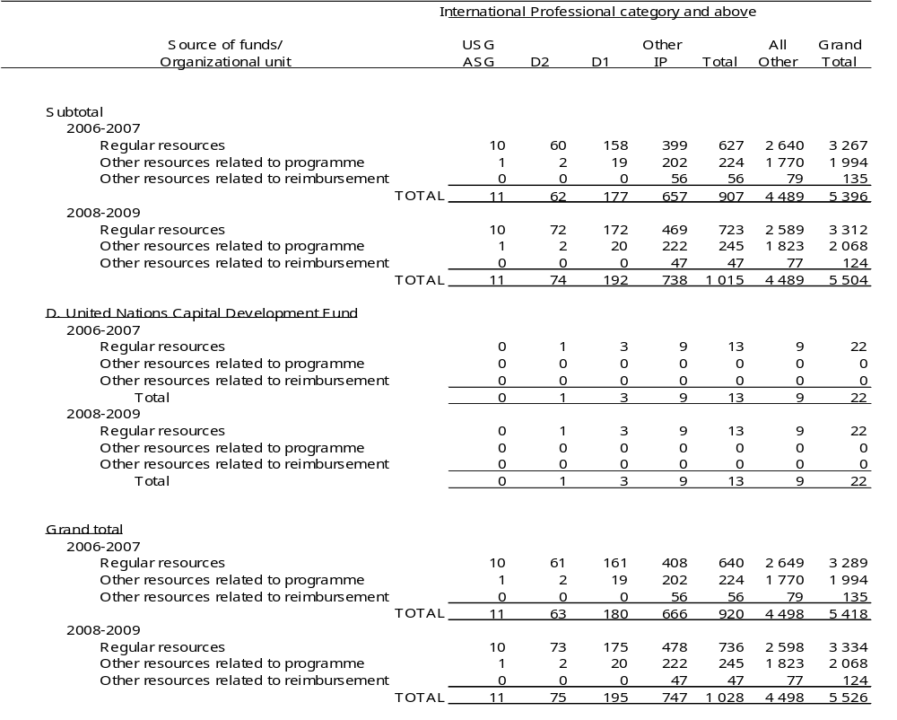

Annex 1
DP/2005/31
ANNEX 3

Actions taken to implement the Advisory Committee on Administrative and Budgetary Questions recommendations as approved by the Executive Board

149. In paragraph 2 of its report on UNDP budget estimates for the biennium 2006-2007 (DP/2005/32), the Advisory Committee on Administrative and Budgetary Questions (ACABQ) expressed its belief there was room to improve and streamline the budget presentation, avoid repetition, and promote greater clarity and transparency. It also requested better justification and rationale on proposals for new posts or reclassifications be provided in related narratives. In paragraph 3, the ACABQ recommended that the process of harmonization towards implementing results-based budgeting for the 2008-2009 biennium be given high priority, and lessons learned by other United Nations organizations with results-based budgeting be taken into account.
150. The Executive Board and the ACABQ have provided guidance on the presentation of more transparent, harmonized and results-based budget estimates. In that regard, a report on results-based budgeting for the biennial support budgets of UNICEF, UNDP and UNFPA – an informal paper presented at the annual session of the Executive Board under financial, budgetary and administrative matters – was prepared and submitted to the ACABQ for review and comments in May 2007. The document contained a harmonized, results-based mock-up budget that was endorsed by the Executive Board. Budget documents of other United Nations organizations prepared in a results-based manner, such as those from DPKO, the World Food Programme, and the United Nations Department of Management, were also reviewed. UNDP has accordingly prepared more streamlined and transparent budget estimates for consideration in DP/2008/3. These estimates better justify and rationalize proposals for new posts or reclassifications in the context of a results-based budget approach, which differs considerably from input-based budgets of previous bienniums.
151. In paragraph 6, ACABQ commented that UNDP should continue to accord priority attention to fundraising activities to increase resources available for programmes. In that regard, all resource contribution estimates reflected in the 2008-2009 resource plan (table 1 of DP/2008/3) are aligned with the strategic plan. The estimated 2008-2009 regular resources contribution estimates of $2.350 billion are considerably higher (23.7 per cent) than the $1.900 billion projected for 2006-2007. Similarly, 2008-2009 bilateral/multilateral other resources contributions of $5.283 billion are higher than the comparable, adjusted projection for 2006-2007 of $4.550* billion. Local resource contribution estimates for 2008-2009 are $2.466 million, or about 5 per cent lower than estimated 2006-2007 local contributions of $2.600 million. UNDP expects to spend $1.218 million, or 16 per cent more on programmes during the 2008-2009 biennium.
152. In paragraph 7, ACABQ noted improvements in channelling more funds to programmes in other resources, and recommended that further efforts be undertaken to reduce expenditure on programme support and administration and management in respect of regular resources, so as to allocate more resources for programmes. During 2008-2009, UNDP anticipates improvement in channelling more regular resources to programmes (reflected in table 1 of DP/2008/3). Whereas for 2006-2007, approximately 71.1 per cent (adjusted from 70.7 per cent**) of regular resources are estimated to be spent on programmes, the corresponding share of regular resources for 2008-2009 is estimated at 73.3 per cent. For bilateral/multilateral donor resources however, the estimated 2006-2007 percentage is 95.1 per cent (adjusted from 93.5 per cent) in comparison to the corresponding estimate of 94.9 per cent* for 2008-2009. This is in line with the need to ensure more equitable burden-sharing of management costs between regular and other resources.
153. In paragraph 12, ACABQ recommended that the Executive Board bear in mind its earlier recommendations that proposals for upward reclassification of posts in United Nations funds and programmes, particularly D1 and D2 levels, be submitted only as a result of significant changes in the level and scope of responsibilities. UNDP conducted a review of the proposed upward post classifications at the D2 and D1 level in 2008-2009, in line with ICSC standards that employ two primary evaluation tools: the master standard, which is a factor-based point rating standard for classification based on the nature of work, the enabling environment, partnerships and results; and the grade level description, which provides a summary of the grade determining characteristics of work and job illustrations for all levels. UNDP also factored in the political, developmental, representational, financial and operational contexts within which these posts function, to confirm that they are reflective of the level and scope of responsibilities of comparable posts classified at these levels. As a result, six posts are proposed for upward classification to D2 at the country level, to include the resident coordinator positions in Bolivia, Guatemala, Haiti, the Russian Federation and Rwanda, and the country director position in Sudan. In addition, 10 posts are proposed for upward reclassification to D1 at the country level, to include six resident coordinator posts and four country director posts. Finally, two headquarters level posts are also proposed for reclassification. Additional details are provided in paragraphs 50-55 of for the present report.
154. In paragraph 13, ACABQ recognized that the staffing component should be viewed in its entirety, including national staff, but was also of the opinion that efforts should be made to hire qualified, skilled professional staff at entry levels so as to ensure rejuvenation of the organization. In that regard, UNDP notes that of the 478 other international professional posts proposed for 2008-2009, 96 (20 per cent) are at the P2/P3 entry levels. This is a net increase of 20 posts over the 76 entry-level posts included in the 2006-2007 support budget.
155. In paragraph 15, ACABQ asked UNDP and DPKO to enhance cooperation and coordination at the field level to avoid fragmented functionalities where peacekeeping missions operate. ACABQ also felt that cooperation and coordination should be effective and enhanced at the managerial and operational levels at headquarters. In that regard, UNDP continues to liaise with DPKO on managerial and operational issues at headquarters, which in turn enhances cooperation and coordination at the field. This is particularly true with respect to human resources and financial matters, as reflected in the memorandum of understanding signed by the two organizations on the cost-sharing of DSRSGs.
156. In paragraph 17, ACABQ indicated that it expected to see tangible results in efficiency gains and savings related to both post and non-post resources, given the considerable expenditure that has been incurred in acquiring state-of-the-art technology. UNDP has benefited in different ways as a result of its decision to migrate to an enterprise resource planning system solution (Atlas), particularly with respect to improved processing speed, enhanced data quality and accelerated reporting in the areas of human resources, finance, procurement, project management, and oversight. This has necessitated the need to strengthen internal controls, increase professionalization of staff and meet additional workload requirements. Additional Atlas benefits are summarized as follows:
(a) Atlas has supported the universal application of human resources related standards and associated transactions in all country offices. Before Atlas, UNDP did not have a system to support human resources transactions, especially with regard to locally recruited staff and related payrolls. The result was limited quality control and transparency.
(b) Atlas has provided a standardized system for procurement purposes and enabled the application of a consistent financial control framework. Previous to Atlas, UNDP lacked a standard procurement system in its country offices and did not have the ability to leverage the Internet for e-procurement.
(c) Atlas has improved transparency and accountability in all transaction-based systems, which in turn has resulted in improved reporting and access to business information, especially on human resources and financial matters.
(d) Atlas has improved the opportunity for real-time programme and project monitoring in line with best international practices.
(e) Atlas has increased the speed of processing transactions across units and in managing currency and bank transactions.
157. In paragraph 20, ACABQ commented on the need for integration, coordination, and rationalization of the security management system to avoid previous duplications of security structures. As the second-largest member of the United Nations security management system, UNDP takes an active leadership role in the CEB, the High-level Committee on Management (HLCM), and the Inter-Agency Security Management Network forums. Through these, UNDP works closely with DSS and other field-based organizations to promote efficient and effective United Nations system activities, while ensuring the safety, security and well-being of staff. UNDP has recently contributed to HLCM technical working groups on surge capacity and cost-sharing arrangements. It also continues to act as a service provider to DSS in the recruitment and administration of international FSCOs, including providing full support at local levels.

Annex 2
Methodology

158. UNDP prepared its biennial support budget according to the results-based approach, where resources are requested based on planned results to be achieved rather than by input category or by broad strategic objective. To start, management results were established in line with management priorities in the strategic plan. Organizational capacity to deliver the results was then assessed, leading to the identification of priority areas that would require additional or new investments, as well as areas where reductions could be realized. The resulting budget was then stated in 2008-2009 terms, incorporating currency and inflationary factors, as well as salary and entitlement-related adjustments.
Establishing management results
159. The first step in developing the biennial support budget was to define key corporate results, performance indicators, baselines and corporate targets within each of the 19 management functions based on the management priorities in the strategic plan. In order to ensure accountability for delivery of planned results, corporate units were designated as ‘corporate sponsors’ for each management function. Corporate sponsors are responsible for leading the process for defining results, performance indicators, baselines and corporate targets within designated management functions, as well as for monitoring, assessing and reporting to senior management on performance against these results. Accountability for delivery of planned results accrues to the concerned operational units at corporate and country office levels.
Assessment of organizational capacities and identification of volume changes
160. The second step in developing the biennial support budget was to assess organizational capacity to deliver the management results, leading to the identification of priority areas that would require investment, as well as areas where efficiency gains could be realized. Based on this assessment, and using the existing organizational capacity as a base, the real increases or decreases in requirements were calculated and designated as volume changes. Volume changes, as defined, represent the controllable elements in the estimates, which are subject to the executive head’s assessment of what resources the organization requires to deliver the results to which it has committed. Such volume changes were calculated at the same price levels as the approved appropriations in order to facilitate comparison with the currently approved base.
Various cost adjustments
161. To the approved appropriations and volume changes are added cost increases or decreases attributable to changes in rates or conditions principally tied to salary and related entitlement cost adjustments. These typically reflect known changes that have occurred in the two years since the preparation of the last biennial support budget. Such cost factors include, for example, decisions of the ICSC on a variety of staff entitlements (such as dependency allowance, education grant) and changes in the average step of posts by grade level. These adjustments may also include estimates to cover within-grade increments for staff if the experience of the organization so warrants. Normally, but not exclusively, such cost adjustments apply to staff costs. An example of this type of cost adjustment for operating expenses would be a change in rate per square foot due to relocation of premises.
Currency adjustments
162. Currency adjustments are then calculated, by year, on the total of approved appropriations, volume and various cost adjustments. Currency adjustments represent the difference between the United Nations operational rate of exchange in effect during the time of preparation of the current biennial support budget and the rate of exchange in effect during the preparation of the proposed budget. This factor is of particular importance given the large number of UNDP country offices where operating costs vary greatly with the strength or weakness of the dollar.
Inflation adjustment
163. To complete the picture and develop the final estimate of requirements for the next biennium, the organization must adjust or estimate inflation over a four-year period. These adjustments are calculated, by year, on the total of approved appropriations, volume and various cost adjustments, as adjusted for currency as follows:
(a) For the first year of the current biennium to the first year of the proposed biennium. The existing estimates already embody earlier estimates of inflation. The inflation adjustment for this transition therefore includes:
(i) The difference between the application of earlier estimates and the actual inflation for the first year of the current biennium;
(ii) The difference between the application of earlier estimates and the revised inflation projection for the second year of the current biennium; and
(iii) The inflation projection for the first year of the proposed biennium.
(b) For the second year of the current biennium to the second year of the proposed biennium.
(i) As in (a) above;
(ii) As in (a) above;
(iii) As in (a) above; and
(iv) The inflation projection for the second year of the proposed biennium.
164. In order to arrive at these estimates of inflation, four inflation factors for each location are adopted for each year:
(a) The estimated movement of post adjustment for international professional staff;
(b) International travel and common staff costs for international professional staff (this is the same for all locations);
(c) Salaries and common staff costs for local staff, i.e., in the national officer, general service and other categories, which may vary significantly from location to location; and
(d) All other costs, such as operating expenses.
165. Within this general framework, New York and Geneva are treated separately from field offices. For these locations, the rates used are the same as those used by the United Nations unless specific contractual commitments differ.
166. Apart from a limited number of cost elements such as international travel and the common staff costs of international staff, the inflation factors for field offices must be location-specific. Estimates are compared with past experience and current global patterns and/or information available and published before being applied to the budget estimates.

Annex 3

Terminology
(Terms upon which common agreement has been reached and their corresponding definitions are given below)
Appropriation line (definition similar to those included in the financial regulations of UNDP, UNFPA and UNICEF): A subdivision of the appropriation for which a specific amount is shown in the appropriation decision and within which the executive head of an organization is authorized to make transfers without prior approval.
Augmentation: Incremental capacity above base structure, defined subject to the volume of resources managed by the organization and the complexity of operating environment; represents variable costs of the organization. Funding of augmentation is to be proportionately aligned between regular and other resources.
Base structure: Minimum capacity that the organization needs in order to be able to deliver on its core mandate; represents part of the fixed costs of the organization. The base structure of the organization is always funded from regular resources and was introduced in document DP/2003/28.
Biennial support budget: The budget of the organization covering a set of functions that support the operational activities of the organization over a two-year period based on a set of defined results derived from the strategic plan.
Cost (increase/decrease): Any increase or decrease in the cost of a resource input in the budget period compared with that in the previous budget period, arising from changes in costs, prices and exchange rates.
Cost classification: Set of criteria and the process of determining programme implementation vs. administration costs, and clarifying distinctions between those.
Cost, mandatory: Cost of a resource input, or any increase thereof during the biennial support budget period, mandated by specific decisions, legislated by the United Nations General Assembly and/or the Executive Board.
Enterprise resource planning: A management information system that integrates and automates business practices associated with the operations of an organization; or multi-module application software that helps an organization to support such systems; or combination of the above.
Extrabudgetary resources: Funds that accrue to the organization as a result of the application of the cost recovery policy to other resources donor-funded projects and programmes for the recovery of general management services provided therein. Also applies to funds recovered for reimbursable services provided to United Nations organizations by UNDP headquarters units and country offices.
Function: A group of activities funded by the biennial support budget that directly supports the management of the organization whose ultimate objective is to ensure development results.
Gross budget: For voluntarily funded organizations, the budget in which staff costs are estimated on a net basis (i.e., exclusive of staff assessment) and all other costs are estimated on a gross basis, i.e., inclusive of income tax payments for staff, total local office costs and costs of services to be rendered.
Local posts: Refers to national professional and general service level posts.
Management and administration of organization: Organizational units whose primary function is the maintenance of the identity, direction and well-being of an organization. This will typically include units that carry out the functions of executive direction, organizational policy and evaluation, external relations, information and administration.
Net budget: For voluntarily funded organizations, the budget which reflects estimates of income to be expected which offsets, in whole or in part, the related gross budget estimates.
Other resources: Resources of a voluntarily funded organization, other than regular resources, that are received for a specific programme purpose (other resources relating to programmes) and for the provision of specific services to third parties (other resources relating to reimbursements).
Other resources relating to programmes: Resources of a voluntarily funded organization, other than regular resources, that are received for a specific programme purpose that is consistent with the aims and activities of the organization. These will include voluntary contributions, other governmental or intergovernmental payments, donations from non-governmental sources and related interest earnings and miscellaneous income.
Other resources relating to reimbursements: Resources of a voluntarily funded organization that are received from third parties to cover the cost of providing specific services not relating to carrying out programmes entrusted to it for implementation.
Practice approach: A culture of knowledge-sharing that facilitates organizational learning, promotes exchange of experiences and ideas, and enables capacity development across a global network. The practice architecture is horizontal (without hierarchies) and all staff can equally participate, contribute and benefit, thereby strengthening the capacity of UNDP to support programme countries.
Prince2: A process-based approach for project management providing an easily tailored and scaleable method for project management, where each process is defined with its key inputs and outputs together with the specific objectives to be achieved and activities to be carried out.
Programmes: Direct inputs needed to achieve the objectives of a specific project or programme for development cooperation. This may typically include experts, support personnel, supplies and equipment, subcontracts, cash assistance and individual or group training.
Programming arrangements: The legal framework containing the principles and parameters for the distribution of regular resources supporting development activities.
Programme effectiveness: Activities that are primarily related to the development, formulation, delivery and evaluation of an organization’s programmes. This will typically include backstopping of programmes on a technical, thematic, geographic, programmatic and advisory basis.
Proportionality: State of resource mobilization and deployment, which ensures proportionate funding between regular and other resources in funding operational costs above the base structure.
Proportionality shift: A shift of costs from regular to other resources with the objective of achieving proportionality.
Regular resources: Resources of a voluntarily funded organization that are co-mingled and untied. These will include pledges of voluntary contributions, other governmental or intergovernmental payments, donations from non-governmental sources and related interest earnings and miscellaneous income.
Various cost adjustments: Cost increases/decreases attributable to changes in rates or conditions not tied to currency or annual inflation adjustments.
Volume (increase/decrease): Any increase or decrease in resource requirements attributable to changes in the level or nature of activities carried out by an organization during the current budget period and those proposed for the forthcoming budget period. Volume is expressed using the same cost factors applicable for the approved appropriations to permit direct comparison of these changes relative to the level of activities approved for the current budget period.

Annex 4

Abbreviations and acronyms

ACABQ Advisory Committee on Administrative and Budgetary Questions
ASG Assistant Secretary-General
BCPR Bureau for Crisis Prevention and Recovery
BDP Bureau for Development Policy
BOA United Nations Board of Auditors
DEX Direct execution
DSRSG Deputy Special Representatives of the Secretary-General
DSS United Nations Department of Safety and Security
FSCO Field Security Coordination Officer
FDQD Financial data quality dashboard
GLOC Government contributions to local office costs
GNI Gross national income
HQPSS Headquarters Products and Services Survey
IAPSO Inter-Agency Procurement Services Office
ICSC International Civil Service Commission
ICT Information and communications technology
IPSAS International Public Sector Accounting Standards
JIU Joint Inspection Unit
LEAD Leadership development programme
MAIP Malicious acts insurance programme
MDG Millennium Development Goals
MOSS Minimum Operating Security Standards
NEX National execution
OAPR Office of Audit and Performance Review
OFA Office of Finance and Administration
OIST Office of Information Systems Technology
OPB Office of Planning and Budgeting
OSG Operations Support Group
PAPP Programme of Assistance to the Palestinian People
RBA Regional Bureau for Africa
RBAP Regional Bureau for Asia and Pacific
RBAS Regional Bureau for Arab States
RBB Results-based budgeting
RBEC Regional Bureau for Europe and the Commonwealth of Independent States
RBLAC Regional Bureau for Latin America and the Caribbean
RBM Results-based management
RCA Results and Competency Assessment
SRF Strategic Results Framework
SU/SSC Special Unit for South-South Cooperation
TCPR Triennial comprehensive policy review
TRAC Target for resource assignment from the core
UNCDF United Nations Capital Development Fund
UNDAF United Nations Development Assistance Framework
UNDG United Nations Development Group
UNDGO United Nations Development Group Office
UNFPA United Nations Population Fund
UNICEF United Nations Children’s Fund
UNIFEM United Nations Development Fund for Women
UNOPS United Nations Office for Project Services
UNV United Nations Volunteers
USG Under-Secretary-General

Real terms represent a restatement in constant 2005 dollars using the Organisation for Economic Co-operation and Development / Development Assistance Committee (OECD/DAC) composite deflators for historical data and a 4 per cent annual discount factor for 2006 and future years.
Derived by dividing the $156 million in this category over two year contribution estimates based on General Assembly report A/62/326. Estimates are based on the assumption that the United Nations share of official development assistance remains constant at 15 per cent in 2008-2009, while official development assistance increases annually as per DAC projections.
The $155.7 million is comprised of $9.5 million in new investments in support of operational activities of the United Nations system, $0.3 million in related cost adjustments, plus $145.9 million, representing 28 per cent of $520.9 million of country office costs. This percentage is defined in paragraphs 135 to 139.
The subject of proportionality was referred to specifically in the context of Executive Board decisions 2003/22, 2004/30, 2055/33, 2005/18, 2006/30, and 2007/18.
See Executive Board decision 2003/22.
In the 2006-2007 biennial support budget, 12 new country director posts were established. In the context of the present submission, it is now proposed that these posts to be considered as part of the base structure of UNDP.
The average data of user satisfaction with the strategic results framework/results-oriented annual report, results-based management system and balanced scorecard.
Knowledge products include UNDP strategy/ policy notes, policy briefs, guidance notes, briefing notes, ‘how-to’ guides, resource kits, United Nations partnership and resource guides, practice network knowledge map, comparative experience reports/maps, and good practices and lessons learned.
Corporate certifications include finance, human resources, procurement and Prince2.
Four certification lines include Prince2 for programme/project managers, procurement, human resources and finance certifications.
Indicators will be included upon completion of the review process and issuance of recommendations.
* Please note: This table is provided for reference only and is presented in a format used in previous bienniums.
* The resource plan for 2006-2007 originally presented in DP/2005/31 has been revised in DP/2008/3 to reflect a higher level of bilateral donor contributions than previously estimated – from $3.00 billion to $4.55 billion, and similarly a higher level of bilateral donor funded programme expenditure – from $2.84 billion to $3.84 billion.
** Adjusted based on the 2007 workload study.

