Annual session 2007
11 to 22 June 2007, New York
Item 3 of the provisional agenda
Funding commitments

Status of regular funding commitments to UNDP and its

associated funds and programmes for 2007 and onwards*

Summary
In decision 98/23, the Executive Board designated its second regular session each year, starting in 1999, as the time to review the status of regular funding commitments to UNDP and its associated funds and programmes. In line with that decision and building on the approach taken in that context, the present report presents the status of regular funding commitments for 2007 and onwards, and a summary of the provisional income for regular and other resources received in 2006.
Elements of a decision
The Executive Board may wish to note that after exceeding the annual targets for 2004 and 2005, UNDP has not been able to meet the third (2006) annual funding target of its second multi-year funding framework (MYFF), covering the period 2004-2007. Current projections suggest, however, that meeting the overall MYFF target by 2007 – the end year of the current cycle – is within reach.
The Executive Board may wish to stress that regular resources form the bedrock of UNDP finances and to request all countries that have not yet done so to provide contributions to regular resources for 2007.
The Executive Board may also wish to encourage those countries that have already made their contributions to consider supplementing their 2007 contributions, if they are in a position to do so, so as to regain the momentum in rebuilding the regular resource base of UNDP.
The Executive Board may further wish to encourage Member States to announce pledges, on a multi-year basis if feasible, and payment schedules for the new planning cycle covering the period 2008-20011, and to adhere to such pledges and payment schedules thereafter.

*The compilation of data required to provide the Executive Board with the most current information has delayed submission of the present report.

I. Introduction

1. The upward trend in contributions to regular (core) resources, initiated in 2001, was consolidated in 2006 after five consecutive years of growth. The $924 million gross regular income reached the same level attained in 2005, falling short, however, of the $1 billion interim target set by the multi-year funding framework (MYFF 2004-2007) for 2006. Volume increases in regular contributions in nominal local currency terms and exchange rate gains were offset by shortfalls with respect to actual 2006 payments.

2. The total income of UNDP and its associated funds and programmes reached almost $4.8 billion in 2006, with other (non-core) contributions to UNDP itself reaching nearly $3.8 billion. Non-core (earmarked) contributions from bilateral Development Assistance Committee of the Organisation for Economic Co-operation and Development (OECD/DAC) donor governments surpassed $1 billion. Virtually all OECD/DAC donors are active in co-financing UNDP programmes. Non-core resources entrusted to UNDP by non-bilateral partners, such as the European Commission, the World Bank and the Global Fund to Fight Aids, Tuberculosis and Malaria reached close to $1.2 billion. Local resources, channeled through UNDP by programme country governments and other local partners in support of their own national development, amounted to close to $1.4 billion, an increase of 24 per cent compared to 2005. As aid mechanisms available at the country level diversify and multiply, UNDP continues to be called upon to support governments to obtain, direct and manage different types of funding in accordance with national priorities.
3. Other (earmarked) resources represent an important complement to the regular resource base of UNDP. However, with non-core income far outpacing core income growth, as illustrated in figure 1 below, the ratio of earmarked to un-earmarked resources remains unbalanced. The ability of UNDP to fulfil its mandate and deliver effective capacity building support for development, including with the help of earmarked funding, critically depends on a level of core funding sufficient to enable UNDP to pursue flexible, integrated management approaches focused on long-term effectiveness and sustainability.
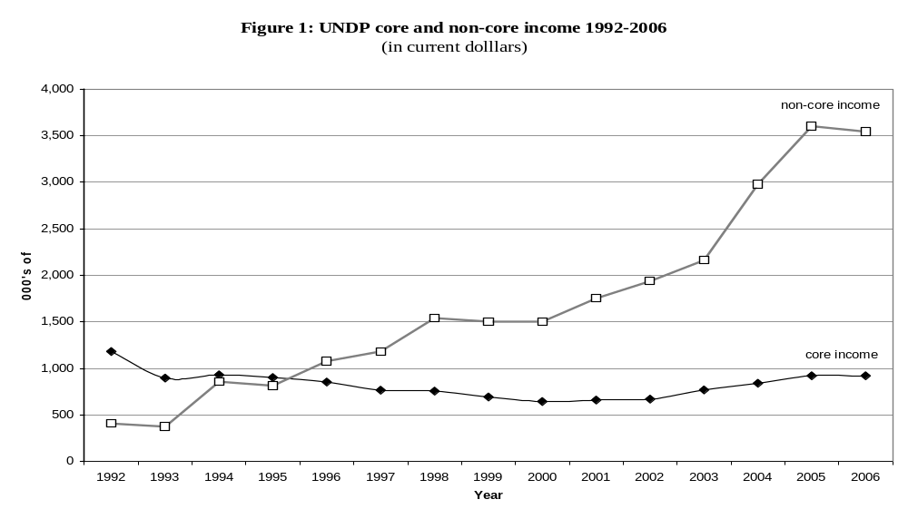

II. Background

4. In decisions 98/23, 99/1 and 99/23 – reaffirmed in decisions 2002/9, 2002/18, 2003/24, 2004/14 and 2005/20 – the Executive Board put in place a funding system for UNDP designed to foster a continuous, transparent dialogue on regular funding; to facilitate the mobilization of adequate regular resources; and to enhance predictability. Within this framework, the Board adopted an annual funding target of $1.1 billion by 2007 and stressed the urgent need to achieve annual increases until the target is met. In decisions 2003/8, 2003/11 and 2004/29 the Board welcomed the encouraging but modest increase in contributions to regular resources, but recognized that the level of growth falls short of the agreed target.
5. The MYFF for the period 2004 to 2007, endorsed by the Board in its decision 2003/24, reaffirms the critical importance of securing an adequate level of regular resources. As reflected in the first and second reports on the MYFF (DP/2005/16 and DP/2006/18, respectively), the gross regular resource income achieved in 2004 and 2005 exceeded the respective annual MYFF targets. In decisions 2005/23 and 2006/24, the Board welcomed the fact that UNDP had met the first and second annual funding targets, and noted that a stable, adequate base of regular resources was within reach, provided that UNDP continued to follow the directions of the MYFF and that Member States not only sustained but increased their funding efforts over the full period of the MYFF. The Board also noted with concern that the projected level of growth could fall short of the agreed target for 2006, and again urged countries in a position to do so to increase their core funding to UNDP to contribute to the attainment of this target.

6. The United Nations Capital Development Fund (UNCDF). The current UNCDF business plan and the UNDP draft strategic plan, 2008-2011, underscore the strategic importance of the UNCDF investment mandate and its focus on the least developed countries (LDCs). In 2006, UNCDF programmatic investments in local development and microfinance grew to $25 million and are planned to increase further to $41 million for 2007 to support joint UNCDF and UNDP programmes in 35 LDCs. To reach its programmatic objectives for 2008-2011, UNCDF will require a substantial increase in programme resources. Against this background, UNDP and UNCDF are exploring alternative financing options that would allow UNCDF to achieve an appropriate level of predictable core funding for its investment activities in the LDCs during the strategic plan period.
7. The United Nations Women’s Fund (UNIFEM). The UNIFEM strategic plan, 2008-2011, has been crafted at a watershed moment in United Nations support for gender equality and women’s empowerment. The leadership of the United Nations has articulated its endorsement for enhancing the coherence, authority, status and resources of the entities that provide technical support for gender equality in the United Nations system. Member States are debating the guidance that they will provide on strengthening the United Nations architecture that supports gender equality in the context of United Nations reform. Without preempting guidance from Member States, UNIFEM has devised a strategic plan that will enable it to move forward in implementing its core business: supporting countries to advance gender equality and women’s empowerment in line with their national priorities. Linking normative commitments to operational realities will be a primary contribution of UNIFEM to demonstrating the ‘how’ of achieving gender equality at the country level; to achieving greater synergy and coherence in the work of the United Nations; and, ultimately, to attaining the MDGs by 2015.
8. The United Nations Volunteers programme (UNV). UNV actively promotes and advocates for volunteerism as a development concept – ‘Volunteerism for Development (V4D)’. The UNV business model, which guides its collaboration with partners, comprises three overlapping clusters of activities: (a) advocating for the concept of V4D; (b) pursuing the integration of V4D into partners’ development planning and programming; and (c) the mobilization of volunteers, including but not limited to UNV volunteers. At the heart of this approach is the conviction that voluntary action by millions of people in programme countries and elsewhere is a vastly under-recognized and under-utilized resource that needs to be engaged strategically if the challenge of attaining the MDGs is to succeed. By implementing its business model, UNV can make distinctive contributions to development effectiveness in three areas in particular: (a) improving access to opportunities, services and service delivery for disadvantaged groups and communities, and enhancing the delivery of such services; (b) inclusion and active participation of all stakeholders, in particular the disadvantaged, in processes that affect their well-being; and (c) community mobilization through voluntary action to address local development issues. In 2006, more than 7,600 women and men from 163 countries served as UNV volunteers in 144 countries. 76 per cent of the volunteers were nationals of developing countries, reaffirming the UNV programme as a concrete expression of South-South cooperation. In financial terms, the magnitude of the programme surpassed $175 million, some 3 per cent of which was financed from the Special Voluntary Fund (SVF).

III. Preparatory process

9. At the beginning of May 2007, the secretariat of the Executive Board wrote to all States members of UNDP to outline the preparatory process for the annual funding meeting, 2007. In line with Executive Board decisions 98/23 and 99/1 – reaffirmed in decisions 99/23, 2000/1, 2002/9, 2004/14, 2005/23 and 2006/24 – members were requested to communicate in writing their voluntary contributions for UNDP and its associated funds and programmes and were encouraged to provide multi-year pledges and fixed payment schedules. As with previous annual funding meetings, members of the Programme were encouraged to address three of the five main elements of Executive Board decision 98/23: volume of regular resources; predictability; and measures to reduce financial dependence on a limited number of donors.
10. As of the time of preparing the present report, 41 countries already indicated their 2007 pledges and, in a few cases, for 2008 as well. However, a number of State members were not yet in a position convey their pledges. Tables 1 and 2 in the statistical addendum to this report have been prepared based on the information received and on the best estimates of the secretariat concerning 2007 contributions. Table 3 in the addendum provides information on government in-kind contributions. It is important to bear in mind that all 2006 figures are provisional and subject to modification upon confirmation of actual income figures for the year.

- Volume

A. Regular resources
11. Following five consecutive years of increases in since 2001, when they increased for the first time after seven years of steady decline, UNDP regular resources stagnated in 2006. Provisional data show that contributions to regular resources for 2006 reached $924 million with the Netherlands, Sweden, Norway, the United States and the United Kingdom, in that order, being the five largest donors in absolute dollars terms. Current projections suggest that almost all OECD/DAC donors will either maintain or increase their contributions in 2007. Based on the official United Nations exchange rates as at 1 May 2007, contributions are expected to approach the MYFF target of $1.1 billion.
12. Thirteen OECD/DAC members increased their contributions to regular resources in 2006, a number of them for the fifth consecutive year. Spain doubled its contribution, and two other donors – Ireland and Luxembourg – increased theirs by 20 per cent or more. Two – Norway and the United Kingdom – increased their contributions by 10 per cent or more. Two were unable to contribute to the core budget at all. Seven – Austria, Finland, Luxembourg, Spain, Sweden, the United Kingdom and the United States – increased their contributions annually over the full period of the MYFF. Exchange rate fluctuations had a modest positive effect on UNDP core income, accounting for approximately 5 per cent of the increased contributions in regular income in 2006.
13. The political commitment of Member States to an enhanced regular resource base for UNDP is also reflected in the fact that 33 programme countries made contributions to the regular resources of the organization in 2006, including 12 which increased or resumed contributions, often despite considerable internal constraints. In 2005, 37 programme countries made contributions to regular resources, with 15 increasing or resuming contributions. Five programme countries – China, Cuba, India, Republic of Korea and Saudi Arabia – contributed in excess of $1 million to UNDP regular resources in 2006.

14. Historical and projected income figures for UNDP are expressed traditionally in nominal terms (dollars, at current values) and cannot capture the variation in the real value of UNDP income resulting from inflation and exchange rate variations. While core income expressed in nominal terms has increased by 10 per cent between 2004 and 2006, real core income adjusted for both inflation and the performance of the dollar vis-à-vis other currencies grew by less than 5 per cent during this period (figure 2). The UNDP funding base remains exposed to exchange rate fluctuations. Reducing this vulnerability and mobilizing an adequate, predictable level of regular resources remains a top priority.

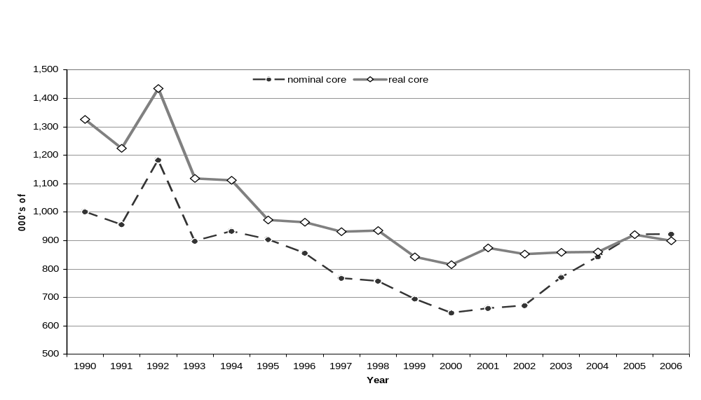
15. The Executive Board recognized, in its decision 2002/16, that the ability of UNDP to fulfil its mandate and to preserve its multilateral, impartial and universal character depends on its having an adequate and secure regular funding base. The issue of restoring growth and enhancing predictability to the regular funding of United Nations development activities has been discussed widely, including in the context of the Triennial Comprehensive Policy Review (E/2004/5) and General Assembly resolutions 56/201 and 59/250. The funding of United Nations development activities also forms an integral part of the recommendations of the Secretary General’s High-level Panel on United Nations System-wide Coherence.
B. UNDP other (non-core) resources
16. Other (‘non-core’) resource contributions decreased slightly in 2006. Provisional data show that total non-core contributions reached $3.79 billion, a slight decrease compared with the level achieved in 2005. Bilateral contributions from OECD/DAC donor governments amounted to almost $1.029 billion. Virtually all OECD/DAC donors are active in co-financing UNDP programmes. In addition, non-core resources entrusted to UNDP by non-bilateral partners and multilateral funds, such as the European Commission, the World Bank and the Global Fund to Fight Aids, Tuberculosis and Malaria, reached $1.2 billion. Local resources, channelled through UNDP by programme country governments and other local partners in support of their own national development, amounted to $1.4 billion, an increase of 24 per cent compared to 2005. Other (‘non-core’) resources represent an important complement to the regular resource base of UNDP; however, regular and other resources are not interchangeable. Non-core resources represent earmarked contributions to specific themes, programmes and activities, and tend to be geographically concentrated.
17. UNCDF.: In 2006, UNCDF achieved its programmatic results and outcomes but was less successful in achieving its resource mobilization targets. Contributions to UNCDF (core and non-core) totalled $22 million in 2006. Core resources increased from $9.5 million in 2005 to $13.9 million in 2006. This growth reflected a 40 per cent increase in the number of core donors contributing to the Fund, and increased contributions from existing core donors. Non-core contributions decreased from $10.3 million in 2005 to $8.1million in 2006. That notwithstanding, projections of non-core contributions indicate that the trend of increasing levels of non-core resources that started in 2003 will continue, and may surpass the $15 million mark in 2007.
18. UNIFEM. Under the previous multi-year funding framework (MYFF) through 2004-2006, UNIFEM total resources increased 14 per cent, from $49.2 million in 2004 to $56.3 million in 2006. UNIFEM raised a total of $160 million over the three years, against a projected $121.3 million anticipated in the MYFF. The increase was largely due to the expansion of non-core resources, from $25.9 million in 2004 to $31.3 million in 2006. On the other hand, core resources stagnated, moving from $23.2 million in 2004 to $25 million in 2006. This is reason for concern, as core resources constitute the bedrock of UNIFEM work and its ability to plan effectively. UNIFEM is looking to a broad array of donors for core funding support in 2007 to enable it to achieve the results outlined in its strategic plan and to advance gender equality worldwide in the context of the MDGs. As the demand for UNIFEM technical assistance, gender expertise and policy advocacy continues to grow; it is vital that it receive the funding levels necessary to realize its mandate.
19. UNV. The importance of the SVF as the primary means through which UNV can continuously develop innovative approaches to increasing the relevance and effectiveness of its work cannot be overemphasized. The SVF – even though a small fund – enables UNV to test ways in which domestic and international volunteerism can best be harnessed as a strategic force in support of the MDGs. By mobilizing an increasingly broad range of volunteers for development and peace, extending the integration of volunteerism into development programming, and scaling-up its global advocacy work, the contribution of UNV towards achieving the MDGs will be maximized. Contributions to the SVF reached $ 5.5 million in 2006, slightly higher than half the optimal level of $10 million per annum endorsed by the Executive Board in June 2004.

- Predictability

20. The voluntary nature of core income exposes UNDP to the volatility of official development assistance (ODA) flows. While UNDP core resources account for less than 1 per cent of total ODA, historical evidence indicates that UNDP core income has been closely correlated with overall ODA trends. Based on past evidence and expressed in real terms, UNDP core income has been particularly responsive to reductions in ODA while only moderately responsive to increases in ODA. In the period 1992-1997, a 20 per cent decrease in ODA was accompanied by a more-than-proportional 35 per cent decrease in core contributions to UNDP, whereas in the period 2000-2005, a 49 per cent increase in ODA was accompanied by a less-than-proportional 10 per cent increase in real contributions to the core. Based on the decline in ODA observed in 2006, the 2006 growth pattern for UNDP core income (corresponding with a decline when adjusted for both inflation and exchange rate variations) is consistent with the historical trend described above.
21. As reflected in General Assembly resolution 59/250 on the Triennial Policy Review of Operational Activities for Development of the United Nations System, and as outlined in Executive Board decision 98/23 – and reaffirmed in decisions 99/1, 99/23, 2002/9, 2004/29, 2005/23 and 2006/24 – Member States are encouraged to provide multi-year pledges in order to enhance the predictability of regular resources. At the time of writing, 41 countries had made indicative pledges for 2007, 11 of which are OECD/DAC donors. Ten OECD/DAC donors now pledge their core contributions on a multi-year basis, thus expressing their strong political support to the organization. A number of the multi-year pledges cover the full MYFF period, and one also entails commitments for annual increases. As the organization nears the end of the second MYYF period, it is critical that donors commit to new multi-year pledges to ensure the predictability of resource flows beyond 2007. Members unable to provide a multi-year pledge formally – owing to national legislative or other restrictions – are encouraged to provide indicative amounts for forthcoming years.
22. The Executive Board determined, in its decision 98/23, that the predictability of core resources could be enhanced if States members of the Programme announced specific payment schedules, with early payment encouraged. In paragraph 12 (b) (iii) of its decision 98/23, the Board decided, inter alia, to review, at the funding meeting, the timing of payments made in the previous calendar year. In 2005, a total of 11 OECD/DAC donor countries provided fixed payment schedules (the same number as in 2003 and 2004), compared to 14 that indicated fixed schedules in 2002 and 15 that did so in 2000. However, of the 11 OECD/DAC countries that provided payment schedules in 2003, 2004 and 2005, many did not pay according to the payment schedule provided. By July 2006, 63 per cent of estimated gross income had been received, compared with 60 per cent in 2004, 47 per cent in 2003 (the last year of the previous MYFF cycle) and 54 per cent in 2000. Although a number of donors paid significant proportions of their pledges in the last quarter, the operational reserves did not have to be used.
23. In the statistical annex presented in conjunction with this document, table 3 provides a payment schedule for 2007 contributions communicated to the Executive Board secretariat at the time of writing this report. The secretariat notes with appreciation the efforts to date on the part of those OECD/DAC donors that communicated payment schedules, as well as the efforts made by four OECD/DAC members to pay their contribution early and in full. Member States that have not already done so are strongly encouraged to inform the secretariat of their intended payment schedules, including, where possible, early payment. All members are encouraged to adhere to the same schedule in terms of currency and timing of payments.

- Reducing over-dependence on a limited number of donors

24. In its decisions 98/23 and 99/1, the Executive Board recognized that overdependence on a limited number of donors carries risks for the long-term financial sustainability of UNDP. Accordingly, it urged all donors and programme countries in a position to do so – most recently in its decision 2005/23 – to increase their contributions to regular resources. It is estimated that the top 10 donors to UNDP will provide close to 81 per cent of total 2007 regular resources. In 2000, the top 10 donors accounted for 86 per cent of total contributions to regular resources. With the aim of reducing overdependence and broadening the donor base, the Administrator continued to reach out systematically in both donor and programme country capitals, as well as regional and international forums, to build commitment for common action to ensure that the resource base of the organization is rebuilt to agreed target levels.
25. Many programme countries contribute to reducing overdependence by providing UNDP with: (a) contributions to regular resources; (b) government cash contributions towards local office costs (GLOC)_; and (c) government in-kind contributions – such as rent-free office premises – in addition to providing substantial resources to UNDP programmes in their respective countries. The total amount of regular resource contributions from programme countries after the application of the accounting linkage to GLOC amounted to approximately $15.6 million in 2006, a decrease of 14 per cent compared with the 2005 level. As many as five programme countries contributed $1 million or more.
26. UNCDF. The efforts of UNCDF to expand its donor base and improve burden-sharing showed some positive results in 2006, but more must be done to achieve that objective. UNDP and UNCDF are exploring alternative financing options that would allow UNCDF to achieve an appropriate level of predictable core funding for its investment activities in the LDCs during the 2008-2011 period, while improving burden-sharing. Furthermore, the 2008-2009 biennial support budget for UNCDF will likely continue to be included in the biennial support budget of UNDP.
27. UNIFEM. Efforts to diversify and increase UNIFEM non-core resources continued to show positive results. In addition, contributions to trust fund modalities increased to $4.8 million in 2006, compared to $4 million in 2005, driven particularly by higher contributions to the UNIFEM-managed United Nations Trust Fund in Support of Actions to Eliminate Violence against Women. UNIFEM is also seeing results from efforts to mobilize resources locally and through private sector partnerships.

VII. Conclusions

28. Notwithstanding the 2006 consolidation, the increase in regular resources since 2001 and the significant increase in other (non-core) resources, particularly since 2003, give a clear indication of the political support extended to UNDP by Member States. If the organization is to play its full role and achieve the clear set of programmatic objectives agreed by the Executive Board for 2004-2007, it is of critical importance to secure a stable, adequate base of regular resources. The ability of UNDP to deliver effective capacity-building support for development, including with the help of earmarked funding, critically depends on a level of core funding that supports flexible, integrated management approaches focused on long-term effectiveness. Development is a long-term challenge requiring a long-term strategic focus combined with tactical flexibility and an ability to respond to crises and opportunities alike. This is what UNDP seeks to achieve and the help and support of its partners.
29. The progress achieved with regard to increased regular resources needs to be sustained. The failure to meet the 2006 target confirms the vulnerability of the UNDP resource base and the importance of its Member States’ contributions towards the prescribed funding targets. Additional increases will be required in order to reach indeed the overall target of regular resources of $1.1 billion, as requested by the Executive Board, and to keep pace with growing demands on UNDP, as expressed in the steep increases in other (‘non-core’) resources. UNDP is committed to working with all its partners to support United Nations reform initiatives and to ensure the most effective use of the resources with which it is entrusted.

Annex. Contributions to regular resources, local office costs and in-kind

for 2004-2006; and income, pledges and estimates received in 2007

30. The table below provides an overview of income received by UNDP from contributions to regular resources, to GLOC and/or in-kind contributions. 2004 and 2005 data reflect actual income received. 2006 data reflects provisional income figures for the year. 2007 data includes actual income received, pledges communicated to UNDP, or projections based on contributions made in the previous year or years. For a detailed overview of contributions, please see the statistical annex to the present report, available on the Executive Board website.

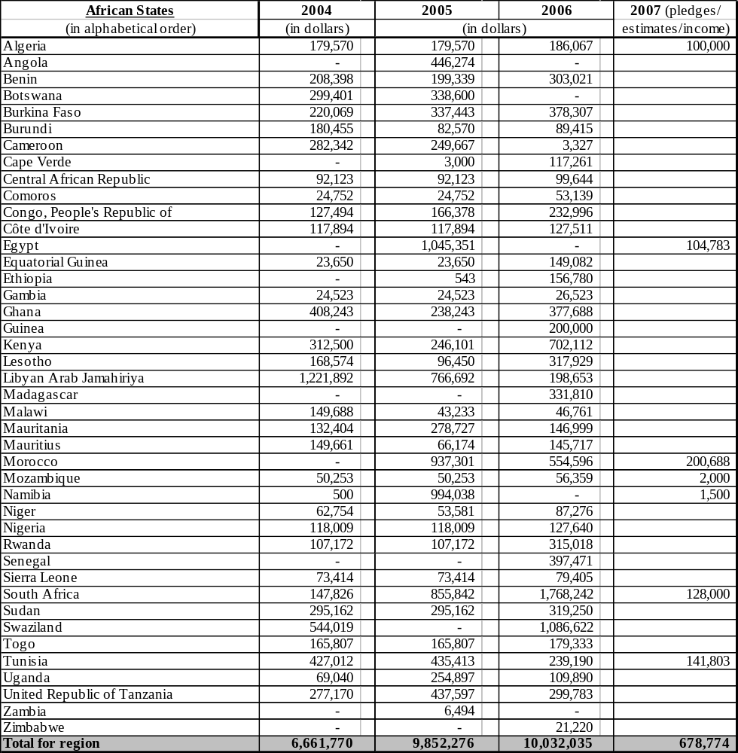

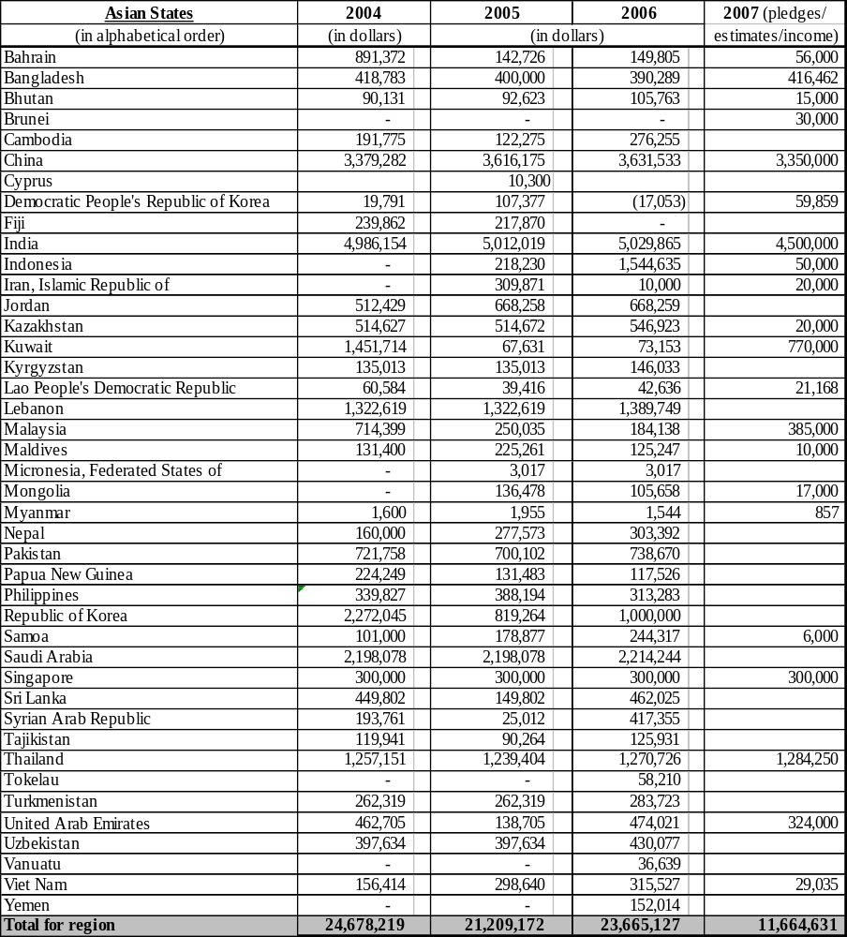

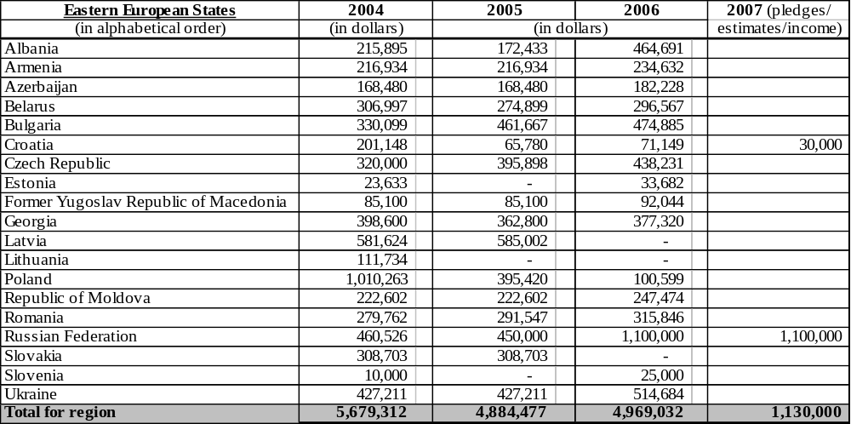

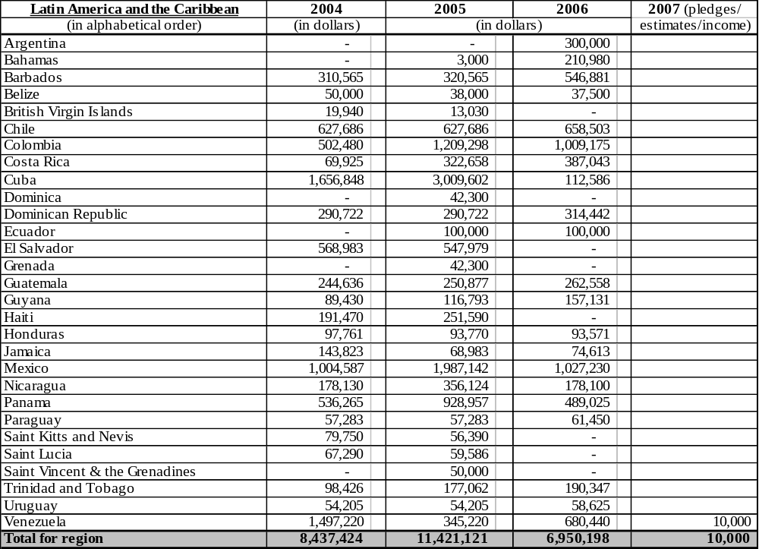

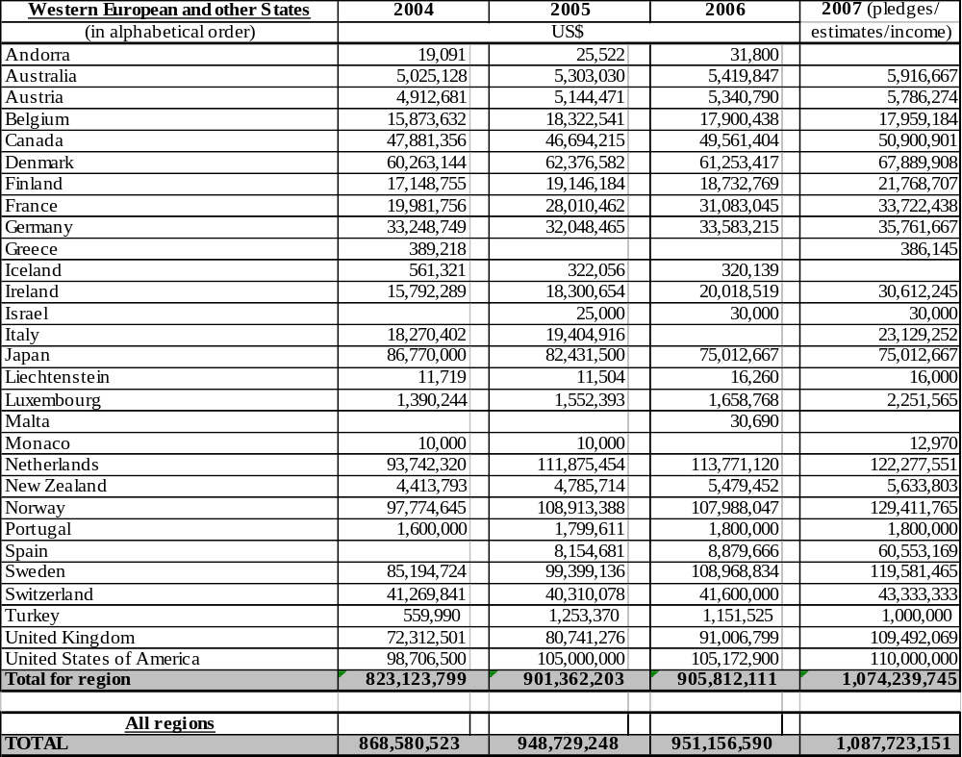

___________

Expressed at current (nominal) prices, in the period 1992-1997, an 8 per cent decrease in ODA was accompanied by a more-than-proportional 35 per cent decrease in core contributions to UNDP, whereas in the period 2000-2006, a 138 per cent increase in ODA was accompanied by a less-than-proportional 43 per cent increase in contributions to the core (ODA figures based on net ODA total from DAC Member States; UNDP core income adjusted for inflation and exchange rate variability using the OECD/DAC composite deflator and expressed in constant 2005 dollars).

