-

Annual session 2006
12 to 23 June 2006, Geneva
Item 6 of the provisional agenda
Annual report of the Administrator

Multi-year funding framework report on UNDP performance and results for 2005

Summary
The multi-year funding framework (MYFF), 2004-2007 (DP/2003/32), was approved at the second regular session of the Executive Board in September 2003, establishing the organizational goals and intended results for the four-year period. The MYFF goals and results are derived principally from the demand for UNDP assistance from programme countries. The goals also embody a range of corporate and international goals and concerns, such as the Millennium Development Goals, United Nations reform priorities, and the specific mandates of UNDP. This document reports on the performance of UNDP in 2005 against those core goals and organizational strategies. The observations made in this report are derived from the performance analysis of 135 country programmes, reporting results achieved against planned annual targets towards intended outcomes. Consistent with Executive Board requirements, the report contains performance information on programme focus and results, organizational strategies, and expenditures to achieve the objectives of the MYFF. Additionally, in keeping with decision 2005/20, the main theme of the report is capacity development, which is integrated throughout the analysis.

Elements of a decision

The Executive Board may wish to take note of the second report in the current MYFF, 2004-2007, cycle and endorse it, acknowledging the effort made by UNDP to feature capacity development as its main theme. Further, the Board may wish to consider the changing internal and external environment as a basis for discussing achievements and challenges. As the organization continues to refine its approach to measuring results and performance over time, the Board will have an opportunity to engage the organization in ongoing dialogue in the process leading to the preparation of the MYFF, 2008-2011.

Contents
Chapter |  |  | Page
I. Introduction |  |  | 5
II. Executive summary |  |  | 6
A. Key data from 2005 |  |  | 6
III. Programme results |  |  | 8
A. Global portfolio distribution |  |  | 8
B. Global performance |  |  | 12
C. Key results by practice |  |  | 12
IV. Implementation of organizational strategy |  |  | 24
A. Partnership and coordination |  |  | 24
B. Management results |  |  | 31
C. Financial results |  |  | 34
V. Conclusion |  |  | 37
LIST OF ABBREVIATIONS
ADR – Assessment of development results
BPFA – Beijing Platform of Action
CBO – Community-based organization
CEDAW – Convention on the Elimination of Discrimination against Women
CPDC – Conflict Peace and Development Cooperation Framework
CSO – Civil society organization
ECIS – Eastern Europe and the Commonwealth of Independent States
ECOWAS – Economic Community of West African States
ECHA – Executive Committee on Humanitarian Affairs
ExCom – Executive Committee
GEF – Global Environment Facility
GFATM – Global Fund to Fight AIDS, Tuberculosis and Malaria
GVP – Global Village Partnership
HIPC – Highly indebted poor countries
IASC – Inter-Agency Standing Committee
ICT – Information and Communication Technology
JPO – Junior Professional Officer
LDCs – Least developed countries
MDGs – Millennium Development Goals
MDGR – Millennium Development Goals Report
MFA – Multi-fibre Arrangement
MOSS – Minimum operating security standards
MYFF – Multi-year funding framework
NCSA – National capacity self-assessment
NHDR – National human development report
ODA – Official development assistance
OECD/DAC – Development Assistance Committee of the Organization for Economic Co-operation
and Development
OECS – Organization of Eastern Caribbean States
PRS – Poverty reduction strategy
PRSP – Poverty Reduction Strategy Paper
SIDS – Small Island Developing States
SMEs – Small and medium-sized enterprises
SWAp – Sector-wide approach
TCPR – Triennial Comprehensive Policy Review
TRAC – Target for resource assignment from the core
TRIPS – Trade-Related Aspects of Intellectual Property Rights
TWN – Third World Network
UNCDF – United Nations Capital Development Fund
UNDG – United Nations Development Group
UNAIDS _ Joint United Nations Programme on HIV/AIDS
UNEP – United Nations Environment Programme
UNIFEM – United Nations Development Fund for Women
UNV – United Nations Volunteers

Note: Numerical totals in this report may not add up exactly, due to rounding.

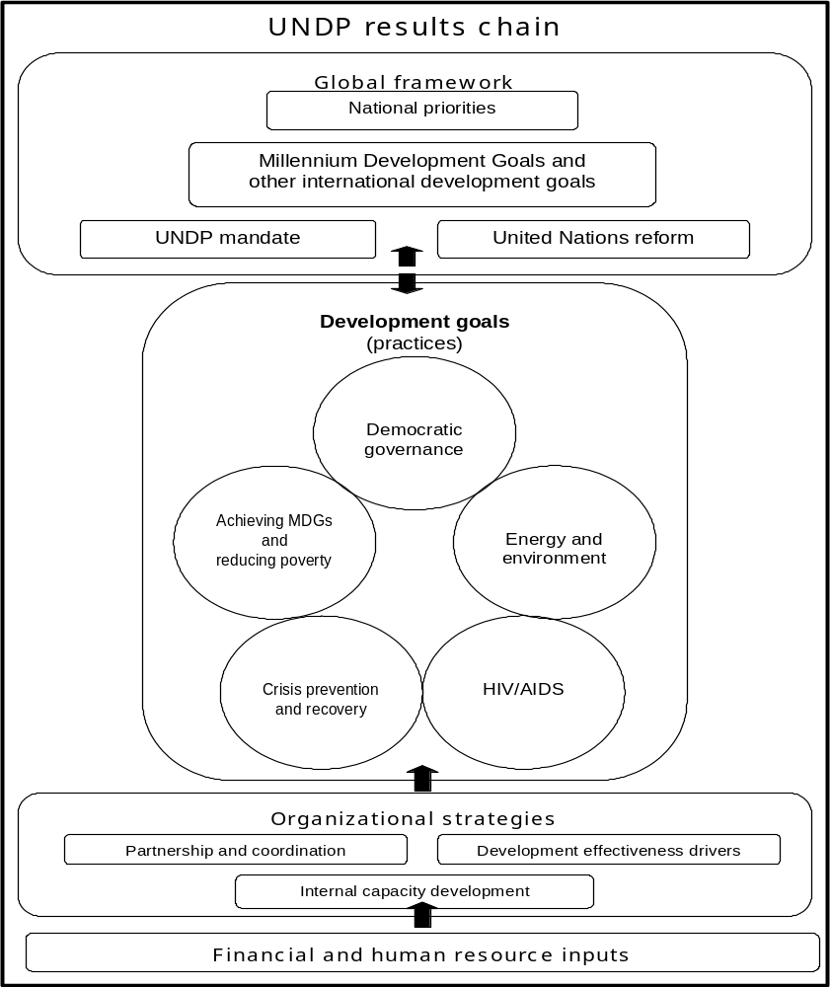
UNDP results chain
Global framework
Development goals
(practices)

National priorities
Millennium Development Goals and
other international development goals
UNDP mandate
United Nations reform

Achieving MDGs
and
reducing poverty

Democratic
governance

Energy and
environment

Crisis prevention and recovery

HIV/AIDS
Organizational strategies
Partnership and coordination

Partnership and CoordinationDevelopment effectiveness drivers
Internal capacity development
Financial and human resource inputs

Note about the results chain of UNDP
The development programming of UNDP is centred on the five practices.
Each practice contains service lines, which are sub-areas of work.
Country offices refer to the practices and service lines to determine the areas of focus of the organization before initiating programmes.
In formulating a development project or programme, country offices begin by determining the intended ‘outcome’ with the government and national stakeholders. Outcomes are normally set for the duration of a country programme. Many projects and programmes can contribute to an outcome.
Outcomes are linked in the results-based management system of UNDP to service lines and practices.
The number of outcomes being pursued gives an indication of the level of programming activity in each service line and practice.
Country offices are required to report on progress made against annual targets for achieving these outcomes. The annual MYFF report is focused on performance on outcome targets.
The ‘drivers of development effectiveness’ are cross-cutting themes that the organization seeks to integrate in all outcomes.
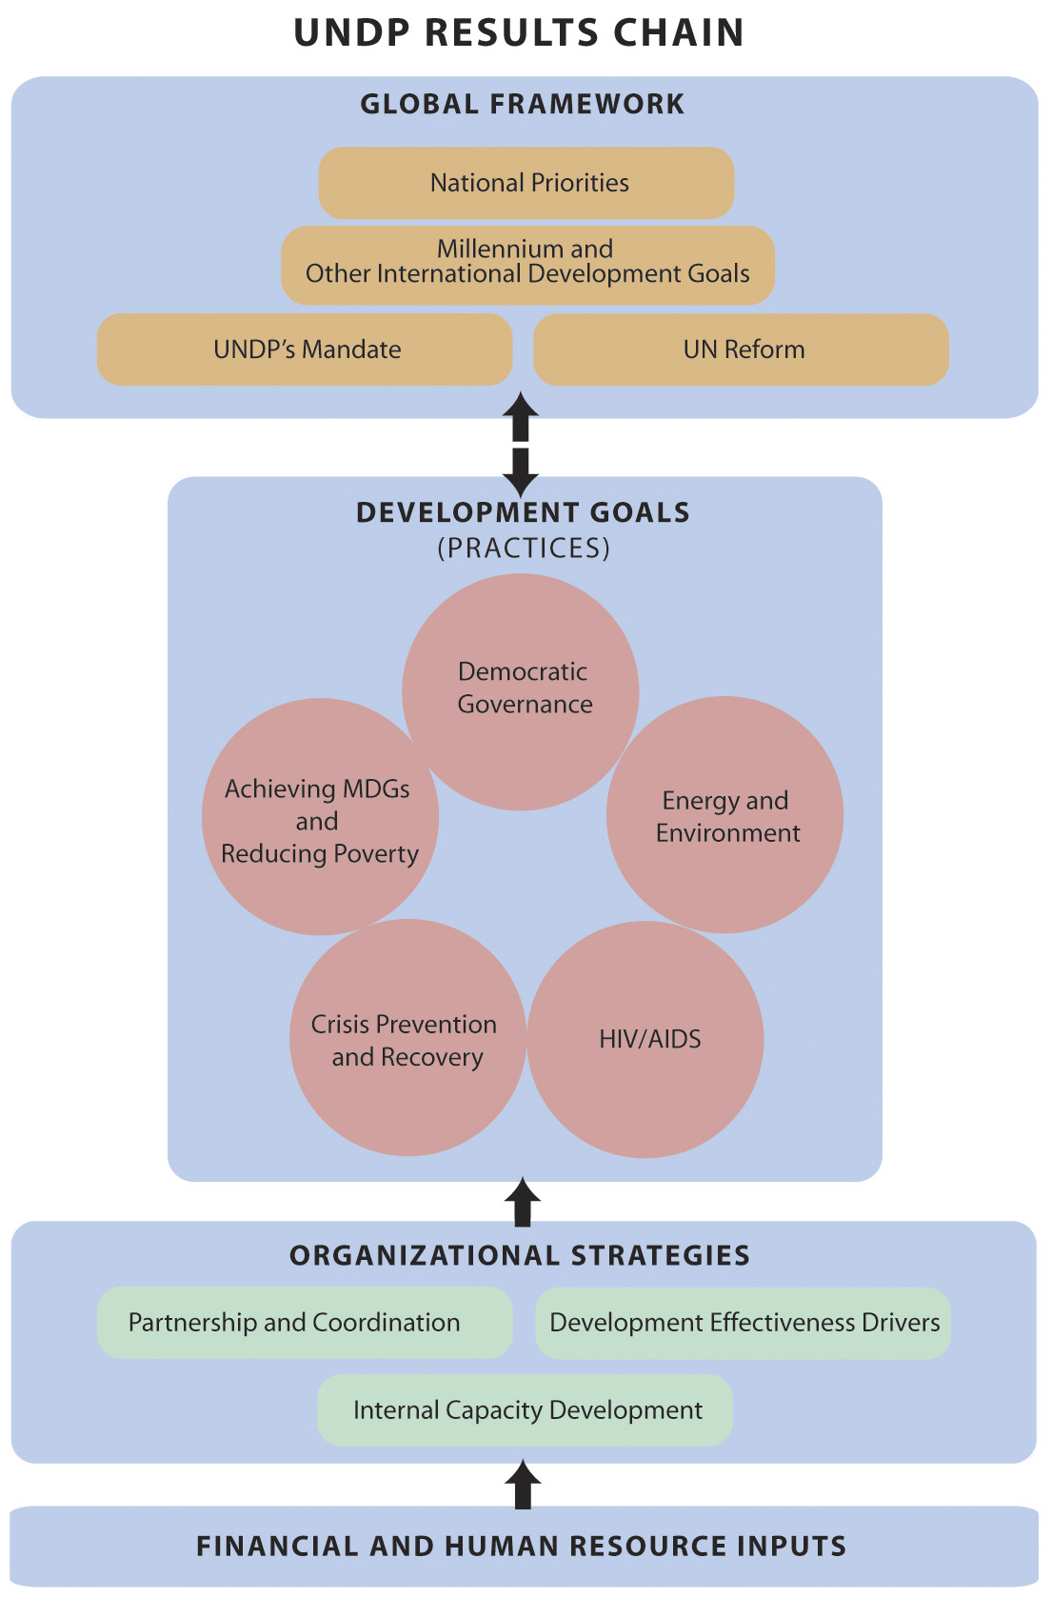
- Introduction
- The second multi-year funding framework (MYFF), 2004-2007 (DP/2003/32), of UNDP was approved at the second regular session of the Executive Board in September 2003. It established goals and intended organizational results over a four-year period. The goals derived principally from the demand for UNDP assistance from programme countries, and embodied a range of corporate and international objectives and concerns, such as the MDGs, United Nations reform priorities and specific mandates enshrined in the UNDP charter.
- Based on these factors, the MYFF, 2004-2007, established the following core targets for the organization: (a) achieving the MDGs and reducing human poverty; (b) fostering democratic governance; (c) managing energy and the environment for sustainable development; (d) supporting crisis prevention and recovery; and (e) responding to HIV/AIDS. As key elements in achieving these, the MYFF outlined three sets of organizational strategies for the cycle. These included: integration of five ‘drivers of development effectiveness’; promotion of partnerships and coordination within the United Nations family and with other development partners; and the development of internal capacity to support the achievement of results (see the ‘results chain of UNDP’ diagram on page 3.)
- The MYFF report on UNDP performance and results for 2005 provides insight into performance against core goals and organizational strategies, and reflects how partnerships with UNCDF, UNIFEM, UNV and the Special Unit for South-South Cooperation of UNDP have helped achieve results and promote the use of the drivers of development effectiveness. The new reporting format was approved by the Executive Board at its first regular session, 2004. For 2005 – an intervening year – a shorter, less comprehensive report was requested. In an effort to provide interested Executive Board members with more detailed analysis, the report makes use of annexes hosted on the UNDP Executive Board website (http://www.undp.org/execbrd/).
- Observations made in this report are derived from the performance analysis of 135 country programmes, reporting results achieved against planned annual targets towards intended outcomes. Consistent with Executive Board requirements, the report contains performance information on programme focus and results, organizational strategies and expenditures to achieve the objectives of the MYFF. Also, in keeping with Executive Board decision 2005/20, the report adopts capacity development as its main theme. The selection of this theme shows recognition of the importance attached to capacity development in the TCPR and the World Summit Outcome and reflects the importance that UNDP attaches to the issue. Capacity development has long been an integral and distinguishing aspect in the approach of UNDP to development, including strengthening the capacity of national actors to drive their own development agenda.
- This report comprises several sections. In addition to the introduction and executive summary sections, programme results present a broad analysis of the programme portfolio, examining the distribution of demand and expenditure as well as progress made against targets set by country programmes. The section also highlights the capacity development work and challenges of UNDP, and some notable achievements. The implementation of organizational strategy section examines two critical strategies outlined in the MYFF, 2004-2007, namely, the integration of drivers of development effectiveness, and partnership and coordination. The management results section outlines progress and achievements on corporate-level organizational strategies such as internal capacity-building, organizational efficiency, transparency and accountability. The section on financial results provides a global view of organizational performance and the sources and uses of funds against key financial indicators, and the entire report is summarized in a short conclusion. The annual MYFF document should be read in conjunction with the accompanying conference room paper (DP/2006/19), which sets out the response of management to key findings in the report.

- Executive summary
- This report is set against a backdrop of far-reaching changes taking place on the global development landscape. The United Nations Millennium Project 2005 report ‘Investing in development: A practical plan to achieve the Millennium Development Goals’ set the stage for new global development ideas and initiatives for the next 10 years. The second high-level forum on joint progress toward enhanced aid effectiveness (known informally as the Paris high-level forum) further redefined development assistance for developed and developing countries in 2005. The High-level Plenary Meeting of the sixtieth session of the General Assembly (known informally as the World Summit) in September 2005 was another landmark event that buttressed the global commitment to United Nations reform and new approaches to development assistance. The High-level Panel on United Nations System-wide coherence in the areas of development, humanitarian assistance, and the environment, which was recently established by the Secretary-General in response to these and other global events, is expected to lay the groundwork for a fundamental restructuring of the United Nations and its operational framework in the coming years.
- A key message emerging from the present report is that UNDP is repositioning itself to respond to development changes and to the United Nations mandate for reform. Country-level data show more offices engaged in joint programmes and participating in new aid arrangements such as SWAps, direct budget support and pooled funds. One of the most positive developments of 2005 was the establishment of the first joint office – the Office of United Nations Funds and Programmes in Cape Verde – a significant step forward in reform at the country level. While the engagement of UNDP in these types of processes is limited, such initiatives offer lessons and models that, together with the findings of the High-level Panel on United Nations System-wide Coherence in the areas of development, humanitarian assistance and the environment, will help guide the scaling-up of efforts in future.
- The overall review of results and performance for 2005 suggests that, despite some constraints and setbacks, UNDP is on track to meet the targets and execute operational strategies of the MYFF, 2004-2007. The encouraging findings in the country programme data are mirrored by positive views of UNDP among partners at the country level and by the upsurge in resources the organization mobilized locally in 2005. It is clear, however, that while 2005 results are largely positive, more needs to be done to address the pressing development challenges at the country level. This report points out a number of internal and external weaknesses faced by the organization in meeting these challenges, addressed in the accompanying conference room paper (DP/2006/19), which sets out a response by management to the issues as well as a preliminary indication of the broad strategic vision for UNDP going forward.

A. Key data from 2005
- UNDP is mainly concentrated in two practice areas, governance and poverty, which together accounted for the bulk of programme expenditures in 2005. In fact, UNDP is one of the largest providers of governance technical assistance in the world. The concentration of the organization in these two practices is partly reflected in the fact that four of the 30 service lines – three in governance and one in poverty – accounted for over half of total 2005 programme expenditures. The majority of country programmes fully or partially met their 2005 performance targets, and almost all programme activities were concentrated within the five practices.
- In keeping with Executive Board decision 2005/20, the report highlights the work and challenges faced by UNDP in developing national capacity, particularly around the MDGs agenda. UNDP views capacity development primarily as a domestically-driven process essential to human development. It is at the core of the mandate of UNDP and is treated as a cross-cutting development driver for all practices. In the light of the shared commitment to fight poverty and the global resolve to increase the volume of aid, the need to build capacity to negotiate, manage, oversee and utilize finance for human development has acquired even greater urgency for the organization.
- In 2005, capacity development featured prominently in the work of UNDP. This was most evident in the poverty practice, as headquarters, regional and country office units stepped up their efforts to make the MDGs an integral part of programme planning and reporting and to roll out of the integrated package of services. The results of these efforts were shown by the many countries that produced MDG reports and/or national human development reports ahead of the World Summit. They are also reflected in the range of countries that developed MDG-based poverty reduction strategies and national development plans with UNDP support.
- Capacity development drove much of the governance practice work of UNDP. This was centred mainly on public sector reform, decentralization and local governance, and electoral system support programmes in a range of complex and often challenging development contexts. In 2005, UNDP supported several large governance capacity development programmes in countries such as Afghanistan, Cameroon, the Democratic Republic of Congo, Haiti, Honduras and Iraq. Strengthening the foundations of democracy as recommended in 2004 UNDP report ‘Democracy in Latin America: towards a citizens’ democracy’, was the central theme in capacity development work in that region, which had the largest share of governance expenditure.
- Devastation caused by natural disasters such as the catastrophic Asian tsunami, Atlantic hurricanes and a number of earthquakes in 2004 and 2005 signalled the need for UNDP to develop greater capacity in crisis and disaster preparedness and response. In 2005, country programmes set about strengthening national and local abilities in disaster-related aid coordination, as well as preparedness, recovery, and management systems, including early-warning technology. Capacity development efforts also targeted man-made crises, and programme initiatives worked to strengthen the capacity of national authorities to assume long-term responsibility for land-mine management.
- The engagement of UNDP in the area of HIV/AIDS was relatively small compared to its extensive efforts in poverty reduction and governance, but it was sharply focused on developing leadership and capacity for national programmes to battle HIV/AIDS. UNDP took the lead role – in collaboration with the World Bank and UNAIDS – to help countries more effectively integrate HIV/AIDS work into MDG-based PRSPs. The programme also worked closely with 32 African countries to build capacity to adapt trade-related intellectual property rights flexibilities and safeguards to ensure access to anti-retroviral drugs.
- A great deal of UNDP work in the area of energy and the environment consisted of strengthening capacity to establish plans and strategies for sustainable development. The NCSA initiative provided a key entry point for organizational support of a large number of countries designing environmental management systems and initiatives. A global support programme was established in 2005 to help over 100 countries starting or already involved in the NCSA initiative.
- This report highlights some of the major capacity development initiatives under way, and also illustrates a number of shortcomings in UNDP performance in this area, including a failure to fully integrate capacity development drivers into the work of the organization. Of particular note is the lack of emphasis that country programmes place on capacity development for national ownership. The report notes that capacity development and efforts to promote national ownership take time and have in some cases led to delays in executing programme activities. Nonetheless, the conclusion from those cases was that investments in fostering national ownership and strengthening in-country capacity are vital for long-term sustainability. The report notes that insufficient resources have been directed towards enhancing the capacity of CSOs and marginalized groups. The 2005 allocation of a portion of TRAC-2 resources to MDG-centred national capacity development should help bring about full integration of capacity development in programme activities over the coming years.
- The report highlights a number of challenges and setbacks regarding other development drivers. While overall performance has been acceptable, results for gender and South-South Cooperation drivers were less encouraging. The 2005 launch of the gender thematic trust fund, the allocation of $10 million of regular resources for gender mainstreaming and a decision by the Administrator to establish and chair a gender steering and implementation committee are some of the initiatives under way to address gender-related shortcomings. A report on progress in implementing the third cooperation framework for South-South cooperation (DP/2006/21) will be considered at the annual session of the Executive Board in June 2006.
- With regard to management, the report outlines a number of key areas in which UNDP is rethinking and reforming its procedures to improve performance and enhance accountability. These include a further reduction in the management to total expenditure ratio; a significant increase in programme expenditure; the updating of the financial regulations and rules to enhance accountability and incorporate risk-management guidelines; and certification of staff in new project management skills. The organization has leveraged the capabilities of Atlas in setting up performance monitoring systems and an internal control framework.
- The performance of UNDP for 2005 was in line with the four-year framework overall, but more will need to be done to overcome the obstacles ahead. The organization is committed to clearing these hurdles and achieving even more in years to come.

III. Programme results
- This section of the report provides a scorecard showing the extent to which UNDP is on track in helping countries achieve development outcomes and results. It should not be seen as a measure of outcomes achieved, but rather as a review of progress and contributions made by UNDP towards attaining intended outcomes established at the country level with governments and other partners. The section looks at the performance of each practice, emphasizing capacity development initiatives and results.

A. Global portfolio distribution
- In 2005, all 135 country programmes were working in the poverty practice (see table 1). All but two country programmes were involved in governance; and 123 in energy and the environment. HIV/AIDS (90 programmes) and crisis prevention and recovery (83 programmes) had lower overall rates of country activity. The country programmes of UNDP, in partnership with national stakeholders, pursued 1,653 development outcomes within the five practices. Thirty-three per cent of outcomes were under the poverty practice, while 28 per cent were under governance, 22 per cent under energy and the environment, 9 per cent under crisis prevention and recovery and eight per cent under HIV/AIDS.
Table 1: Distribution of programming activity
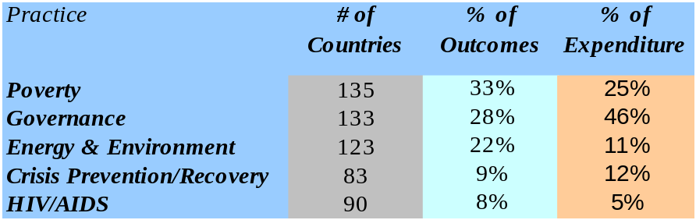

- Turning to finances, programme expenditures totalled $3.65 billion. Of this amount, $3.33 billion were country programme expenditures, with the remaining $325 million spent from headquarters and regional programmes on initiatives such as the Programme of Assistance to the Palestinian People. Ninety per cent, or $3.038 billion, of the country programme expenditure was directly linked to the five practices. The major share (46 per cent) of this was spent in the governance practice, followed by the poverty practice, which accounted for 25 per cent of expenditure, and the crisis prevention and recovery and energy and the environment practices, with approximately 12 per cent of expenditures each. The HIV/AIDS practice accounted for 5 per cent of programme expenditure. Further analysis of the data reveals that four of the 30 UNDP service lines accounted for 50 per cent of total expenditure in 2005. Three of the four service lines were in the governance practice, and the fourth in the poverty practice. The service lines were public administration and anti-corruption, accounting for 16 per cent of expenditure; electoral systems, 12 per cent; local poverty initiatives, 11.8 per cent; and decentralization and local governance, 10 per cent.
- The relatively high expenditure within the governance practice was due to the implementation of a number of large public sector reform and electoral systems projects in Africa, Asia and Latin America. For example, in 2005 UNDP provided technical assistance and coordinated donor support to the electoral processes in Afghanistan, the Democratic Republic of Congo and Iraq, which entailed significant expenditures. Programme activity and expenditure were considerable in the Latin America and the Caribbean region, accounting for 41 per cent of governance expenditure. UNDP and its partners are making a concerted effort to address some of the threats to democracy highlighted in the 2004 report ‘Democracy in Latin America: towards a citizens’ democracy’. The report high-lighted the need to tackle weaknesses in public institutions, including lack of transparency, accountability and the capacity to deliver services effectively. Many of the efforts made by UNDP in the region have gone towards strengthening public institutions, moving down through the level of national state actors to provincial and local levels. Decentralization in this region, as in Africa and Asia, will contribute to ensuring that public institutions are able to function effectively and deliver necessary services.
Figure 1. 2005 country programme expenditure, by practice
(in millions of dollars)

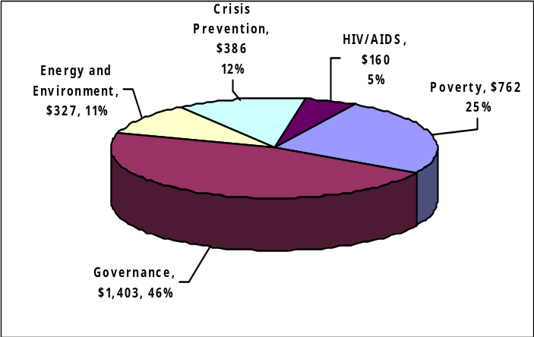

Total $3,038 billion

- The work of UNDP in countries such as Afghanistan and Iraq, as well as in the countries affected by the tsunami, led to relatively high expenditures in the crisis prevention and recovery practice. A significant amount of funding for programmes in this practice and in the governance practice was derived from other resources.
- Viewed by regional bureau, countries in Africa accounted for 45 per cent of regular programme (TRAC) expenditures. Asia and the Pacific region was next with 32 percent of regular expenditures, followed by Europe and the Commonwealth of Independent States (8 per cent), Arab States (8 per cent) and Latin America (6 per cent). However, when other expenditures are included, Latin America and the Caribbean accounted for 39 per cent of total programme expenditures. The countries in Asia-Pacific (24 per cent) and Africa (20 per cent) regions were next, followed by those in the Arab States (9 per cent) and Europe and the Commonwealth of Independent States (8 per cent). Work in countries such as Afghanistan and those affected by the tsunami helped account for the relatively high share of expenditures in the Asia and the Pacific region.
Figure 2. 2005 distribution of regular expenditure,
by region
(in millions of dollars)

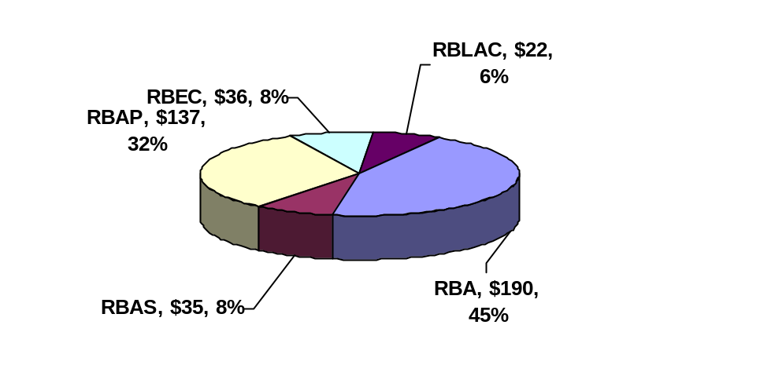

Total $524 million

Figure 3. Distribution of total expenditure, by region
(in millions of dollars)

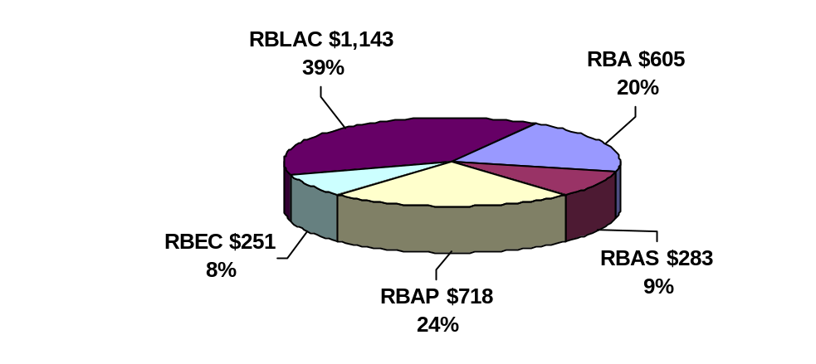

Total $3.038 billion

- The analysis indicates that the organization has met one of the key strategic objectives of the current MYFF cycle: concentrating programming activity and financial resources within the five practices and 30 service lines. Close to 100 per cent of UNDP programming is now within the service lines (see table 2), and is consistent across all regions. In 2005, nine outcomes (0.3 per cent) of the 1,653 outcomes fell outside the established service lines. Analysis of the financial data for these nine outcomes shows that they accounted for $2.1 million (0.07 per cent) of country programme expenditure. This finding highlights the issue of the corporate framework vis-à-vis national demand and priorities and the importance of ensuring organizational flexibility while maintaining corporate focus.
Table 2. Degree of focus
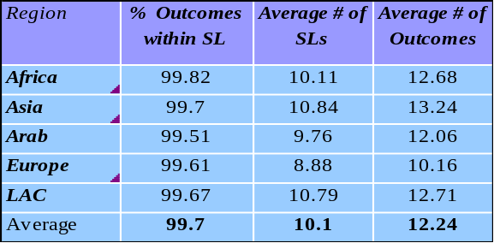
- On average, country programmes are now focusing on 10 service lines and 12 outcomes, a small improvement over 2004. While this moves the organization further in its efforts to focus programme resources in achieving greater impact, it still falls short of the 6-10 outcome target of the MYFF, 2004-2007.
- Results from the 2005 UNDP partners survey demonstrate that in all practices, a majority of local stakeholders regard UNDP as an active and critical development partner (see figure 4). In keeping with the corporate mandate, 131 country programmes had aligned their outcomes with national priorities and development strategies. This underlines an increasing readiness on the part of county programmes to respond to the challenges set out in the United Nations reform agenda and the principles of the Paris Declaration on Aid Effectiveness.
Figure 4. Partners who see UNDP as critical, by practice
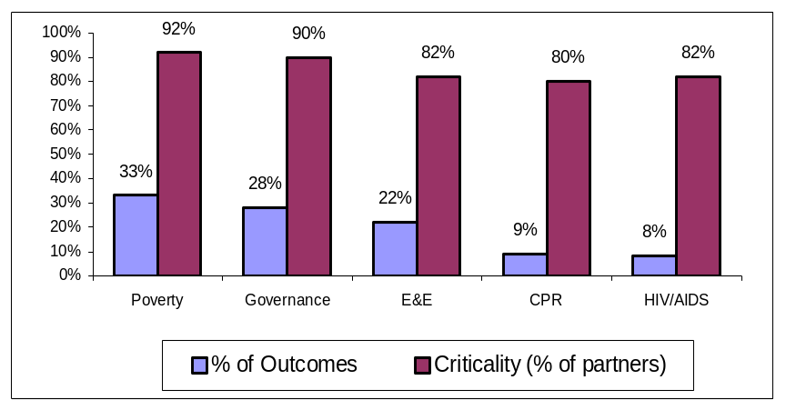

Figure 4. Partners who see UNDP as critical, by practice

B. Global performance
- The 2005 data reveal that the majority of country programmes either fully or partially met their programme targets, with minor variations across regional bureaux and practices. The HIV/AIDS practice had the highest percentage of fully achieved targets (61 per cent). On average, country programmes reported 54 per cent of targets fully achieved, 42 per cent partially achieved, and 4 per cent not achieved.
Table 3. Rate of achievement of targets, by practice
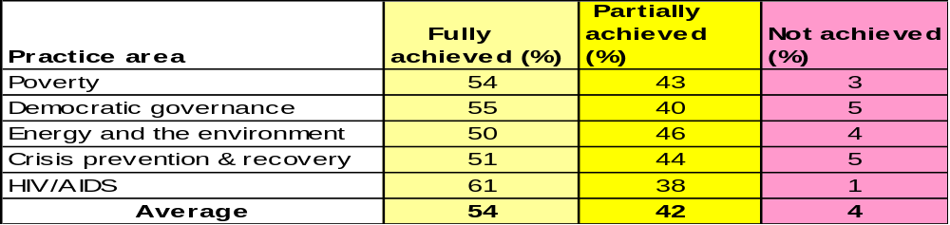

Figure 5. Rate of achievement of targets, by region and practice
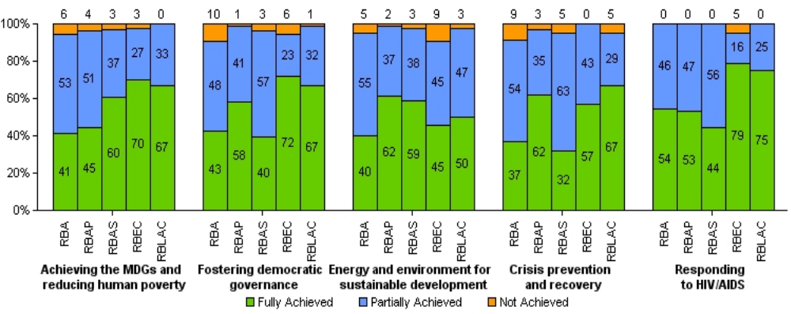

C. Key results by practice
Poverty reduction
Table 4. Programme demand and expenditure within the poverty practice
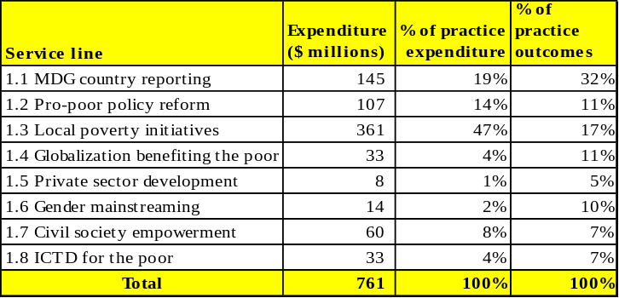
- In 2005 there was strong country demand for services in support of achieving the MDGs and reducing poverty. With all 135 countries reporting, the practice registered the highest level of demand. Ninety-seven per cent of all country programmes reported having fully or partially met their targets in the practice.
- Country commitment to achieving MDGs and reducing poverty was reflected in the fact that 57 per cent of the $761 million expenditure in the practice came from local resources. The practice also accounted for the largest expenditure of regular resources in 2005, with 32 per cent of the total. This is consistent with the country and global priority to focus UNDP resources on the MDGs and reducing poverty, and with the demand for poverty practice advisory services.
Table 4: Programme demand and expenditure within the poverty practice

Capacity development and national ownership of the MDG agenda
- As part of the build-up to the World Summit in September 2005, UNDP was called upon to support countries in preparing MDG reports as a tool for public advocacy. Of the 152 national MDG reports prepared for the World Summit, 50 were directly supported by UNDP. In some countries, NHDRs complemented MDG reports. As a result of UNDP support, the quality of MDG and NHDR reports published in 2005 improved visibly. The focus and approach to reporting and monitoring varied by country, with many innovations highlighting country specific situations. Chile, for example, produced macroeconomic simulation models to explore policy impacts to achieve the MDGs. Venezuela incorporated MDG monitoring into an integrated system of social indicators for government. In Africa, countries focused mainly on poverty monitoring and using the Millennium Project handbook to initiate the preparation of national development strategies to achieve the MDGs. Burkina Faso, Nigeria and Tanzania are examples of countries that focused on poverty monitoring within the context of the MDGs. Another noteworthy innovation in reporting is the MDG8-focused report of Thailand, which outlines development cooperation policy and priorities to achieve the MDGs.
- Significant capacity development was recorded in MDG reporting and monitoring. Priority interventions included: strengthening statistical capacity for data collection and monitoring poverty and inequality through the deployment of DevInfo, in partnership with UNICEF; using statistics to improve policy design and address issues of gender and other social inequalities; setting benchmark indicators to monitor MDG progress; and promoting broad stakeholder involvement in policy dialogue and ownership of the development agenda. Notable results included the production by Libya of its first MDG report and the simultaneous establishment of a national DevInfo database. Rwanda, with support from donors and the United Nations country team, established a statistical institute to improve data and statistics gathering and analysis.
- While progress is being made on developing capacity to utilize empirical data in development planning processes, a number of challenges remain. Some of these challenges are emerging as the focus shifts from data collection to managing the growing amount of information on human development and the MDGs. In this respect, enhancing the statistical literacy of users in government and amongst civil society organizations and other stakeholders has become a key concern. In addition, constraints associated with data quality are being encountered on two fronts: (a) relevance and quality of data; and (b) effective monitoring systems for compiling, retrieving and analysing data. These constraints are particularly evident in the LDCs and post-conflict countries, which often lack adequate data collection and monitoring systems. A lack of capacity to tailor the MDGs to country-specific contexts and conditions is another handicap to achieving the MDGs.
- With respect to national ownership and local stakeholder engagement in national development processes, progress was made in 2005: UNDP supported countries in fostering civil society engagement in policy formulation, implementation, and monitoring and evaluation of the MDGs. Work in Egypt, for example, resulted in a new social contract between government and civil society to achieve the MDGs by 2015. But while many countries concentrated on building wide stakeholder support for the MDG agenda, the data also indicate insufficient advocacy and capacity-building for disadvantaged and marginalized groups to participate effectively in development dialogue and implementation processes.
- Work under the pro-poor policies service line was focused on support for national capacity building to assist countries in linking their poverty reduction strategies to MDG-focused economic policies for pro-poor growth. In all, 2005 saw intensive capacity-building activities on MDG-based PRSPs in all regions. Kenya, for example, mainstreamed the MDGs into its national budget, while Ecuador established an observatory of fiscal policy to facilitate a nationally-owned fiscal policy planning and consultation process with wide stakeholder participation. In Laos, the focus was on MDG costing and sequencing, and on prioritizing public expenditure to achieve the MDGs. The Maldives vulnerability and poverty assessment survey was a good example of support provided in the Asia and the Pacific region in formulating country-sensitized MDG-based national action plans in response to the tsunami and other natural disasters.
Box 1. The UNDP/UNIFEM partnership on gender and the MDGs
Advancing gender equality within the MDGs is a notable achievement, thanks to cooperation between the United Nations system and government and civil society. With UNIFEM as executing partner, Kyrgyzstan lowered its transaction costs by aligning MDG reporting frameworks with those for the Convention on the Elimination of Discrimination Against Women and the Beijing Declaration and Platform for Action. In Peru and Morocco, UNIFEM has brought new constituencies to the United Nations coordination team campaign to promote national ownership to achieve the MDGs., UNIFEM contributions to MDG monitoring and policy review were reported by Nepal and Thailand, while UNIFEM funding contributions were noted to the poverty reduction strategy paper programme in Azerbaijan.
- UNDP support for initiatives that connect and integrate the MDGs with national development strategies helped lay a foundation for follow-up to the World Summit. However, a number of important challenges also remain in this area. Chief among these is the limited absorptive capacity in many countries, which constrains efforts to transform national development plans into MDG-based development strategies. In some cases, national ownership has been inadequate due to extensive reliance on external experts to formulate policies and undertake MDG-based needs assessments, costing and monitoring.
- Support for national aid coordination is an important element of the work of UNDP under the globalization benefiting the poor service line, particularly in least developed countries. Ethiopia, as the designated pilot country for the aid management platform to facilitate aid harmonization and alignment, has the difficult task of leading the operationalization of the principles outlined in the Rome Declaration on Harmonization. The lessons from this pilot will be important for future initiatives. The service line also covers support for trade and debt relief. In 2005, through regional programmes in Africa, Asia and the Arab States, UNDP assisted countries to better utilize development finance, improve their capacity to integrate into the global economy, and negotiate trade arrangements and debt relief for highly indebted poor countries. Cambodia, for example, received support to assess the social and human development impact of World Trade Organization accession. Additionally, UNDP in collaboration with other cooperating agencies supported the coordinated delivery of trade-related capacity building technical assistance to over 29 LDCs under the integrated framework, with commendable progress in integrating trade into their respective anti-poverty strategies. This notwithstanding, various assessments have indicated continuing constraints on the ability of many LDCs to enhance their supply-side response.
- Within the private sector development and local poverty initiatives service lines, partnerships with the private sector were supported to build the capacity of organizations serving SMEs and the informal sector, as well as to promote the delivery of more inclusive financial services. UNDP, in partnership with UNCDF, supported programme countries to access microfinance, productive resources and basic social services to help the poor overcome human poverty. In 2005, UNCDF supported programmes in 23 least developed countries, including Sierra Leone, which launched a $10.3 million programme to build its microfinance sector in late 2004. In 2005, the programme provided benefits to thousands of mainly female and formerly displaced persons to build or rebuild their livelihoods. Mozambique, Pakistan and Syria, are among the countries that received support to develop or review their national policies and strategies for microfinance.
At the regional level, UNCDF and UNDP approved a programme to build inclusive financial sectors in the Africa region. ICT was also used to support job creation, SME development and economic empowerment.

Box 2. Partnering with United Nations Volunteers to strengthen management capacity in Bolivia
As a part of its poverty reduction interventions through building local partnerships, UNDP partnered with UNV and the Ministry of Popular Participation in Bolivia to implement a unique poverty reduction programme for municipal governments. Recruiting national volunteers from universities, these volunteers work hand-in-hand with local governments to not only deepen capacity in the field of administration, planning and project management, but also expand relationships with civil society organizations.

Governance
- One hundred and thirty-three of 135 UNDP country programmes are promoting democratic governance. With over $1.4 billion worldwide, UNDP was one of the largest providers of governance technical assistance in the world in 2005. The majority of UNDP resources in this practice are from non-core sources, and of these, a full 41 per cent were generated in 2005 at the country level. UNDP is playing an increasingly important role in providing governance assistance in conflict and post-conflict countries, particularly in the area of transitional justice and security sector reform. It is working to help countries transition from United Nations peacekeeping operations to stability through electoral and constitutional processes and institution-building of state bodies. These are also key areas of capacity development work, as explained below.
- In 2005, 464 programme outcomes focused on democratic governance. Twenty-three percent of these were in the area of justice and human rights, while decentralization, local governance and urban/rural development accounted for 22 per cent. The distribution of expenditure reveals that three service lines together accounted for approximately 83 per cent of the resources in governance (public administration reform and anti-corruption; electoral systems and processes; and decentralization and local governance). Projects falling under these service lines included electoral support programmes in Afghanistan, Cambodia, the Democratic Republic of Congo, Iraq, and large decentralization and local governance initiatives in countries such as Haiti and Honduras.
Table 5. Programme demand and expenditure within the governance practice
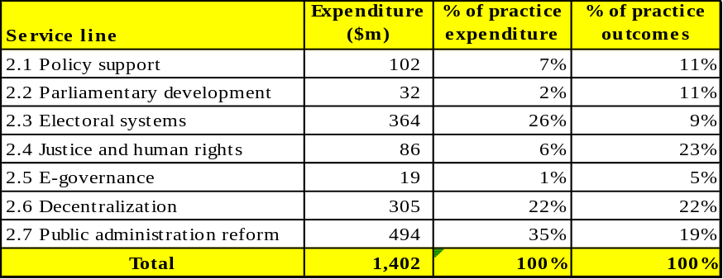

Table 5. Programme demand and expenditure within the governance practice

Strengthening governance institutions and processes
- The core results of UNDP in each of the governance service lines include an emphasis on developing capacities. In 2005, the practice placed increased focus on governance at the local level and decentralization more generally, with more than two-thirds of country programmes reporting outcomes in this area and almost $1 billion in expenditure. Given the increased focus, the practice had strong emphasis on all three capacity development drivers for these activities, and paid particular attention to developing the capacity of local governance actors. This is demonstrated by the performance in services lines 2.1 (policy support for democratic governance) and 2.6 (decentralization, local governance and urban/rural development) in table 5. In decentralization, local governance and urban/rural development, capacity building of local governance actors to achieve the MDGs in urban/rural areas continues to be dominant and is happening in countries as diverse as Albania, Barbados, Kenya, Mozambique and the Philippines. UNDP continues to emphasize support for national decentralization policy-making; local governance institution-building, including strengthening participation and partnerships in social service delivery; policy formulation and resource management; and urban and rural development.
- An analysis of country activity reveals progress in influencing national, sectoral and local development strategies to incorporate MDG targets; strengthening the capacity of public and civil society institutions to monitor and report resource use for development results; and facilitating policy dialogue among key state and non-state stakeholders aimed at building broad-based consensus. In Barbados, UNDP supported capacity-building initiatives assisting the Organization of Eastern Caribbean States and Small Island Developing States in the formulation of pro-poor policies and development agendas to address traditional vulnerabilities in a new wide-ranging development context, which includes issues such as women’s rights, youth, serious crime, drug trafficking, high debt and economic diversification. Efforts in this service line also focused on improving the capacity of national and sub-national agencies in service delivery for the poor. In Sierra Leone, UNDP supported the decentralization of agriculture and health services to local councils through pilot activities with a focus on transparency, accountability, participation and an explicit link to MDGs.
Box 3. UNCDF/UNDP partnership in Mozambique
As reported in the 2004 assessment of development results, “UNCDF/UNDP Mozambique scores high with the performance of … its flagship programme in decentralization and strengthening of local government.” In the current phase (2004-2007), the UNCDF-led consortium of five donors (UNDP, Development Cooperation Ireland, the Netherlands, the Norwegian Agency for Development Cooperation,and the Swiss Agency for Development Cooperation) finance a $15 million pilot local development programme in Nampula and Cabo Delgado provinces, aimed at strengthening local administration and governance through strengthened capacities for participatory district planning, combined with the financing of small-scale infrastructure. The critical success of the model has led to its being adopted by the Government at the policy level and replicated by other donors such as the World Bank.

- The capacity development work of UNDP is also seen in the public administration reform and anti-corruption service line, which is mainly focused on reform for efficient, effective, responsive, and pro-poor public services as well as institutional, legal and policy frameworks to promote and enforce accountability, transparency and integrity in the public service. This is happening in countries such as Afghanistan, China, the Democratic Republic of the Congo, the Lao People’s Democratic Republic, Timor-Leste, Sao Tome and Principe and Yugoslavia.
- Capacity development also featured prominently in the justice and human rights work of UNDP. The organization is leveraging its recognized impartiality and trust by working in sensitive but critical issues such as post-conflict situations to support transitional justice and security sector reform. Efforts in this area have included assistance in drafting legislation for the establishment of truth and reconciliation bodies and special courts/tribunals to address crimes of the past (such as Bosnia Herzegovina, Liberia and Sierra Leone). UNDP has worked to increase human resources capacities through the introduction and consolidation of systematic training for legal, judicial and administrative officers in the justice system (Timor-Leste), and provision of human rights knowledge for police, judiciary, media, and the expansion of human rights advocacy networks (Egypt). UNDP is increasingly engaged in joint programming processes related to the implementation of the United Nations-wide Action II programme, which further strengthens national human rights promotion and protection systems.
- In parliamentary development, UNDP capacity development support in 2005 centred primarily on enhancing the representation function. Work in this area involved diverse contexts from
Benin to Viet Nam. In Benin, with UNDP support and National Assembly funding, Members of Parliament organized annual nationwide public consultations on matters of national and local interest in order to better connect with constituents and inform the legislative process.
Box 4. Civil society capacities for MDG advocacy and dialogue in Brazil
Through a partnership with UNV, UNDP assisted in intensifying cooperation with civil society (nongovernmental organizations, universities, schools, private companies, the community), on deepening capacities for advocacy and facilitating public dialogue on the MDGs at the local and regional levels. Inclusion of civil society in such multi-stakeholder processes is a key strategy for capacity development.
- Regarding electoral systems and processes, UNDP placed heavy emphasis and made significant progress in results achieved related to establishing legal and institutional frameworks that enable free, fair, transparent and sustainable elections at all levels in 2005. This area of work emphasizes capacity development of electoral management bodies both during elections and between elections. For example, UNDP provided support to the independent electoral commission of Iraq in the form of advisors and training to help them prepare for the elections, and provided support to strengthen the capacity of the Cambodian national election committee as a permanent body in the inter-election period to manage the continuous voter registration process and undertake civic education. Another example of clear results is the work of UNDP in helping to establish and enable the Afghan national assembly. Support from UNV was essential in helping to strengthen capacity and organize elections in Afghanistan, Burundi and Liberia in 2005.
- E-governance and access to information was also used as an important entry point for facilitating capacity development in 2005, with UNDP utilizing these tools to both increase opportunity and enhance capacity of especially vulnerable groups to participate in policy making processes. In India for example, UNDP is using community radio as a medium to empower marginalized groups through discussions on human rights issues and as an alternative forum for dispute resolution. In Armenia, UNDP efforts focused on strengthening the capacity of civil society to effectively monitor the national anti-corruption strategy; training civil society organizations, private sector, parliamentarians and public officers in advanced lobbying practices; and establishing information and communication technology public access sites in all regions.
Energy and environment
- In 2005 there were global reality checks on the state of environmental resources and ecosystems services. The short conclusion of this stocktaking as echoed in the world summit is that good intentions and efforts so far have not been sufficient to reverse the loss of environmental resources and significantly improve the lives of the poor. UNDP contributed to this global wake-up call and, in the face of challenging realities, the energy and environment practice served 123 programme countries in 2005. Twenty-two percent of total outcomes are focused on energy and environment for sustainable development. The distribution of demand is similar across all regions, with the lowest demand coming from Africa and the highest from Latin America and the Caribbean. Overall, the areas of frameworks and strategies for sustainable development (96 countries), conservation and sustainable use of biodiversity (66 countries) and access to sustainable energy services (56 countries) were the areas receiving priority attention.
- In 2005, country programme expenditure for the energy and environment practice was $327 million, including $103 million from the global environmental facility (GEF). An additional $77 million of GEF funding for energy and environment activities was reported under global initiatives and the small grants programme. In total, the GEF contribution amounted to approximately $180 million, representing 50 per cent of donor and trust fund contributions to total energy and environment expenditure for the year.
- Contributions from donors and trust funds represented 89 per cent of total expenditure with the balance of 11 per cent coming from regular resources. Locally mobilized resources represented 26.5 per cent of expenditures, consistent with the increased importance given to energy and environment issues at the national level. Government cost-sharing was the major contributor of local resources, providing evidence of both demand for and country partner engagement and ownership in tackling energy and environment issues.
- Core results across the service lines are increasingly devoted to the integration of energy and environment in national development strategies and policies. More than a third of the practice’s outcomes (118) are focused on the integration of sustainable management of environment and natural resources in poverty reduction strategies and national development frameworks in the service lines of strategies for sustainable development, water governance, energy, land management and biodiversity. These converging efforts to influence macro economic and poverty reduction planning frameworks are yielding promising results. For example, support to the government of Viet Nam is helping integrate sustainable development indicators in the five-year national socio-economic development plan, incorporate explicit poverty reduction efforts into the natural resource and environment sector plan, and coordinate aid-funded projects toward poverty and environment links. Likewise, support in Ethiopia is making environment actions explicit in the second generation poverty reduction strategy paper. UNDP support is helping to make diversity of energy sources an integral part of Cameroon’s development plans and sustainable development objectives part of Malaysia’s macro-economic framework. Plans for clean and renewable energy and agro-biodiversity are also making their way into Syria’s key development plans.
Table 6. Programme demand and expenditure within energy and environment practice
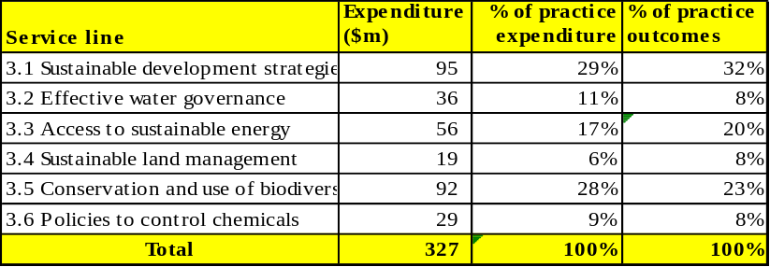
Strengthening environmental management capacity
- The most significant capacity development drivers within the energy and environment practice are developing national capacities and fostering an enabling policy environment. Activities are particularly strong in contributing to capacity development diagnostics for pro-poor responses and influencing national, sectoral and local development strategies to incorporate MDG targets. A key programme supporting the diagnostics of environmental management capacities is the national capacity self-assessment (NCSA).
- In terms of capacity for MDG planning, country programmes are working to ensure that activities under this practice support countries in incorporating MDG targets into national, sectoral and local development strategies, and to adapt MDG targets to national conditions and priorities. Setting country-specific targets for ensuring environmental sustainability is instrumental, not only for advancing the environmental goals of MDG7 by helping to focus attention on priority issues but also by contributing to sustained progress in meeting all MDGs.
Box 6. National capacity self-assessments
In 2005, the first 13 countries completed their capacity assessments and prepared follow-up action plans, with some novel approaches. The Seychelles built on the recent reorganization of its environment ministry to propose an integrated approach to manage environmental issues; Lesotho is using the NCSA to strengthen a continuing decentralization programme and to promote a standing committee for the environment, supported by convention focal points, as part of current parliamentary reforms; the Ethiopia NCSA is focusing on environment-poverty links, promoting environmental technologies, eco-investment and sustainable livelihoods. However, the process has often led to the design of separate capacity-building activities or single follow-up projects, rather than strengthening the main strategic themes of environmental management. While clearly producing a number of benefits to countries, both through the systematic assessment and planning process and from the products and outcome generated, the process also presents a number of challenges. A global support programme was established in 2005 to help address these challenges. Six regional workshops were held in Asia and Africa to assist the 75 countries that have not yet started, as well as the 42 countries that are in the process of review and assessment and the 24 countries currently developing action plans.
- A review of MDG reports shows that over 50 per cent of countries have set time-bound and measurable national targets, primarily tailoring the global targets for increased access to water and sanitation (known as Target 10). Adapting targets to reverse the loss of environmental resources has been less successful, where only 23 per cent of countries have developed national and sub-national targets. Conversely, the number of countries with at least one environmental sustainability (MDG7) target tailored to national settings has increased from seven to 73 countries over the last two years. But countries with an effective system for data indicators and monitoring progress on environmental sustainability are the exception. Support to MDG7 target setting, monitoring and reporting is in many cases carried out as part of the MDG reporting service line. Some countries recognize the need to reinforce the environmental sustainability portion by dedicating specific efforts to that MDG in particular, but scaled-up systematic efforts to bridge those gaps are so far too low with only seven countries and $2 million worth of activities allocated to the task. Noteworthy efforts have been reported in the Ukraine, Senegal and Ecuador.
- While the significant efforts reported by most UNDP country programmes to support planning, target-setting and capacity development diagnostics to achieve the MDGs is positive, this work is not sufficiently matched by concrete efforts to increase delivery of on-the-ground energy, water and sanitation to concretely contribute to progress on the MDGs. However, some initiatives are paving the way in supporting such service delivery and implementation capacities. The support of UNDP in providing access to safe water and sanitation services has yielded significant results in Tajikistan, where 100,000 inhabitants in 40 communities are being serviced, and Myanmar where access to clean water and sanitation was improved in over 500 communities. In Niger, 11 water sources were made accessible and in Uzbekistan 250,000 people were provided access to clean water. Activities to support access to energy services, electricity or cleaner fuels in rural areas saw a welcomed increase in 2005, with initiatives to improve access to energy services in 19 villages in remote areas of India, and six schools and 13 health centres in Tanzania – examples of the work of UNDP in energy at the community level. In addition, critical regional strategic planning of energy services initiatives such as the economic community of West African states offer a promising outlook to increase energy access significantly.
Crisis prevention and recovery
- The trend of expanding demand for services linked to the crisis prevention and recovery practice areas continued in 2005. Eighty three of 135 UNDP country offices worked in this practice area, compared with 82 in 2004 and 54 in 2000. The most requested service line was natural disasters, followed closely by recovery. The natural disasters service line was especially prominent in the Asia and the Pacific and Latin America and Caribbean regions due to the 2004 tsunami and the overactive 2004-2005 Atlantic hurricane seasons. By contrast, the recovery service line was particularly in demand in Africa and to a lesser extent in Asia the Pacific. The significant rise in recovery activities associated with core result three – restoration of sustainable livelihoods – mirrors the surge in recovery needs in tsunami-affected countries. These two service lines also make up almost one third of the resources spent globally in the crisis prevention and recovery practice in 2005, partly an expression of high investment and expenditure in the post-tsunami recovery efforts.
- Overall, the highest expenditure was in the special initiatives for countries in transition service line. Initially, this may be surprising given the low percentage of outcomes but can be explained by the particular initiatives in Sudan – the Sudan recovery and rehabilitation programme and the Global Fund for AIDS, Malaria and Tuberculosis – and Afghanistan, with a comprehensive package of crisis and post-conflict programmes, ranging from disarmament, demobilization and reintegration to de-mining and drought relief. Conflict prevention and peace-building also saw a significant share of global expenditure in the crisis prevention and recovery practice area.
- In absolute numbers, the Africa region had the most countries in which UNDP was active in crisis prevention and recovery (25 countries), followed by Asia and the Pacific (20), Europe and the Commonwealth of Independent States, Latin America and the Caribbean (14 each), and Arab States (10). Seen proportionally, however, 80 per cent of all countries in Asia and the Pacific were active in crisis prevention and recovery, 59 per cent of countries in the Arab States region and around 56 per cent of the countries in each of the other regions.
Table 7. Demand and expenditure in the crisis prevention and recovery practice
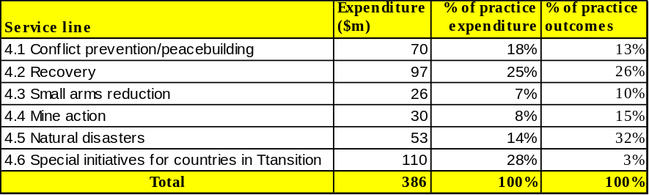
Table 7. Demand and expenditure in the crisis prevention and recovery practice
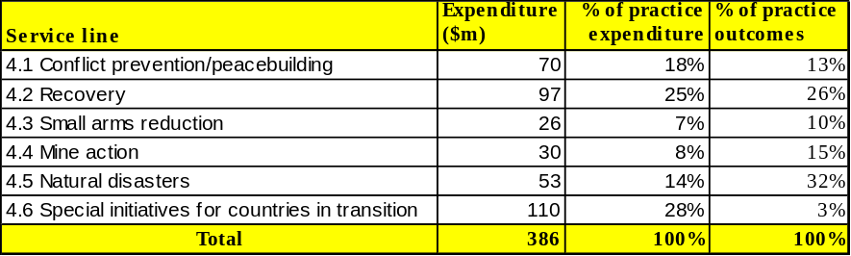

- In light of the changing international architecture of the United Nations system and the imperative nature of United Nations reform, UNDP has been front and centre in contributing to policy development and advocacy in crisis prevention and recovery; the organization’s inputs and leadership role can be seen in many different yet related fields. Within the UNDG/Executive Committee on Humanitarian Affairs working group on transitions, UNDP continues to be instrumental in adapting the post-conflict needs assessment methodology that was applied over the past year in Somalia and previously in Haiti, Liberia, and Sudan. UNDP was designated the lead agency for early recovery in the framework of the inter-agency standing committee reform of the humanitarian response and will work towards enhancing capacity at the global level to ensure integrated humanitarian and recovery responses. UNDP was an active contributor to the work of OECD/DAC on the fragile states, conflict, peace and development cooperation network. UNDP is the lead agency for discussions with Bretton Woods Institutions, as well as donor and mine-affected countries, on the need to integrate mine action concerns into development plans, programmes and budgets.
Capacity development for crisis prevention and recovery
- Capacity assets are particularly challenged in crisis and post-conflict contexts, whether at systemic, organizational or individual levels and in response, there was strong emphasis on capacity development in the crisis prevention and recovery practice. This particularly noticeable in the area of mine action. UNDP seeks to foster an environment where national authorities are able to solve the problem of landmines by supporting the development of appropriate structures and policies for coordination and implementation of mine action activities as well as ensuring that adequate and sustainable human and financial resources are available to ‘finish the job’. Most country offices reported strong emphasis on capacity development in this area.
- With UNDP heavily involved in the mobilization and management of large amounts of official development assistance in response to the tsunami and several major hurricanes and earthquakes, particular emphasis was placed on supporting and facilitating national aid coordination arrangements and on enhancing national ownership. The tsunami highlighted some of the existing gaps in government institutional capacity to effectively manage disaster situations. Setbacks in recovery coordination were indicated in some areas of post-tsunami reconstruction, largely due to: divergent views on priority setting between national and sub-national levels; lengthy processes in resolving land allocation formalities; slow finalization of technical details for procurement processes; and unfamiliarity of technical counterparts with certain UNDP and new government procedures with regard to tsunami recovery.
- UNDP has focused on strengthening policy and institutional responsibilities for improving systematic disaster risk reduction. In some instances, this has meant having some trade-off with the pace of implementation of disaster risk reduction activities. In Sri Lanka, delays in creating a legal mandate for an appointed institution delayed many planned disarmament, demobilization and reintegration (DRR)-related activities. However, the time allocated to building institutions for disaster risk reduction coordination and clarifying their legal foundations significantly increased national ownership of disaster risk reduction initiatives. The importance of national ownership for achieving a sustainable reduction of risk levels was highlighted as part of a UNDP review in 2004, providing recommendations for strengthening institutional and legislative systems for disaster reduction. The conclusion from the field experience is that, fostering national ownership and strengthening local capacity may introduce delays but are ultimately indispensable for long-term sustainability.
- A further challenge regarding the natural disasters service line is that potential benefits of private sector engagement in post-crisis reconstruction and in the disaster prevention process remain untapped. The private sector can play a key role in generating local employment and restoring livelihoods and contributing to sustainable recovery and development. However, effective strategies to harness private sector capacity especially at the local level have yet to be developed.
- DDR of ex-combatants was another major field of UNDP engagement in crisis prevention and recovery, and UNDP programmes prioritized supporting national actors in disarmament, demobilization and reintegration efforts. National institutional capacity development is complemented by a strong focus on enhancing the capacities of local authorities and communities to engage effectively on DDR. UNDP, however, recognizes that limits to national capacity on DDR can exist due to security and political factors; the need for rapid implementation; and the importance of neutral third party participation. In these cases, UNDP can provide both direct service support together with capacity development actions, without undermining effective national ownership.
Box 7. Disaster risk reduction in Afghanistan
An example of the work of UNDP in disaster risk reduction is in Afghanistan, where one of the key aims of UNDP programmes is to transfer ownership and responsibility for disaster risk reduction to the Government. UNDP works closely with the Government’s two disaster risk reduction-related commissions to invest in institutional strengthening efforts, such as the introduction of management and monitoring systems, and facilitation of multiple stakeholders around a framework for disaster risk reduction, with support for implementation.
HIV/AIDS
- Recent estimates show that the HIV/AIDS epidemic continues to grow across almost all regions. Although improvements in treatment effectiveness and prevention efforts are cause for guarded optimism, there are now more people living with HIV and AIDS than ever before – 40.3 million. Country results indicate that UNDP has continued to intensify capacity development efforts and build momentum at all levels of government and civil society to effectively respond to the epidemic.
- In 2005, 90 country programmes were involved in the fight against HIV and AIDS. The regional distribution continues to mirror the reach of the epidemic. In Africa, home to almost two-thirds of all people living with HIV, UNDP undertook development support activities in 80 per cent of countries. Asia and the Pacific region followed with 63 per cent. Europe and the Commonwealth of Independent States, Latin America and the Caribbean and the Arab States regions each had roughly half of countries having HIV/AIDS programming. Overall, the focus of the HIV/AIDS interventions of UNDP in the different regions could be seen to mirror the spread of the epidemic, reflecting both organizational focus and responsiveness to national demand. The analysis shows that development planning and implementation was the service line with the highest demand and expenditure, followed by leadership and capacity development and, lastly, advocacy and communication.
Table 8. Programme demand and expenditure within HIV/AIDS practice
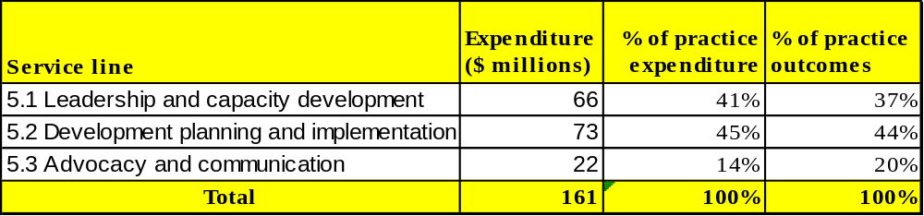
Table 8. Programme demand and expenditure within HIV/AIDS practice
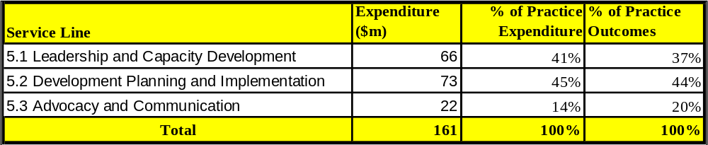
National ownership and capacity to fight HIV/AIDS
- The majority of outcomes associated with service line 5.2, development planning and implementation, were centred on mainstreaming HIV/AIDS into national development plans, a result area that remains central to the HIV/AIDS work of UNDP. Moreover, this distribution of outcomes reflects increased country demand in 2005 for support in integrating HIV/AIDS into MDG-based poverty reduction strategies. In response to this demand, as well as the evolving global environment and the Global Task Team recommendations, UNDP was assigned the lead role in collaboration with the World Bank and UNAIDS to support countries to more effectively mainstream HIV/AIDS into MDG-based poverty reduction strategy papers. In 2005, seven African countries including Mali, Senegal, Zambia and Ethiopia, benefited from capacity development support to plan, manage and deliver on an increasingly robust response to the epidemic through the joint UNDP, World Bank and UNAIDS initiative. In 2006, support will be expanded to meet demand from a further 13 countries.
- Another key area of growing demand from countries is support to advance the ‘three ones’ principles of: one agreed national action framework; one national AIDS coordinating authority; and one agreed country-level monitoring and evaluation system. These efforts have improved the capacity of national governments in aid coordination and harmonization in several countries, including Russia, Zambia, Kyrgyzstan and Indonesia. In countries such as Rwanda and Mozambique, country efforts have focused on strengthening national AIDS councils.
- The HIV/AIDS service line with the second highest demand was leadership and capacity development, with support for leadership efforts continuing across all regions in both high and low prevalence settings. A key shift in the work under this service line is the adaptation of the capacity development methodologies to targeted outcomes in development planning and human rights. For example, through the leadership development programme implemented in China’s Sichuan and Hubei provinces and Tiajin municipality, the capacities of 300 local leaders and legislators were developed on prevention policies and strategies for implementing enabling HIV/AIDS legislation. Significantly fewer outcomes are now being reported under service line advocacy and communication, which may indicate a shift from making the case for action on HIV/AIDS to large scale, multi-sectoral programmes. It also reflects a recent trend toward integrating media initiatives into ongoing leadership capacity development programmes.
- Looking more broadly at the emphasis placed on capacity development within the practice area, a number of substantial initiatives and results stand out. In Africa, UNDP achieved significant results in the areas of mainstreaming HIV and AIDS responses into poverty reduction strategy papers, sector plans and building regional and sub-regional capacity on TRIPS to ensure sustainable access to low-cost, quality AIDS medicines. UNDP has worked closely with 32 African countries to build capacity to adapt TRIPS flexibilities and safeguards to ensure anti-retroviral access.
- A highly successful workshop with the African Union and Third World Network in Addis Ababa provided a forum for sharing best practices and developed the capacities of participants to formulate and adopt TRIPS provisions into patent legislation that would allow for both the import and manufacture of generic essential medicines. In the world’s worst affected sub-region, Southern Africa, efforts are ongoing to support improved capacity of national and sub-national agencies to deliver services. The Southern Africa Capacity Initiative reports progress in the development of strategies to strengthen social service delivery in high prevalence countries. In support of the scale up of access to treatment in this region, UNDP has conducted, in partnership with the World Health Organization, a training of trainers on community capacity enhancements for treatment preparedness in order to implement the ‘3 by 5’ initiative.
Box 8. Partnering with UNIFEM on gender and HIV/AIDS
The HIV/AIDS practice placed the highest emphasis on gender issues in 2005, with gender continuing to be an integral part of the leadership and community programmes of UNDP around HIV/AIDS. Programmes in Sudan and Papua New Guinea led to the formation of women’s groups addressing gender aspects of HIV/AIDS. In Ethiopia, the cross-practice initiative with UNIFEM on women’s inheritance and property rights was successfully launched and yielded important results, including the formation of a coalition and network of 60 leaders from government and civil society to address the gap between progressive statutory law and practice. Despite progress reported however, the rapid feminization of the epidemic requires that UNDP bolster its efforts to address its gender dimensions. This process gained momentum last year when human rights and gender became one of the three HIV/AIDS service lines. Following from this, an upcoming organizational consultation will be held to define the global strategy of UNDP on HIV/AIDS and gender, and how to most effectively support country efforts to ‘engender’ their national HIV/AIDS responses.
- In the Arab States region, the overarching focus is still on building leadership capacity to break the silence surrounding the epidemic. More recent interventions now focus on working in partnership with UNAIDS to advance rights-based approaches to HIV/AIDS prevention. In Asia, UNDP reported notable results in promoting decentralized leadership at the provincial and district levels in China and mainstreaming efforts in India. The Pacific HIV/AIDS programme developed close partnerships with UNIFEM, the Global Coalition on Women and HIV and local women's groups to identify gender entry points and influence policy and practice at the local and international levels. Latin America and the Caribbean region’s efforts focused on strengthening national strategic plans and on prevention and vulnerability reduction. Efforts in Europe and the Commonwealth of Independent States region addressed harm reduction, human rights and the development of capacities of government and civil society to respond effectively to HIV/AIDS through leadership development programmes in countries such as Ukraine and Russia.
- The HIV/AIDS practice continued to play an important role in developing country capacity for improved implementation of multilateral funding initiatives such as the GFATM. While UNDP continues to act as principal recipient of last resort for global fund grants in 24 countries, the success of UNDP engagement will ultimately be judged by the extent to which it builds the capacity of local partners to implement the grants. This ‘coach- and train-as-you-go’ model has already enabled the successful hand over of principal recipient to a local partner in Haiti and similar results will soon be seen in Benin and El Salvador.

IV. Implementation of organizational strategy

- The MYFF, 2004-2007 not only establishes the overall objectives and priorities of the organization over the funding period, but signals the key strategies that will be adopted to ensure high quality results. The MYFF, 2004-2007, established a number of these key organizational strategies, including: (a) actions to deepen partnerships and coordination within the United Nations system and with the development community; (b) actions to promote the drivers of development effectiveness; and (c) actions to build internal organizational capacity. The following pages of the report feature a scorecard of UNDP progress on promoting partnership and coordination and integrating the development drivers. The third strategy, which relates to internal capacity development, is reported on under the management results section.

A. Partnership and coordination
Coordination
- In line with the Paris Declaration, the country level support of UNDP to national ownership focused on addressing the issue of absorptive capacity. Targeted support was provided to governments in facilitating public sector capacity for improved overall management of development finance. This included aid management initiatives in over 50 programmes. A particular momentum for coordination and partnership development was provided by the new aid environment that includes direct budget support, sector-wide approaches (SWAps) and pooled funds. In 2005, the number of country programmes that reported involvement in SWAps and pooled funds increased from 18 to 24, while the number of country programmes participating in direct budget support programmes increased from four to 12. In 2005, UNDP introduced an operational policy, now in effect, to support countries utilizing and managing direct budget support and SWAps.
- Country office support to poverty reduction strategy processes opened space for policy dialogue platforms for planning, programming and financing the MDG targets at the country level in an integrated, long-term manner. Building on the opportunities of new-generation poverty reductions strategies, more than 30 country programmes reported support for mainstreaming MDGs into national poverty reduction strategies. The round-table and consultative group mechanisms, as well as government-led development forums, provided space for policy dialogue on poverty reduction strategies. A sharper focus on strengthening national aid coordination and management mechanisms that are fully government-led with broad-based national stakeholder participation is emerging in this field.
- On behalf of the United Nations system, UNDP provided support to common services and participated actively in joint programming. In 2005, UNDP initiated nearly 90 joint programmes, bringing the total number of ongoing joint programmes to approximately 200, up from an estimated 65 in 2004. The majority of these involved Executive Committee agencies addressing MDG results. Moreover, in 2005 the Executive Boards of the Executive Committee agencies agreed to a common country programme document for Cape Verde, with a joint office and a common United Nations representative. UNDP serves as the support organization for this Office of United Nations Funds and Programmes, as it is designated.
- The corporate commitment of UNDP to strengthening the resident coordinator system and the coordination capacity at the country level continued. To this end, the organization is expanding the country director concept by placing UNDP country directors in countries with complex development situations, which facilitates focusing and strengthening the role of resident/humanitarian coordinator. In 2005, UNDP obtained Executive Board approval for the reallocation of resources in the amount of $5.6m under the regular budget in order to fund seven country director posts and additional resource requirements of the UNDG office. Furthermore, UNDP has earmarked and deployed junior professional officers in support of resident coordinators. Currently one quarter of serving resident coordinators come from agencies other than UNDP. The male-to-female ratio was 73:27.
Partnerships
Box 9. CBOs plan and implement 76 small projects in Albania
In Albania, the UNDP Local Governance Programme supported the voluntary establishment of 139 community-based organizations and helped to mobilize community members in assessing and prioritizing their needs. Community-based organizations planned and implemented 76 small community projects at a cost of $1.96 million, with an estimated 19,049 households benefiting from them. The independent assessment of the Kukes Area-based development programme quoted “93.2 per cent of people interviewed said community-based organizations have been an effective means to address development issues facing their community”.
- Partnerships around the MDGs were an important priority for the organization in 2005. UNDP and UNDP-assisted initiatives played a key role in putting the MDGs high on the global agenda in the build-up to the World Summit. The process was kick-started in January with the launch of the final report of the United Nations Millennium Project, ‘Investing in development: A practical plan to achieve the Millennium Development Goals’. The report was the outcome of an ambitious intellectual effort by the United Nations system, and generated wide media coverage of development issues. Concurrently, the advocacy of the United Nations Millennium Campaign with civil society networks through the Global Call to Action against Poverty rallied public opinion in favour of increased global action for poverty alleviation and the MDGs. UNDP supported these initiatives in addition to the global, regional and country monitoring processes that underpinned the policy advocacy and campaigning. At the end of 2005, 130 countries and territories had produced 155 MDG reports. At the same time, 11 regional and sub-regional reports were published and OECD/DAC countries had produced 22 reports on their MDG Goal 8 obligations.
- At the country level, the 2005 data provide evidence of increasing networking and partnership among United Nations organizations and other partners. Eighty-five per cent of all outcomes in 2005 involved partnership-based approaches. During the year UNDP strengthened partnerships with United Nations organizations on the implementation of many of the recommendations from the TCPR. Working with the UNDG, UNDP responded to the calls made at the Paris high-level forum, implementing 12 integrated offices with UNIDO and pursuing hosting arrangements with UN-HABITAT in some 46 country offices.
- The UNV programme is an integral part of UNDP, strategically positioned to ensure grass-roots involvement, improve access of disadvantaged groups to public services and include marginalized groups in decision-making processes. In 2005, UNV mobilized more than 3,000 UNV volunteers in the context of UNDP-supported programmes. Around 100 country offices referred to their partnership with UNV, and most countries participating in the Southern Africa capacity initiative highlighted the critical importance of the involvement of UNV in the initiative. The partnership with UNCDF was also strategically strengthened in 2005, both operationally and financially. UNCDF has moved closer to UNDP physically by expanding its presence in UNDP regional service centres in Bangkok, Dakar and Johannesburg, and financially through the decision to mainstream the administrative budget of UNCDF for 2006-2007 within the UNDP biennial budget. Collaboration with UNCDF, as demonstrated in this report, is most evident in the governance and poverty practices.
Box 10. Partnerships for tsunami recovery and reconstruction
In the aftermath of the 2004 Indian Ocean tsunami, UNDP supported national recovery efforts and the coordination of international aid offered by governments, the private sector and foundations. Foundations that contributed included the Alianza por Asia, the America India Foundation, the Asia Society, the Bush-Clinton Tsunami Fund, the Ford Foundation, and the United Nations Foundation, among others. UNDP Mexico partnered with the Alliance for Asia to mobilize $4 million for the transitional shelter programmes in Indonesia, and the United Nations Foundation was instrumental in engaging other foundations to leverage more than $10 million. In the Maldives, strong partnerships with the private sector and other actors were built around the ‘Adopt-an-island’ programme which supported communities in rebuilding homes and infrastructure.
- The UNDP-UNIFEM partnership continues to be important for UNDP in its efforts and ability to advance gender mainstreaming; improve the integration of gender perspectives into policies and programmes; and enhance opportunities for women to participate fully in development processes at all levels. Long-term UNIFEM relationships with CSOs have enhanced the support of UNDP to capacity development strategies in the areas of poverty reduction, HIV/AIDS and democratic governance, especially through collaboration on MDGs and gender-responsive budgets. UNIFEM has worked to build and strengthen women’s networks in specific areas and to empower women to participate in decision-making processes at all levels. This enables the partnership to amplify voices and perspectives that would not otherwise be heard in planning and decision-making.
- Strengthened relationships between donors and UNDP have been of tremendous value in 2005. Thirteen DAC donors increased their core funding to UNDP, and 11 donors now pledge to UNDP regular resources on a multi-year basis. At the end of 2005, growth in regular resources reached approximately $921 million, up 9.3 per cent from 2004. Third-party contributions to other resources rose by 47 per cent to a record $2.5 billion. In addition, significant efforts were made to broaden the UNDP partnership base, as the organization deepened operational ties with key multilateral regional banks, and effectively engaged with non-traditional partners, including city and local governments, for the benefit of programme countries in Africa, the Commonwealth of Independent States and Latin America.
- UNDP brought together 150 civil society partners to prepare a community position on the issues raised in the report of the Secretary-General, ‘In larger freedom: towards development, security and human rights for all’, and to ensure a CSO/CBO collective agenda for the June 2005 hearings. UNDP participated in the task force of the President of the General Assembly to organize the informal hearings with civil society, NGOs and the private sector. Country programmes reported forging partnerships with civil society under all practice areas. Initiatives encompassed indigenous peoples in policy dialogue, gender advocacy, and rights awareness; many programmes reported working with civic partners in combating HIV/AIDS.
- In total, 87 country programmes reported private-sector partnership activities, which ranged from facilitating public-private dialogues and support to achieving the MDGs, to catalysing private investments that benefit development. Twenty-six country offices were involved in activities relating to the Global Compact, which is the main United Nations initiative to engage the private sector. Under the growing sustainable business initiative, UNDP brokered and facilitated private-sector investment projects that are profitable and address local development priorities. In 2005, seven country offices were involved in fostering sustainable business activities, an initiative that continues to expand in 2006.
- UNDP is building partnerships with foundations in all regions of the world to combine knowledge, networks and resources to address development challenges. In 2005, UNDP partnered with close to 60 foundations to support new and ongoing initiatives, and continued to foster partnerships with locally-based foundations in Chile, China, Moldova, the Philippines and Togo, among others.
Development drivers
- One of the key corporate strategies of UNDP for ensuring quality development results is centred on the promotion and integration of six critical and cross-cutting development drivers into its programmatic work. The data for 2005 suggest that the majority of country programmes have placed a medium to high level of emphasis on four of the six drivers. These are: developing national capacities (75 per cent medium-high), fostering an enabling policy environment (77 per cent), forging national partnerships (85 per cent), and seeking South-South cooperation (57 per cent).
- As figure 6 also shows, more work will need to be done in integrating the gender equality and national ownership drivers, both of which showed low emphasis placed by a majority of country programmes. The data also suggest that there is scope for improvement on the other four drivers as well, as the levels of ‘high emphasis’ expected were not realized. As seen from the figure, and corroborated by the findings on partnership presented earlier, forging partnerships for results was the driver with the highest level of emphasis. The focus on partnerships is a clear signal from the field level of a growing responsiveness to the changing aid environment. But the disparity between this and other drivers may also be an indication of a need to refine the measuring methodology for the drivers.
Figure 6. Degree of emphasis on drivers

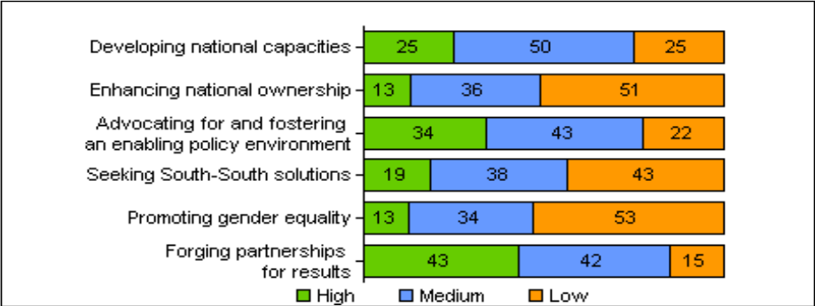

Capacity development, national ownership and policy environment
- Capacity development is at the core of the mandate of UNDP and cuts across all practices. In keeping with the Paris Declaration on Aid Effectiveness, the TCPR outcome document and the UNDP integrated package of services initiative, UNDP made significant investments in capacity development in 2005. During the year, a portion of TRAC-2 allocations were provided on the basis of a set of criteria that emphasized national capacities for the MDGs. This has set the stage for increased targeted programming in this area, the results of which should be seen in future MYFF reports.
- UNDP intensified efforts to enhance its corporate-level technical capacity to support capacity development work in the field, including the publication of practice notes on capacity development and on capacity assessments, which guided a more systematic and analytical process for assessing and supporting local and national capacities. These efforts contributed to enhanced understanding of the functionalities of capacity development in advocacy, enabling environment for policy reforms, national development planning, knowledge management, service delivery and monitoring and evaluation. Country programmes appear to have embraced capacity development as their core business and have integrated it into their day-to-day work. Much of the substantive work in developing national capacity has been presented in Chapter III of this report, under each practice. The present chapter provides an overview of the extent to which the cross-cutting capacity development drivers have been integrated into programming.
Figure 7. Emphasis on developing national capacity
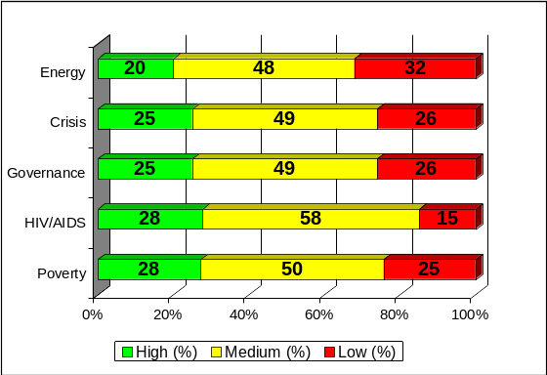

- Deepening capacities to achieve the MDGs requires enhancements at the systemic, organizational and individual levels. The developing national capacities driver is therefore targeted at these three critical levels. UNDP uses the concept of capacity development to address enhancing national ownership and fostering an enabling policy environment, which are identified as two additional capacity development drivers.
Figure 7. Emphasis on developing national capacity
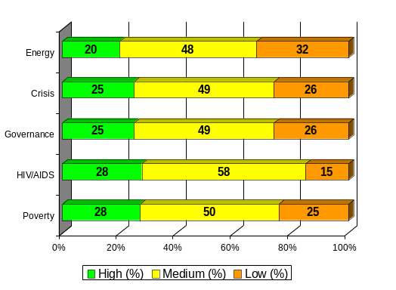
- National ownership and enabling policy environments are critical prerequisites not only for development effectiveness but also for long-term sustainability of development interventions. UNDP works to specifically build capacity in these two areas into all its programmes. Capacity development can be viewed as having three dimensions within the organization. The first is general capacity development to assist countries design, plan and implement development programmes and projects. The second is capacity development to facilitate national ownership of development interventions. The third is capacity development targeting policy environments.
- In 2005, country programmes reported considerable integration of these three drivers of capacity development into their work. They emphasised the developing national capacities and fostering enabling policy environment drivers, with at least three-quarters of outcomes having medium or higher-level emphasis. The HIV/AIDS practice had the highest level of integration of the developing national capacity driver, with 85 per cent of outcomes showing high or medium level of emphasis on this driver (figure 7). The energy and environment practice, on the other hand, showed only 68 per cent of outcomes with high or medium emphasis. The HIV/AIDS practice also led the practices with respect to efforts to develop capacity around policy environments, with 88 per cent of outcomes showing high or medium emphasis (figure 9). The crisis prevention and recovery practice trailed the other practices, with 74 per cent of its outcomes placing medium emphasis on this driver. Country programmes placed the least emphasis on the enhancing national ownership driver, with only half of outcomes having ‘medium’ emphasis or better. The crisis prevention and recovery practice showed the highest emphasis (60 per cent) while the poverty practice had the lowest (46 per cent).
Figure 8. Emphasis on enhancing national ownership

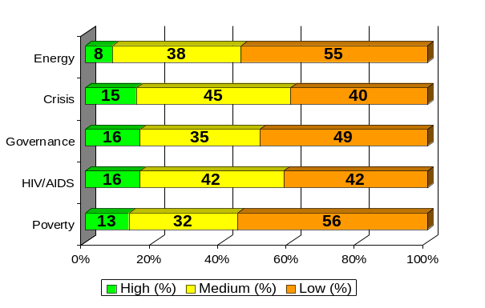
- Overall, the data confirm that capacity development drivers were strongest in the HIV/AIDS practice. This was due to work on capacity development as a cross-cutting issue within the practice, as well as specific programming focused on capacity development activities. The poverty practice area also placed reasonably high overall emphasis on capacity development. This is in part explained by the its MDG focus and the UNDP core commitment to strengthening national capacity in this area. Major emphasis was placed on enhancing statistical and other capacities and fostering an enabling policy environment for the MDGs. The low reliance on the promoting national ownership driver in the practice area was anomalous, and may have been due to the narrow interpretation given to the driver.
Figure 9. Emphasis on foster an enabling policy environment

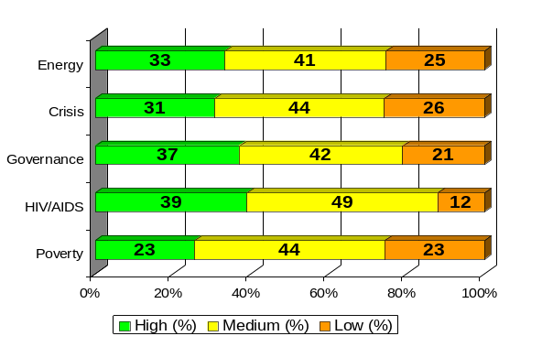
- Although the combined ‘high’ and ‘medium’ emphasis on the capacity development drivers was at an acceptable level, the extent to which a ‘high’ level of emphasis was placed on the drivers was somewhat weak and warrants further focus and strengthening in programming practices. The data may also be a reflection of weaknesses in the results-based management system and specifically in the methodology of defining, measuring and reporting on the cross-cutting capacity development drivers. These three drivers, currently separate, are defined and reported on with considerable and understandable overlap. This requires review in 2006.
Gender equality
- For 2005, UNDP underwent a critical independent evaluation of its gender mainstreaming strategy and plan. The evaluation noted that while many gender mainstreaming activities were taking place, they had yet to be institutionalized. The gender thematic trust fund (TTF) was implemented in 2005 to build capacities for gender mainstreaming at two levels – institutional and individual. Support from the gender TTF has resulted in the formulation and implementation of the gender mainstreaming strategy in many country programmes and has helped to ‘engender’ UNDP programme portfolios. As a further indication of the commitment of UNDP to advancing gender mainstreaming, $10 million was made available from core resources for the implementation of the Gender Action Plan, 2006-2007,, which responds to the recommendations of the 2005 evaluation and demonstrates organizational commitment in institutionalizing gender mainstreaming. In addition, a gender steering and implementation committee to be chaired by the Administrator was established, along with accountability mechanisms to track allocations and expenditures on gender mainstreaming and to pre-test the gender scorecard to measure the performance of UNDP in programming.
Figure 10. Degree of emphasis on gender across practices

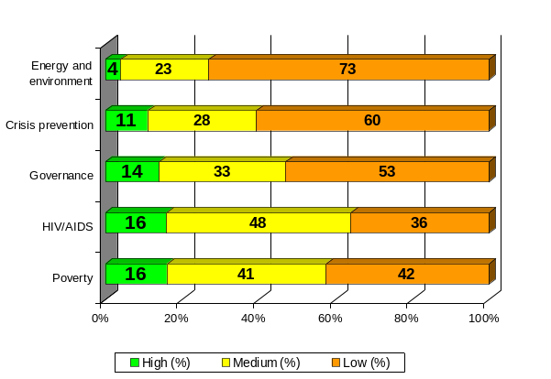
- The review of the 2005 country programme data reveals that, while there is better understanding and indeed better application of the gender driver in programming, there are still substantial challenges to be overcome. The emphasis on the gender driver still lags behind when compared to the other five drivers of development effectiveness, as in 2004. More than half (53 per cent) of the emphasis on the gender driver falls in the low category. An area of particular concern relates to the fact that country office reports frequently cite women as being involved in processes on the ground, but not at the policy level; and in many instances, women were seen as beneficiaries rather than active participants in the design and implementation of programmes and policies, since gender was reported as not being relevant to programmes. The energy and environment and crisis prevention and recovery practices showed the lowest level of reliance on the driver.
- In areas of progress, a large number of countries have reported significant use of gender analysis in programming in their qualitative reports. This was seen most notably in respect to the work of UNDP in gender mainstreaming policy instruments such as NHDRs, MDG reports and PRSPs, which are increasingly incorporating gender perspectives and more consistently utilizing gender-disaggregated data. The analysis also reveals that public policies and national budgets have tended to incorporate gender concerns in countries where the MDG framework has been institutionalized using MDG needs assessments, MDG progress reports, and MDG task forces.
- Encouragingly, the poverty and HIV/AIDS practices have placed considerable emphasis on this driver, with gender mainstreaming being integrated into MDG and NHDR processes and being taken on board in the fight against HIV/AIDS, the gender dimensions of which are becoming increasingly evident. While the strong emphasis in the poverty practice was partly attributable to service line 1.6. – gender mainstreaming – which is located within this practice, it was also due to the fact that countries engaged in MDG report and NHDR processes describe a high reliance on the gender driver. This resulted in the many concrete examples of gender mainstreaming, including production of gender-sensitive MDG reports (15 countries), gender-sensitive NHDRs (seven countries), gender budget audits, gender-disaggregated data (Cambodia, United Arab Emirates), gender-sensitive legislation (Fiji, Rwanda, Samoa, Swaziland), and gender-mainstreamed national development plans (Bahrain, India, Moldova, Turkey).
- Under the gender mainstreaming service line, UNDP is supporting the implementation of the Beijing Declaration and Platform for Action and the Convention on the Elimination of Discrimination against Women in fulfilling state obligations by harmonizing domestic laws in conformity with the convention and targeted activities for elimination of violence against women. This service line constitutes an important catalyst in overcoming gender gaps and steering the support of UNDP towards helping governments in achieving gender equality outcomes. In 2005, 46 countries reported on specific programmes and outcomes under this service line.
- Regarding the HIV/AIDS practice, high reliance was due to the fact that gender-specific targets have been incorporated into the practice. This reflects growing recognition of the fact that more women than ever bear the brunt of the disease owing to gender inequality and discrimination against women. The high overall emphasis may conceal some important regional variations. For example, it was noted that countries in Asia and the Pacific placed relatively lower emphasis on gender in their HIV/AIDS work, with potentially significant implications given the increasing vulnerability of the region to the threat. This is a clear message that even within the HIV/AIDS practice more gender mainstreaming work needs to be done.
- The governance practice placed high priority on building women’s political leadership skills and participation in elections, as well as on increasing women’s participation in local governance, policy dialogues and civic debates. The work of UNDP focused on increasing the capacity of governance institutions at national and local levels to understand gender issues and undertake gender mainstreaming.
- Overall, the data suggest that while efforts are being made to increase gender mainstreaming, insufficient targeted interventions are in place to bring about the desired results. In many cases the low emphasis on the gender driver was due to the fact that it was not considered relevant or applicable to country programmes. It should be noted, however, that this is only the second year of introduction of the driver, and its full integration into programming may require more time. Finally, the methodology appears to lead to inconsistencies, with some countries focusing on the gender mainstreaming service line in their reports and others on the driver. A key conclusion from the analysis is that there is a need to review and streamline reporting on gender.
South-South cooperation
- Globally, reliance on South-South cooperation in 2005 was very similar to 2004. A significant percentage (43 per cent) of country programmes placed low emphasis on this driver. Crisis prevention and democratic governance were the practices with the highest reliance on South-South approaches. While HIV/AIDS was in the medium range, reliance on South-South cooperation was lowest in the energy and environment and the poverty practice areas.
- While South-South cooperation has not received the scores expected on the quantitative measure, a significant number of countries have reported on programmes in which they have integrated the driver. For example, the qualitative data indicates welcome support provided by the Special Unit for South-South Cooperation in recruiting Southern disaster risk management experts (from India, Kenya and Laos) to enhance the capacity of UNDP country programmes through training in community-based disaster management. The Special Unit provided support for institutional capacity development of civil society organizations in Sri Lanka, sharing experiences from India on civil society engagement. A significant South-South cooperation effort was also by Sri Lanka, in collaboration with Thailand and the Philippines, in exchanging experiences they had had in working to achieve the MDGs, and lessons learned in the process.
- Many country programmes reported that low reliance was due to the fact that most UNDP-supported initiatives and targets are country specific and do not necessarily call for sharing of experiences or obtaining Southern services or goods. The South-South driver is often seen as an incidental element of country office programmes and has trailed the other drivers in terms of the degree of emphasis reported.

B. Management results
- Building on results achieved in the first year of the MYFF period and the preceding years, UNDP remained focused on enhancing organizational capacity to deliver development results in 2005. This section of the report outlines the most important activities of UNDP towards attaining key management results, which are grouped around three strategic areas: support to the United Nations reform efforts pertaining to the alignment of its operational capacities; strengthening accountability frameworks; and improving organizational effectiveness and efficiency.
Supporting United Nations reform
- Regarding United Nations reform, the efforts of UNDP were informed by the TCPR report of operational activities for the United Nations development system, which urged further financial, technical and organizational support to the resident coordinator system. One such important result is implementation of the joint office pilot initiative, discussed in Chapter III, section A. This multifaceted change management process was supported by UNDP and spanned efforts in planning and budgeting; financial policies and controls; the array of human resources management policies; information technology infrastructure; and procurement guidelines. The new joint office offers a model for United Nations development system operations at the country level and a convincing case for further efforts in this area.
- With respect to the simplification and harmonization agenda, UNDP contributed to the implementation of a United Nations development system cash transfer framework closely linked to the roll-out of common country programming tools seeking to reduce transaction costs to national partners. Among other initiatives and results in this area are the United Nations programme for the prevention of harassment, sexual harassment and abuse of authority; the common services management system; the common procurement scheme; and, related to system-wide strategic management of human resources, the inter-agency mobility policy and the inter-agency transfer approach.
Strengthening accountability
- Over the years, UNDP has made steady progress in building a culture of accountability. In 2005, the organization continued to improve its management tools and accountability frameworks with the ultimate objective of strengthening the ability of UNDP country programmes to achieve development results. In introducing new tools and improving existing tools and standards, UNDP is striving to shift the focus of accountability from compliance to results.
- In this vein, the year in review was marked by a strategic enhancement of the balanced scorecard – one of the most comprehensive performance assessment tools used by UNDP – with an addition of the ‘fifth perspective’ measuring country office performance in the programme area. A series of newly introduced management tools, which leverages the financial performance assessment opportunities provided by Atlas, put UNDP further ahead analytically,and prepared the ground for results-based budgeting, which is on the Executive Board agenda for 2006-2007.
- To meet evolving requirements, as well as external and internal stakeholder expectations of accountability, UNDP updated and obtained the approval of the Executive Board in 2005 for its Financial Regulations and Rules. These clearly define accountability, incorporate risk management guidelines and facilitate project delivery by creating space and setting requirements for country office management of financial resources within defined risk parameters. To ensure observance of best practices and standards in audit and financial controls, UNDP launched an internal control framework aligned with the Atlas system.
- As the programme portfolio of UNDP continued to grow, risk management became an important and cross-cutting concern in all areas of operations. Efforts towards enhanced risk management in the finance function were matched by improvements in the area of procurement and technical infrastructure. In procurement, UNDP revised its policies on procurement ethics and launched an online tool for the UNDP Advisory Committee on Procurement, ‘ACP Online’, which was instrumental in preparing the organization to manage its growing procurement portfolio. With respect to information and communication technology infrastructure, the organization completed its security risk assessment and ensured stability of the out-hosted environment.
Box 11. Measuring corporate confidence: Global Staff Survey (GSS) 2005.
Favorable responses to questions on accountability and transparency:
In my office…
I clearly understand the results I am expected to deliver | 87%
Financial transactions are processed transparently | 86%
Procurement is conducted transparently | 80%
Programmes are managed transparently | 76%
Audit recommendations are implemented in a timely manner | 68%
Recruitment is conducted transparently | 66%

- While these efforts hold significant potential, UNDP is cognizant of areas for improving performance and accountability (see Box 11) and will continue to scale up its response to the challenges. Based on lessons learned during the review period and in close consultation with the Executive Board, the organization will review the effectiveness of its results and risk management systems and realign its business and decision making processes accordingly. UNDP will also seek to ensure full and consistent implementation of recently updated policies and operational guidelines and will launch new modules and accelerate overall efforts towards certification and professionalization of staff. Further efforts will also be directed at cultivating an accountability environment within the organization. The first phase of the management and workflow review of UNDP commissioned by the Administrator towards the end of 2005 and the second phase initiated in early 2006 will help to further the organization’s efforts at a comprehensive accountability system.
Enhancing organizational effectiveness and efficiency
- The UNDP MYFF, 2004-2007, affirms that efficiency and cost effectiveness are paramount for headquarters and country office operations. Hence, change management, business process reengineering and internal capacity development are key management priorities.
- From an overall efficiency perspective, UNDP registered a zero nominal increase in management expenditure and a 30.7 per cent increase in programme expenditure, resulting in a reduction in the management versus total expenditure ratio from 10.8 per cent in 2004 to 8.5 per cent in 2005. Increased operations efficiency allowed for strategic resource management and reallocation of resources towards strengthening the resident coordinator function and enhancing organizational capacity, as outlined in the UNDP biennial support budget for 2006-2007. More than 50 country offices made concerted efforts to strengthen their office performance by going through structured change processes in 2005, in line with the methodology and guidance of the ‘Toolkit for Managing Change’.
- Key assets of UNDP are its human resources, their talent, knowledge, experience and capabilities. In 2005, UNDP introduced new workforce reports which, by aggregating analytical data and offering strategic insight on human resources management issues, helped UNDP assess long-term challenges and requirements to inform decision-making. One of the strategic requirements of UNDP human resource management is to ensure that its workforce reflects the diversity of the communities it serves, particularly with respect to gender equality. The gender and diversity scorecard was enhanced during the review year with a new feature called ‘Tracking the Progress’. Most recent data suggest that while substantial progress has been made towards equitable gender representation in entry-level and middle-management professional posts, achieving gender balance in UNDP will require sustained work and commitment.
- Organizational capacity development will require continued emphasis on the implementation of practice approach and professionalization of staff members. In 2005, UNDP launched procurement certification – an accreditation course to improve professionalization and learning among procurement staff. Preparations were made for the roll-out of certification programmes in finance and human resource management, and more than 500 UNDP staff members were certified in project management in accordance with the internationally recognized ‘Prince2’ methodology. The Learning Resources Centre provided scores of staff members with training in 12 role-based induction programmes, 46 business and technical training sessions and six management development workshops. The focus on professionalization is matched by an enhanced knowledge management architecture, supported in 2005 by the launch of the UNDP user guide in results-based management and in contracts and procurement, as well as the ‘Toolkit for Managing Change’.
Box 12. 2005 Global Staff Survey responses regarding management and supervision
Management team provides direction and leadership
All offices - 69% favourable
Arab States - 75% favourable
Men and women receive equal treatment in UNDP
Female colleagues - 74% favourable
Male colleagues - 78% favourable
Satisfied with information received on what’s going on in the office
Male colleagues - 69% favourable
Female colleagues - 59% favourable
- One of several innovations brought about by the user guide is the requirement to include security risk management as an integral part of programme/project design and implementation, a first step towards full mainstreaming of security risk management in all planning and greater sustainability for funding of the security measures. The efforts made by UNDP to improve security for its staff on the ground led to improvement in MOSS compliance from 40 to 80 per cent during 2005 and to the expansion of the corps of security officers. As illustrated by successful interventions in Nepal, Iraq and in number of other countries, integrating security risk management into programme design can enhance delivery and significantly expand geographic coverage of the programme portfolio in complex development situations. To be able to replicate the positive experiences, and given the fluid global security environment, UNDP will continue efforts in this area, shifting its focus from targeted interventions to a comprehensive security framework.

C. Financial results
Resources
- The upward trend in contributions to UNDP continued in 2005. From a high of $3.8 billion in 2004, overall resources contributions grew again in 2005 to $4.5 billion. Contributions to regular resources ($923 million) reflect a 10 per cent or $81 million increase over the level of income reached in 2004 ($842 million). The income level in 2005 exceeded the projection underlying the MYFF, 2004-2007, of $900 million for the period. As seen in table 9, contributions to other donor and local resources of UNDP also increased, both in comparison to 2004 and when considered against 2005 MYFF income projections.
Table 9. Income, by source of funding (in millions of dollars)
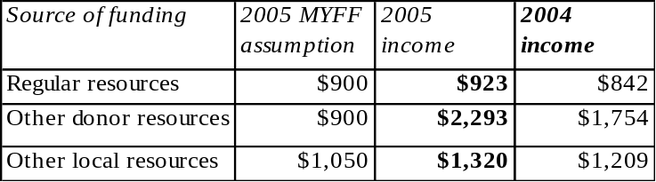

Programme expenditures
- Programme expenditure by source of funding is presented in table 10 (a more detailed table with expenditures by practice and service lines is attached). Programme expenditures in 2005 totaled $3.65 billion, which represents an increase of 29 per cent over the level of expenditure in 2004 ($2.8 billion). The $3.6 billion total included $524 million funded from regular resources, which was spent primarily in LDCs and low-income countries. Programme activities funded from other donor resources and local resources reached $1,907 million and $1,214 million, respectively (see figure 11 below).
Table 10. Programme expenses, by source of funding (in millions of dollars)
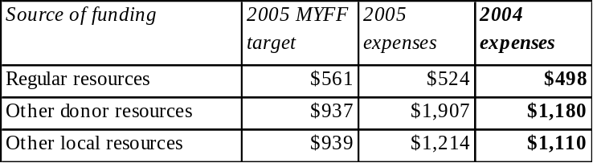
- A comparison of the programme expenditures in 2005, with the targets derived from the MYFF, 2004-2007 and the 2004 expense level is shown below in table 10. The regular resources-funded programme expenses reflect an upward trend and are on track to meet the MYFF target. Also noteworthy is the high level of programme expenses funded from other donor resources and, to a lesser extent, other local resources when compared to the respective 2005 MYFF targets or levels reached in 2004. Large shares within the expenses funded from other donor resources are in the areas of tsunami-related activities, the Global Environment Facility, Iraq, and several trust funds for electoral support. Local resources remain concentrated in a small group of countries in Latin America and the Caribbean.
- Overall country programme expenses by practice have been reflected in section III of this report. The figures below highlight these expenditures by source of fund. When considering the source of funding, differences emerge in the attribution of resources to practice areas, most prominently in the areas of achieving MDGs and reducing human poverty. Note that 39 per cent of regular resources and 37 per cent of local resources are spent in this area, in contrast to only 12 per cent of other donor resources. Also, in the area of crisis prevention and recovery, there are differences: 20 per cent of other donor resources are spent in this area, in contrast to 13 per cent of regular resources and only two per cent of local resources
Figure 11. Programme expenses, by source of funds
(in millions of dollars)
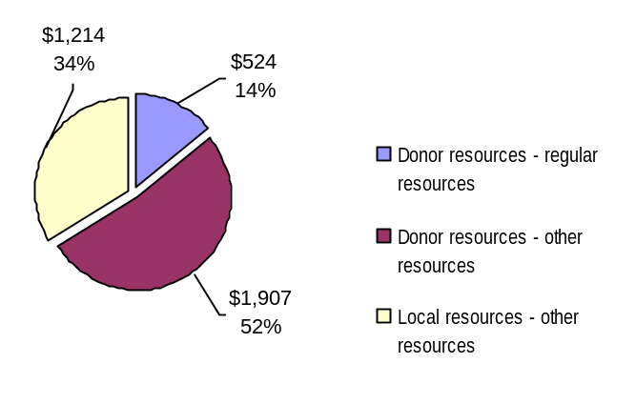
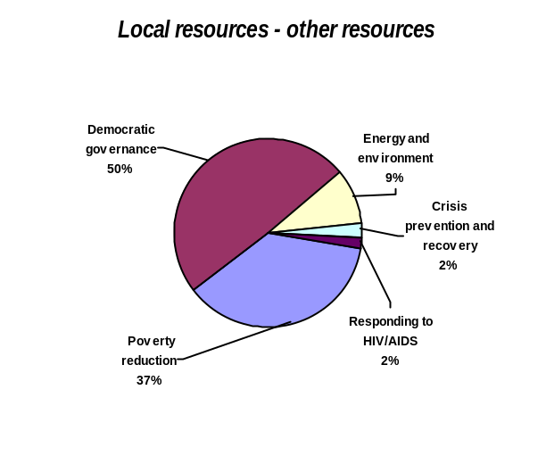Figures 12-14. Programme expenses, by practice area and source of funds (in millions of dollars)
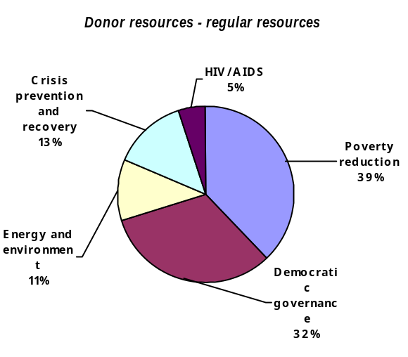

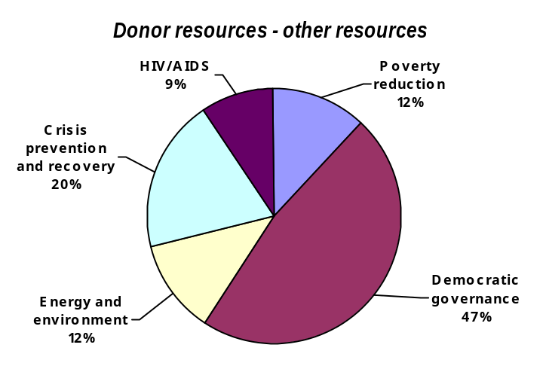

Programme support, management and administration
- In 2005, expenses in the categories of UNDP support and support to operational activities of the United Nations were within the targets set in the MYFF, 2004-2007.

Table 11. UNDP support expenses (in millions of dollars)
Category | MYFF target | 2005 expenditure | 2004 expenditure
Programme support | $264 | $263 | $256
Management and administration | $81 | $77 | $85
Total UNDP support | $345 | $340 | $340

- In the area of support to UNDP activities, expenses related to programme support for 2005 amounted to $263 million, in line with the target of $264 million set in the MYFF, 2004-2007. Of the $263 million, 89 per cent was derived from donor resources. Management and administration expenditures for 2005 amounted to $77 million, which is also below the target set of $81 million. Support to United Nations operational activities amounted to $81 million, in line with the corresponding MYFF target of $82 million. As seen in table 12, the ratio of UNDP support over UNDP support plus total programme for the year 2005 is again below the ratio derived from targets in the MYFF, 2004-2007.
Table 12. UNDP support ratio (in millions of dollars)
Category | Annualized MYFF 2004-2007 | 2005 expenditure | 2004 expenditure
Total programme (a) | $2,437 | $3,645 | $2,788
Total UNDP support (b) | $345 | $340 | $340
Total programme + UNDP support (c = a + b) | $2,782 | $3,985 | $3,128
UNDP support ratio (b / c) | 12.4% | 8.5% | 10.8%

Resource prospects for 2006 and beyond
- UNDP is a multi-funded organization experiencing increased growth in its resource base. However, regular resources provide UNDP with its all-important funding base, especially with respect to its universal presence and country-driven focus. Regular resources also provide the platform to support the United Nations system and the resident coordinator functions at the country level. While UNDP continued to experience steady growth in regular resource contributions during 2005, sustained increases will nevertheless be required during 2006 and 2007 if the respective $1 billion and $1.1 billion MYFF targets are to be achieved. The limited number of partners adhering to multi-year funding commitments and exchange rate exposure are elements of considerable concern in resource projections.

V. Conclusion
- The 2005 review of UNDP performance suggests that the organization is on track with regard to meeting the performance targets and executing the operational strategies of the MYFF, 2004-2007. The assessment of field operations confirms that the organization is operating in line with United Nations reform principles and mandates, while remaining aligned with and responsive to national priorities. The country programme performance is supported by the positive views expressed by key partners of UNDP and an increased volume of resources mobilized at the local level.
- The report demonstrates that with respect to capacity development work, UNDP conforms to the recommendations of the TCPR and the World Summit Outcome, with country programmes involved in a wide range of substantive capacity development programmes in each practice. Significant capacity development interventions were highlighted around the MDGs and national efforts to integrate the MDGs into development planning. Similarly substantial support went into strengthening governance institutions to enhance the efficiency and effectiveness of both public and private sector entities and create more stable foundations for democracy.
- The review has highlighted a number of areas for improvement for the organization. One key gap pertains to the drivers of development effectiveness. While the overall performance on the drivers has been acceptable, the data point to continuing challenges, particularly on the gender, national ownership and South-South cooperation drivers. Attention has also been brought to the methodology on which the drivers are based, and the feedback from country programmes has suggested a need to revise the methodology to better capture work on the ground.
- Finally, the review of programme finance has brought attention to the portion of country programme expenditure (10 per cent) that is currently not mapped to the practice architecture and which, as a result, was not analysed within the practices and service lines.

The development drivers, which were increased to six in 2004, are (a) developing national capacities, (b) enhancing national ownership; (c) advocating for and fostering an enabling policy environment; (d) seeking South-South solutions; (e) promoting gender equality; and (f) forging partnerships for results.
As indicated in DP/2004/CRP6, UNDP agreed to report on MYFF results in a comprehensive manner every two years.
Data sources include the partners survey, internal audit reports, and the balanced scorecard to verify self-assessment of results.
At the World Summit in September 2005, global leaders resolved to “strengthen and update the programme of work of the United Nations so that it responds to the contemporary requirements of Member States…” The report of the Secretary-General, ‘Mandating and delivering: analysis and recommendations to facilitate the review of mandates’ (A/60/733), presents key challenges to meet this objective.
SWAps involve multiple agencies working with government to address problems in a sector in a coherent, coordinated manner. Direct budget support involves providing financial resources directly to governments through the national budget. Pooled fund arrangements normally entail a number of partners coming together to undertake a specific programme or initiative and contributing to a common fund to implement activities.
UNDP is committed to establishing 20 joint offices by the end of 2007, as decided by the UNDG.
UNDP defines capacity as “the ability of individuals, institutions, and societies to perform functions, solve problems, and set and achieve objectives in a sustainable manner.” Capacity development is the process through which this ability is obtained, strengthened, adapted and maintained over time.
The United Nations Millennium Declaration, the Paris declaration on aid effectiveness and the 2005 World Summit Outcome reflect the growing global prominence of capacity development.
In response to demand for development services in this practice, at the end of 2005 UNDP introduced its IPS) to support national MDG-based strategies. The objectives of the IPS are to provide UNDP with (a) a framework to deliver a menu of corporate services to respond to country demands for technical assistance to prepare, strengthen and implement MDG-based national development strategies; (b) a concrete mechanism to engage countries in dialogue leading to development outcomes in pursuit of MDGs; and (c) a concrete mechanism to engage with other United Nations Development Group agencies and the Bretton Woods Institutions to leverage their particular expertise.
The remaining 10 per cent of expenditure were not linked by country programmes to the practices at the time of reporting. The reasons for this were also not established as of the time of reporting.
The report can be found online at http://democracyreport.undp.org
Other resources include government cost-sharing and other donor/third-party contributions.
The partners survey captures the views of a range of partners at the local level, including governments, international development agencies, and private and not-for-profit entities.
For example, most reports had data disaggregated by gender, age, and region.
http://www.undg.org/documents/6604-2005_World_Summit_Outcome_Document.pdf
Rome Declaration on Harmonization, Rome, 25 February 2003
The active integrated framework countries are: Burundi, Cambodia, Mauritania, Guinea, Nepal, Madagascar, Senegal, Malawi, Ethiopia, Lesotho, Yemen, Mali, Benin, Lao People’s Democratic Republic, Mozambique, Zambia, Chad, Rwanda, Sierra Leone, Maldives, Sao Tome and Principe, Tanzania, Uganda, Gambia, Djibouti, Angola, Burkina Faso and Niger
It should be noted also that some GEF funds were not mapped to the energy and environment practice, or were reported under other practices, possibly reflecting cross-practice initiatives.
Indonesia, Maldives, Mauritius and Sri Lanka all reported activity under this core result.
The United Nations Development Group and the Executive Committee on Humanitarian Assistance established a joint working group on transition issues to respond to two sets of policy directives contained respectively under Economic and Social Council resolution E/2002/32 and Action Point 14 in the report of the Secretary-General (A/57/387/2002). The working group agreed to focus on processes of transition from conflict to peace, while recognizing that the term “transition” is applied to different but often overlapping processes of transformation.
The reform of the humanitarian response is an inter-agency effort to develop an accountable, reliable and predictable response to man-made and natural disasters, resulting from the independent humanitarian response review which the United Nations Emergency Relief Coordinator had commissioned in 2005 to better understand and correct deficiencies of the global humanitarian system.
The conflict peace and development cooperation framework group brings together major OECD donors working on development issues to develop joint activities, harmonize policy approaches, and create common systems and tools for donors on peace, conflict and fragile states issues.
Country offices which indicated low emphasis on these three drivers include those where: 1) The programme is very mature (e.g. Mozambique); 2) The dedicated mine action support of UNDP is no longer needed (e.g. Croatia); 3) The mine action support provided is part of an integrated peacekeeping mission (e.g. Burundi, Sudan); 4) The in-country security conditions are difficult (e.g. Iraq).
The leadership development programme brings together leaders from government, civil society and the business sector to generate individual and collective commitment and breakthrough actions that respond to the epidemic, address its underlying causes and empower others to act.
The Southern Africa Capacity Initiative is a framework for responses that supports countries in southern Africa in designing and implementing a set of additional actions and strategies which address the complex human capacity challenges in a systematic and integrated manner.
This conclusion is supported by the qualitative feedback from offices, which often indicate that while significant initiatives are being undertaken to promote certain drivers, the drivers will not appear across all outcomes and service lines in a quantitative manner. For example, Gabon falls within the low overall reliance on south-south cooperation driver, but reports heavy reliance on the experience of Burkina Faso in formulating its national poverty reduction strategy. Likewise the Gambia, which also reported low overall reliance, reported using lessons learnt from Vietnam and the Congo in designing their MDG reporting systems. Similar findings were reported for all other drivers.
The Gender Action Plan, 2006-2007, was approved by the Executive Board at its first regular session 2006.
At its second regular session of 2002, the Executive Board recommended that the UNDP Evaluation Office undertake a global evaluation of gender mainstreaming in the organization to gauge the effectiveness of its approach and validate the results of past efforts in gender mainstreaming and advancing gender equality. The evaluation was carried out between December 2004 and June 2005.
The gender scorecard approved by the Executive Board in 2004 is intended to summarize organizational performance in gender mainstreaming. It builds on programme performance indicators contained in the MYFF gender driver and complements the gender balance scorecard managed by the Office of Human Resources
For more comprehensive report on partnership and building national capacities, see the report of the Administrator on the implementation of the Third Cooperation Framework, 2005-2007.
In 2005, the Advisory Committee on Procurement reviewed 892 submissions (with amounts in excess of $100,000 each) for a total value of $599 million, up from 591 cases for a total value of $450 million in 2004.

