Annex 1 to DP/2009/23:
Charter of the Office of Audit and Investigations
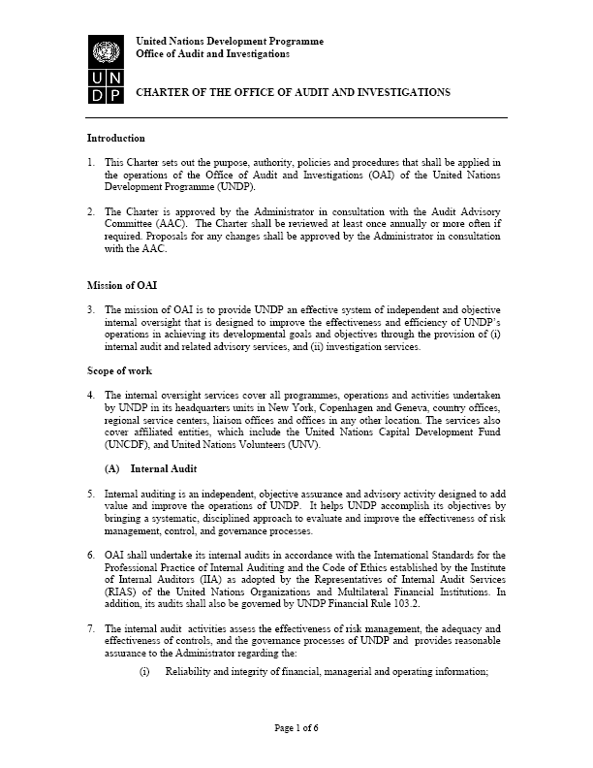
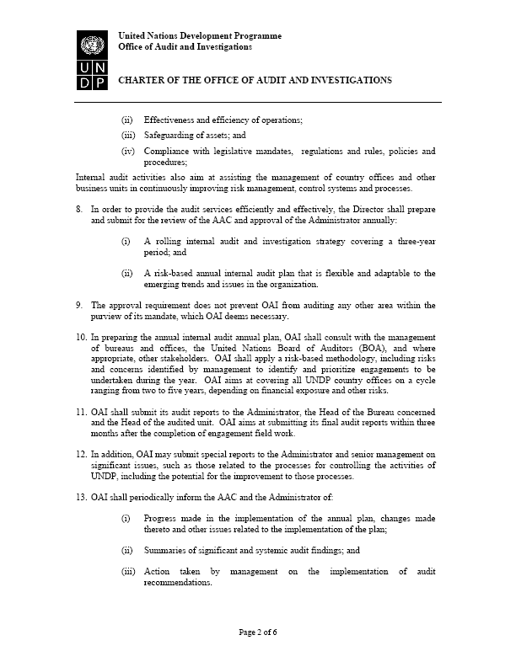

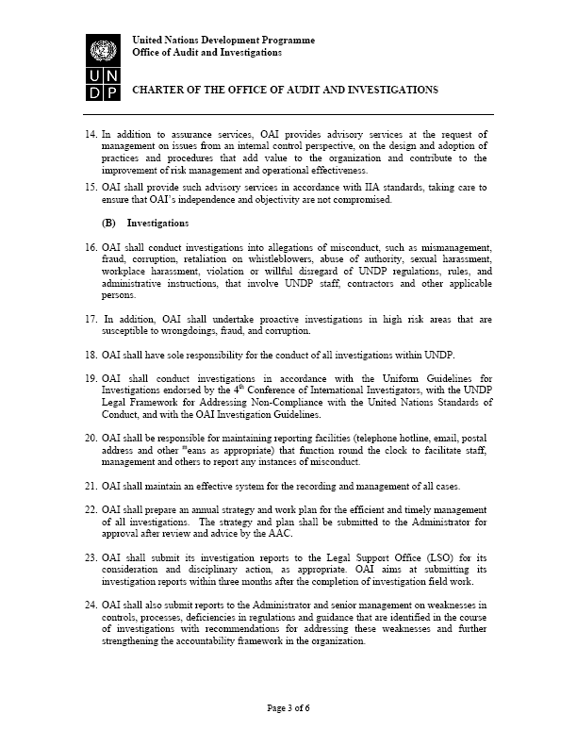

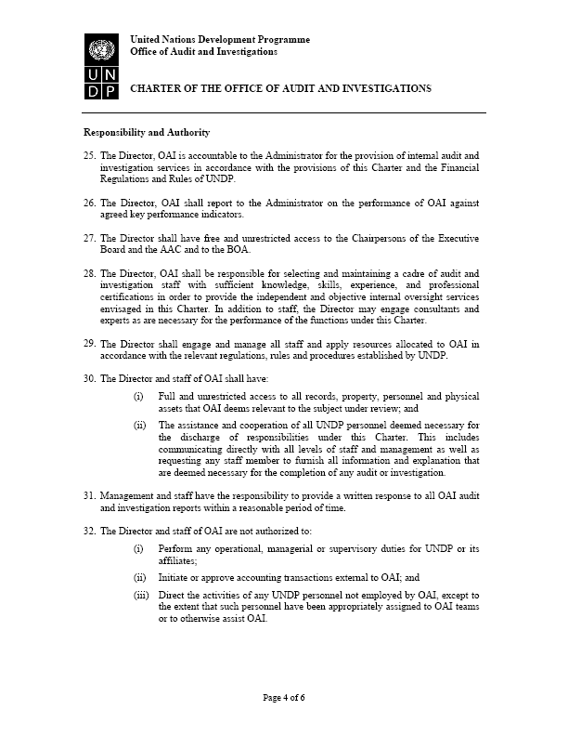

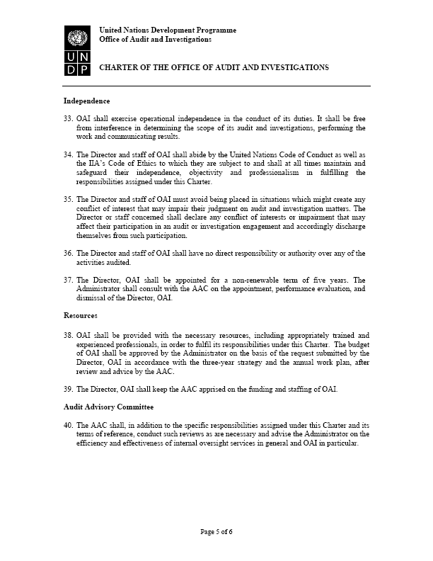

Annex 2 to DP/2009/23:
Recommendations unresolved for 18 months or more
a. Analysis of recommendations outstanding for 18 months or more
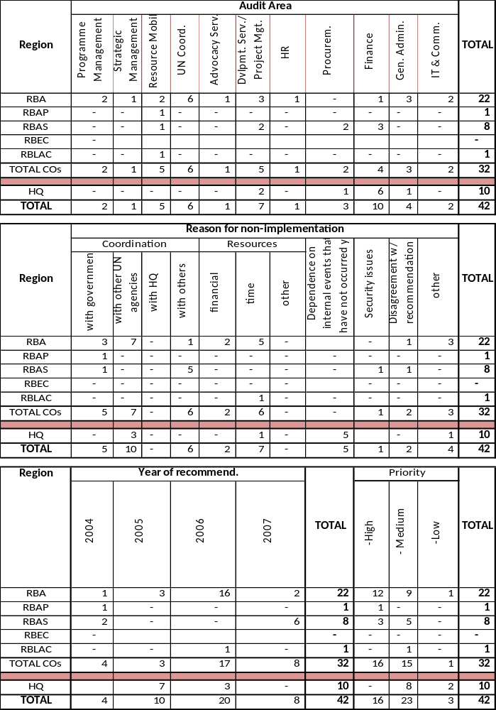Note: CO = Country Office, HQ = Headquarters

b. High priority recommendations unresolved for 18 months or more, by year

Unresolved recommendations | Explanation for prolonged implementation time
Year 2004
- Partnership and resource mobilization - Pursue collection of Government contribution to local office costs (GLOC), by either signing the standard agreement or continue with ongoing efforts. | Involves extensive discussions with the Government
- Human Resources - Need to review current staffing situation in the HR unit. | Lack of financial resources
- Financial resources - Need to close bank accounts with certain banks. | Security situation in country
Year 2005
- Support to United Nations coordination - Need to strengthen common services management. | Involves coordination with other United Nations agencies
- General Administration – Travel - Need to set up travel agreements. | Coordination with other agencies
Year 2006
- Partnership and resource mobilization - Collect government’s contributions. | Involves extensive discussions with the Government
- Support to United Nations coordination - Sign agreement and collect rental costs from other agencies; amend existing agreement. | Coordination with other United Nations agencies
- Development services - Ensure financial closure of operationally completed projects. | Needs more time
- Development services - Submit documentary evidence to audit firm for clearance. | Involves interaction with appointed auditor
- Financial resources - Need to clear outstanding salary advance account. | Needs more time
- ICT - Establish a more systematic and effective off-site back-up of files. | Needs more time
Year 2007
- Development services - Ensure return of project assets to UNDP. | Coordination with implementing partners
- Development services - Ensure that project funds are used only for the purpose intended. | Needs more time

The 42 recommendations outstanding for 18 months or longer constitute 0.9 per cent of all recommendations given by OAI in a 3.5 year period ending 31 December 2008.

