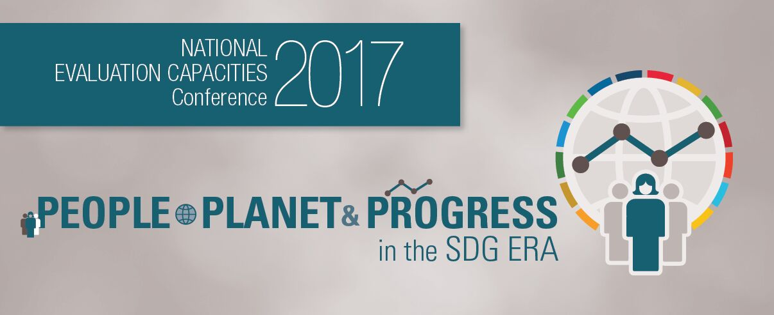

NATIONAL EVALUATION CAPACITIES (NEC) 2017 BURSARY PROGRAMME

UNDP is pleased to be able to offer a limited number of bursaries for the National Evaluation Capacities (NEC) Conference 2017, thanks to generous support from the Government of Finland. This in recognition of the importance of building capacities, collaborative networks and facilitating the exchange of ideas and experiences to strengthen national evaluation capacities in all countries. Bursaries will be awarded through an application process.
Applications must be submitted by 29 August 2017.
Financial assistance to attend the conference may take the form of waived registration fees and/or support to economy travel and/or support to accommodations, however, participants are expected to cover some of the costs of attending the conference to demonstrate their institution’s engagement and commitment.
Eligibility
- Applicants must come from, and live in and work most of the time in, an ODA-eligible country. Priority will be given first to participants from least developed countries, then to other low income countries, and then lower middle income and finally, upper middle income countries (see http://www.oecd.org/dac/stats/documentupload/DAC%20List%20of%20ODA%20Recipients%202014%20final.pdf)
- Priority will be given to government officials from national and sub-national institutions directly and indirectly engaged with evaluation and/or the SDG agenda, who have the potential to inform and influence the development of national evaluation capacities and/or who have a demonstrated track record of commissioning, using or conducting evaluations.
- Some support will be provided to young evaluators (evaluators under age of 35 years, with technical knowledge on evaluation and potential to influence the evaluation agenda in their country in coming years).
- Female applicants are strongly encouraged to apply.
- Persons with disability are strongly encouraged to apply.
- Applicants must submit an abstract for a paper by 29 August 2017 (see: http://web.undp.org/evaluation/nec2017/call-for-abstracts.shtml)

Application process
Applicants should download the application form at ( https://goo.gl/1visnv )and submit the complete application to ieo.nec@undp.org. by 29 August. The application will include:
- A statement of interest (max 300 words)
- A current CV
- Copy of abstract submission
UNDP will review applications and determine the successful recipients and will inform the applicants of the outcome of their application by 8 September 2017. UNDP bursary support can only be received once by each individual. As only limited bursaries will be given out, applicants are encouraged to apply for funding elsewhere.
All bursary recipients are required to:
• Attend the pre-conference workshops and conference programme
• Prepare a conference feedback report (1 page) outlining the conference highlights and its contribution to professional growth to ieo.nec@undp.org by 31 October 2017.

Important dates:

Deadline for applications: 29 August 2017

Notification of applicants: 8 September 2017

Should you need further information please do not hesitate to contact us at ieo.nec@undp.org

